For Immediate Release

Wyandotte High School Auditorium Gets Upgrade with Bose® RoomMatch® Loudspeaker And PowerMatch® Amplifier System

Steven Brown of Progressive Electronics and Bob Ledo of Coffeen Fricke and Associates, Inc. agree that the RoomMatch® loudspeaker technology provided the right solution for a challenging acoustical environment

Framingham, Massachusetts, May 15, 2013 – RoomMatch® loudspeakers and PowerMatch® amplifiers from Bose® Professional Systems Division are creating new fans at a fast clip. Leading Midwest AV systems integration company, Progressive Electronics, based in Raytown, Missouri, near Kansas City, has recently completed its third project using RoomMatch loudspeakers and PowerMatch amplifiers. This was the historic 1,500-capacity Wyandotte High School Auditorium in suburban Kansas City. The Bose RoomMatch system, designed by Coffeen Fricke and Associates, Inc. and installed by Progressive Electronics, consists of two stereo left-right arrays using RM5520, RM7020 and RM7040 loudspeakers and a center array using RM7010, RM9010 and RM9020 loudspeakers. These are powered by seven Bose PowerMatch PM8500N amplifiers.

The result, says Steven Brown, Systems Design & Sales for Progressive Electronics, “In a word, astounding! Everyone who has heard these speakers has the same reaction. They are simply the finest-sounding loudspeakers I’ve installed in over 20 years of doing this.”

Bob Ledo, Senior Vice President at Coffeen Fricke and Associates, Inc., the consultant that specified the system, points out that the historical nature of the auditorium and its lack of acoustical treatment made it a particularly difficult challenge, but one that the RoomMatch system was especially well suited for. “The RoomMatch array modules allowed us to customize the sound system for the room without having to affect any of the space’s aesthetics, because the loudspeakers can be so precisely aimed, letting us keep the sound off the side and rear walls,” he explains. “And because the dispersion is so precise, it also meant that the system did not need additional fill speakers other than several below the balcony. That reduced the potential complexity of the system, and minimized the need for any additional hardware, which was also important for keeping the historical nature of the interior untouched,” he adds.

As a result of its unique advantages, Brown says that the RoomMatch loudspeakers and PowerMatch amplifiers are essentially selling themselves. An installation that he did using them at the Rolling Hills Church in Overland Park, Kansas, has also been used to demonstrate the RoomMatch system’s superior audio quality to other clients and has led to other sales, such as the installation at the World Revival Church in Kansas City, where Brown says its new three RoomMatch array clusters combined with a RM215 four module bass array and multiple PM8500N amplifiers is routinely used at volumes of up to 100 dB several nights a week with absolute sonic integrity across the frequency spectrum. “When I first heard these speakers in a demo in Boston last year I was floored,” says Brown. “The sound was spectacular. Phenomenal. Awesome. Two of the projects I’ve used the RoomMatch loudspeakers and PowerMatch amplifiers on came as a result of just hearing the system at the Rolling Hills Church. The quality of the sound is immediately apparent as soon as you hear it. In fact, the Rolling Hills Church, which has a largely elderly congregation with many who are hard of hearing, said they have gotten letters praising the sound quality of the new system from the congregation, who are ecstatic that they can now hear everything clearly. The pastor told me that the system was a total homerun. Any time I have the opportunity to use the RoomMatch and PowerMatch systems, I will. I will expect similar successes from every properly designed system.”

About RoomMatch Array Module Loudspeakers
Introduced in 2011 and recently expanded with several new modules, the Bose RoomMatch series offers a new class of curvilinear arrays – the progressive directivity array – providing both concert-quality sound for live music and clear vocals for spoken word, with unmatched seat-to-seat tonal balance consistency for installed sound systems. The full-range modules are available in 20 different combinations: horizontal coverage patterns of 55, 70, 90 or 120 degrees, and vertical coverage patterns of 5, 10, 20, 40 or 60 degrees.

The progressive directivity array offers the ability to vary both the horizontal and vertical coverage patterns for each module in the array based on the room dimensions. More precise coverage control helps sound system designers ensure good intelligibility with spoken-word program material, especially in reverberant rooms, as well as the best possible tonal balance throughout the listening area.

# # #
Photo File: Wyandotte.JPG
Photo Caption: The historic 1,500-capacity Wyandotte High School Auditorium in suburban Kansas City, the site of a P.A. upgrade featuring RoomMatch® loudspeakers and PowerMatch® amplifiers from Bose® Professional Systems Division, installed by Progressive Electronics, based in Raytown, Missouri. Photo by Wyandotte student Evelyn Rueda. © 2013.
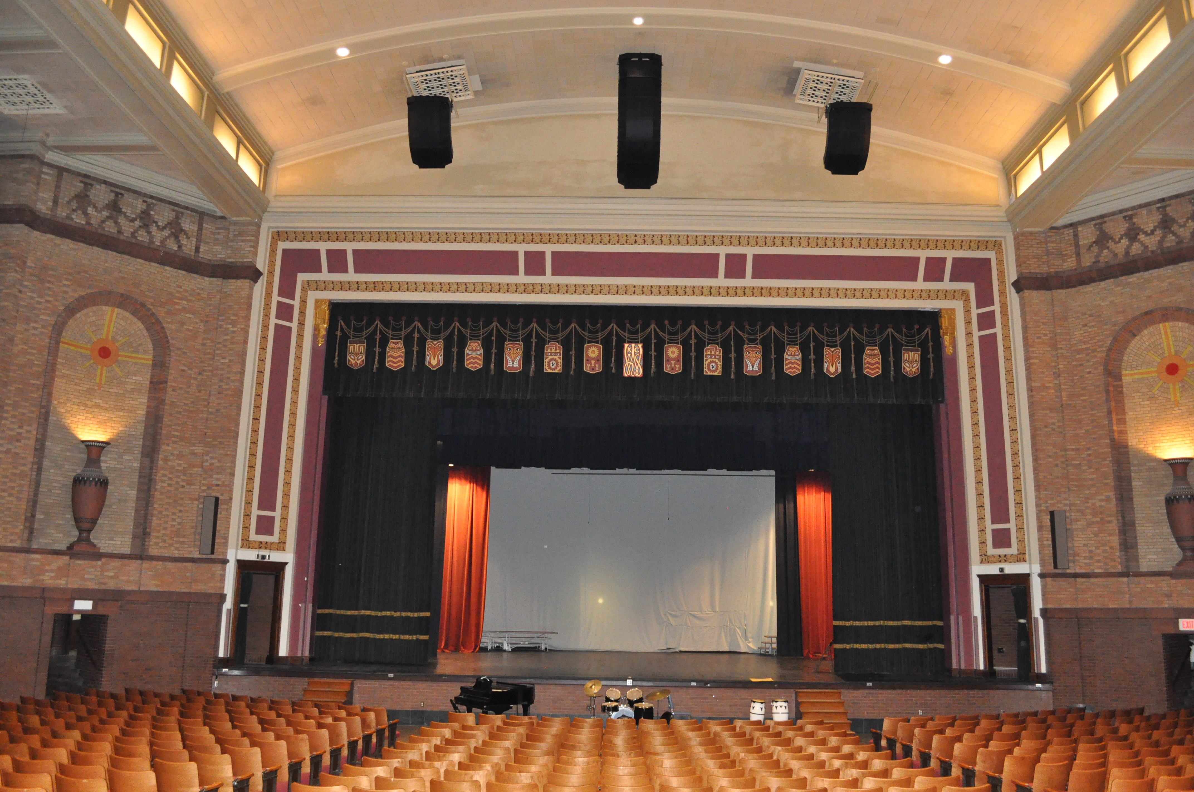
About Bose Corporation
Bose Corporation was founded in 1964 by Dr. Amar G. Bose, professor at the Massachusetts Institute of Technology. Today, the company is primarily known for acoustics; however, its research has resulted in products for non-audio fields. Bose inventions have improved the performance of:

- Loudspeakers
- Home entertainment systems
- Automotive music systems designed for the interior acoustics of each car model (first introduced by Bose)
- Noise reducing headsets for pilots and the public (first introduced by Bose)
- Sound in public spaces
- The production of sound for musicians requiring electronic amplification of their instruments
- Materials testing and durability simulation instruments for biomedical, industrial and commercial applications
- Driver suspension systems for heavy-duty trucks
# # #
Bose Contact:
Bose Professional Systems Division
508-614-6441
Bose_Professional_Systems@bose.com
pro.bose.com

