For Immediate Release

Bose® RoomMatch® Sound System Allows The New Gymnasium At Webster City High School To Host Sporting Events As Well As Live Concerts
Bose RoomMatch® RM12060 modules are the backbone of a system that also includes Bose PowerMatch® PM8500 power amplifiers, RoomMatch RMS215 subwoofer modules and a Bose ControlSpace® ESP-00 processor
Framingham, Massachusetts, November 13, 2012 – Can you make a gymnasium sound like a concert hall? That’s what Electronic Sound Company (ESC), a Des Moines, Iowa AV systems integrator, was able to do at the newly constructed gym at Webster City High School, thanks to the RoomMatch® RM12060 array module from Bose® Professional Systems Division. ESC chose Bose Professional components as part of their sound and acoustics strategy for the new gymnasium, including eight RoomMatch RM12060 array modules, three Bose PowerMatch® PM8500 configurable professional power amplifiers, two RoomMatch RMS215 subwoofer modules, and a Bose ControlSpace® ESP-00 processor. This system, along with acoustical treatment design, also by ESC, allowed the high school to move an upcoming fundraiser concert by Iowa-born operatic basso-baritone vocalist Simon Estes from the school’s auditorium, which seats only 650, to the new gymnasium, which can seat up to 2,500.
“RoomMatch is the best speaker that I have ever used for control over the sound,” proclaims Al Osborn, CEO of ESC. “It is a highly controllable speaker. In this situation, we needed to keep the sound away from very specific parts of the room, such as the lower parts of the walls, because as a gym we couldn’t put acoustical treatment materials on the first 16 feet of the wall height. So we had to have a sound system that was precisely controllable and highly directional. That system includes Bose RoomMatch array module loudspeakers.”
Osborn also has praise for the Bose ControlSpace ESP-00 processor, which is used on this project as both a DSP processor and a router. The ControlSpace ESP engineered sound processor provides control and audio processing in a single, expandable unit and offers eight expansion card slots accommodating a range of input/output options, including control via RS-232 and serial over IP, analog audio, AES-3, Dolby Digital®, DTS® and PCM digital stream formats, as well as CobraNet® network audio. The ControlSpace ESP-00 features an asymmetrical I/O matrix capability where up to 64 digital channels or 32 analog channels can be routed and processed, a function that Osborn used to allow the sound system to operate in specific zones as needed. This further helps control the sound energy in the room, supporting the intelligibility of the sound, by minimizing reverberation.
And finally, the two RoomMatch RMS215 subwoofer modules that Osborn incorporated into the system design play a very special role at Webster City High – the school’s sports mascot, a lynx, needed its own sound effect for games played in the gym. Osborn found a recording of what he called “an appropriately angry lynx” that provided the full-throated roar the school was looking for. “The two RoomMatch RMS215 subwoofers are just what they needed to get that extra level of excitement across,” he says. From opera to wild lynxes, the Bose RoomMatch sound system offers everything you need for a wide range of applications.
# # #

Photo File 1: Webster_Photo1.JPG
Photo Caption 1: A RoomMatch® RM12060 array module from Bose® Professional Systems Division, recently installed at Webster City High School by Des Moines-based Electric Sound Company.
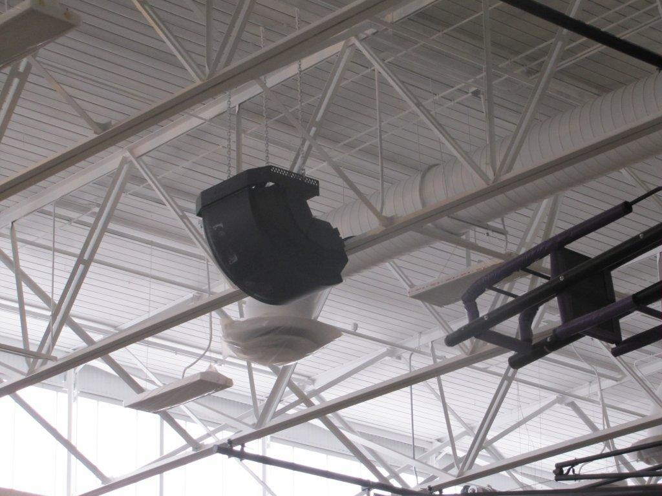

Photo File 2: Webster_Photo2.JPG
Photo Caption 2: A RoomMatch® RMS215 subwoofer module from Bose® Professional Systems Division, recently installed at Webster City High School by Des Moines-based Electric Sound Company.

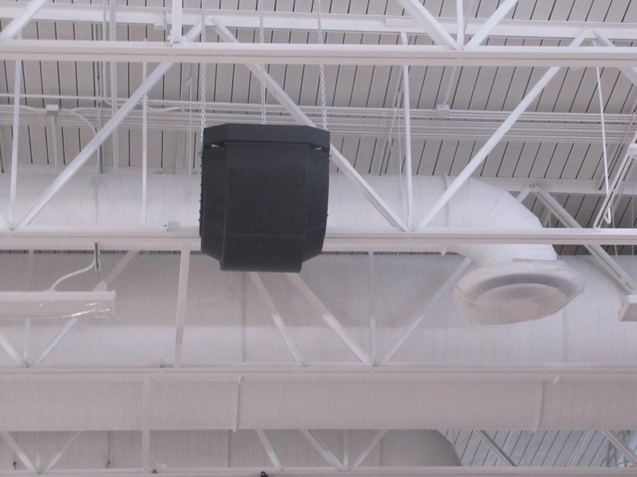

About Bose Corporation
Bose Corporation was founded in 1964 by Dr. Amar G. Bose, professor at the Massachusetts Institute of Technology. Today, the company is primarily known for acoustics; however, its research has resulted in products for non-audio fields. Bose inventions have improved the performance of:
- Loudspeakers
- Home entertainment systems
- Automotive music systems designed for the interior acoustics of each car model (first introduced by Bose)
- Noise reducing headsets for pilots and the public (first introduced by Bose)
- Sound in public spaces
- The production of sound for musicians requiring electronic amplification of their instruments
- Materials testing and durability simulation instruments for biomedical, industrial and commercial applications
- Driver suspension systems for heavy-duty trucks
Bose Contact:
Bose Professional Systems Division
508-614-6441
Bose_Professional_Systems@bose.com

