For Immediate Release

Bose® RoomMatch® Sound System Chosen for University of Rhode Island’s Edwards Auditorium
A range of Bose RoomMatch® modules, powered by Bose PowerMatch® PM8500 power amplifiers, provide URI’s Edwards Auditorium with a flexible, clear-sounding audio reinforcement solution
Framingham, Massachusetts, February 1, 2013 – The historic 920-seat Edwards Hall Auditorium on University of Rhode Island’s Kingston Campus recently upgraded its sound system with a selection of products from Bose® Professional Systems Division. The system was spec’d and installed by Sudbury, Massachusetts-based Adtech Systems. Adtech’s Senior Design Engineer Charlie Crane served as Lead on the project. The final system consists of two L/R clusters consisting of two RoomMatch® RM12060, two RM9020, two RM7010 array modules, and two RMS215 subwoofers, all powered by four PowerMatch® PM8500 configurable professional power amplifiers.
Crane points out the unique challenges of tackling the project in such a space: “The room was originally built as a library and converted into an auditorium much later, so they’ve always struggled with good sound quality in there. The university’s architect was working with administration, and they were primarily concerned with the room’s acoustics. But more accurately, they simply had a problem of coverage – the existing system was not covering every seat. They wanted a new system that would not only cover the room and increase speech intelligibility for lectures, demonstrations and other different things that you would expect in a large auditorium at a college, but they also wanted it to be able to accommodate high-energy music. With these concerns of coverage and versatility of use in mind, it was not hard for us to decide on a Bose RoomMatch system.”
The coverage patterns available with RoomMatch loudspeakers makes designing a new system completely customizable to the space. Crane continues: “The room has a very deep balcony with seating underneath, but with the progressive nature of the RoomMatch arrays, we could throw sound deep into the balcony without blowing the people out of their seats right in the front of the room. We chose the cabinets with the right coverage patterns – a combination of 120x60, 90x20, and 70x10 degrees – and we ended up with a great front-to-back coverage ratio. The client is more than thrilled – they now love the room. RoomMatch offers incredible sound quality and pattern control… Just awesome.”
RoomMatch Array Module Loudspeakers
Introduced in 2011 and recently expanded with several new modules, the Bose RoomMatch series offers a new class of curvilinear array loudspeaker – the progressive directivity array – providing both concert-quality sound for live music and clear vocals for spoken word, with unmatched seat-to-seat tonal balance consistency for installed sound systems. The full-range modules are available in 20 different combinations: horizontal coverage patterns of 55, 70, 90 or 120 degrees, and vertical coverage patterns of 5, 10, 20, 40 or 60 degrees.
The progressive directivity array offers the ability to vary both the horizontal and vertical coverage patterns for each module in the array based on the room dimensions. More precise coverage control helps sound system designers ensure good intelligibility with spoken-word program material, especially in reverberant rooms, as well as the best possible tonal balance throughout the listening area.

# # #

Photo File 1: EdwardsAuditorium_Photo1.JPG
Photo Caption 1: RoomMatch® Loudspeaker clusters from Bose® Professional Systems Division, recently installed at Edwards Hall Auditorium on University of Rhode Island’s Kingston Campus by Sudbury, Massachusetts-based Adtech Systems.
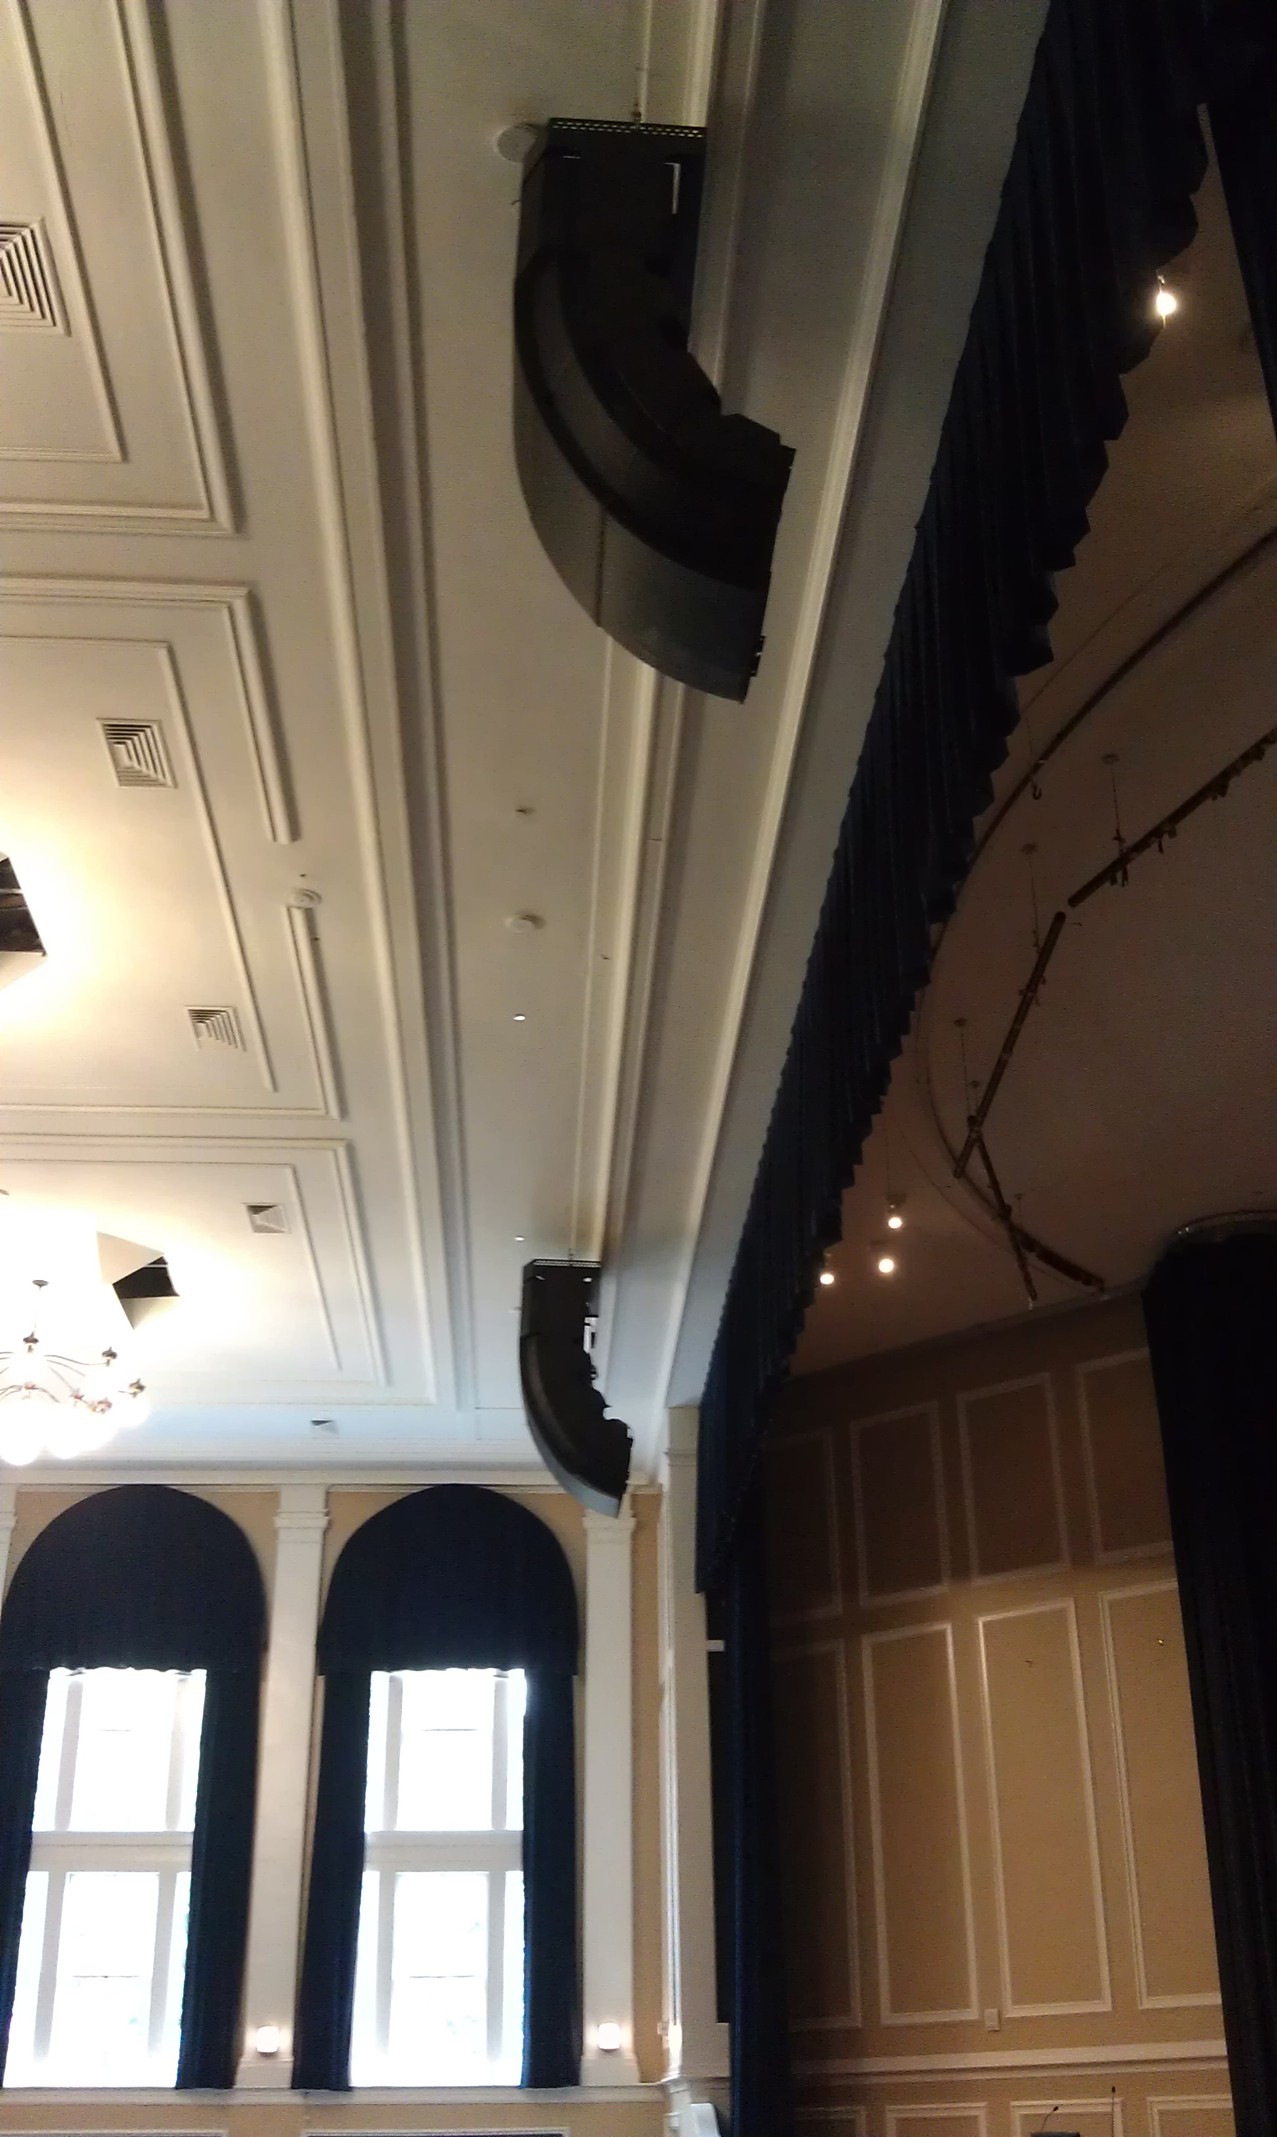

Photo File 2: EdwardsAuditorium_Photo2.JPG
Photo Caption 2: Edwards Hall Auditorium on University of Rhode Island’s Kingston Campus, featuring RoomMatch® Loudspeaker clusters from Bose® Professional Systems Division, recently installed by Sudbury, Massachusetts-based Adtech Systems.
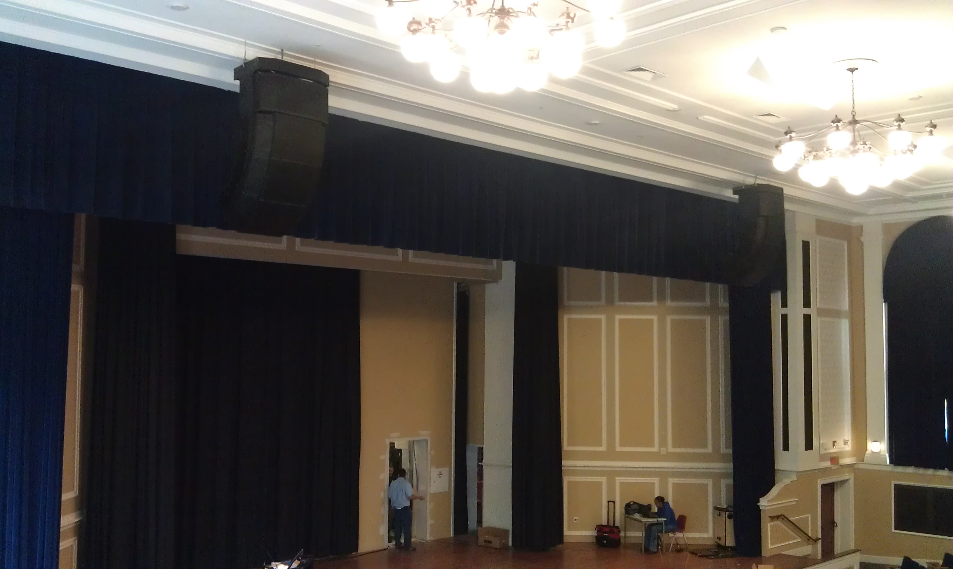

About Bose Corporation
Bose Corporation was founded in 1964 by Dr. Amar G. Bose, professor at the Massachusetts Institute of Technology. Today, the company is primarily known for acoustics; however, its research has resulted in products for non-audio fields. Bose inventions have improved the performance of:
- Loudspeakers
- Home entertainment systems
- Automotive music systems designed for the interior acoustics of each car model (first introduced by Bose)
- Noise reducing headsets for pilots and the public (first introduced by Bose)
- Sound in public spaces
- The production of sound for musicians requiring electronic amplification of their instruments
- Materials testing and durability simulation instruments for biomedical, industrial and commercial applications
- Driver suspension systems for heavy-duty trucks
Bose Contact:
Bose Professional Systems Division
508-614-6441
Bose_Professional_Systems@bose.com

