For Immediate Release

The Bose® L1® System Is Sound Designer Richard Devine’s Ambient Prism for Creative Sound Effects for Films, Television And Video Games
Richard Devine’s unique sounds are ubiquitous in sound libraries used for major film projects and video games, and he relies on the L1® system’s fidelity and long projection range to add ambience, turning existing sound effects into creative new ones
Framingham, Massachusetts, April 8, 2013 – Richard Devine initially bought a PA system to play music for his wedding reception, never realizing that the very same PA system would end up becoming a crucial tool in the sonic palette of his sound design business. But finding new ways to make sound great is exactly what the L1® sound system from Bose® Professional Systems Division did for Richard Devine. His Atlanta-based Devine Sound provides sound effects and other services for a wide range of sample and music libraries, including the Hollywood Edge and Sony Creative Software; his effects have appeared in films including The Last Exorcism Part II and Surveillance, and in commercials for clients like Audi, BMW, HBO and McDonald's. Devine has also remixed top Warp Records artists like Aphex Twin and Mike Patton of Faith No More, done programming for Trent Reznor of Nine Inch Nails, and released four full-length albums of his own. He has a keen understanding of what makes sound unique and is constantly looking for new ways to achieve that – enter the Bose L1 system.

“As part of my regular work, I’ll take sound effects recordings into the field and play them back through speakers in order to re-record them with different kinds of ambiences, such as gunshots or tires screeching in big garage or train station environments,” Devine explains, crediting award-winning sound designer Walter Murch’s “worldizing” concept of reimagining Foley techniques by immersing sound effects in real-life environments to add realistic ambiences.

Devine continues, “For my methods, you can‘t use near-field monitors because you need some distance from the sound source in order for the ambience to develop around the sound. I’ve used other PA speakers before, but they never totally gave me the effect I was looking for – they would distort at the low end or not provide enough projection of the original sound for the ambience to develop around. But after I listened to the music playing through the Bose L1 system we used for my wedding, I realized that this was not your typical PA speaker. I knew that I had found a cool new tool for my sound design work.”

After upgrading his original L1 systems to include a pair of Bose B2 bass modules, Devine finds that a much larger spectrum is available for his sounds, one that lets all of the nuances of the original effect remain as it takes on new ambient aspects. “I’m also using the Bose L1 system to generate sweep tones and capture the impulse responses that let me create new reverbs and other spatial effects,” he says. “And I can do all of this with a system that’s very portable and able to easily set up anywhere, and with fewer cables. I can get right to work. It’s pretty incredible – it started out as a personal thing, a PA for my wedding, but ended up as an important tool for my work every day.”
# # #

Photo File: Devine.JPG
Photo Caption: Sound designer Richard Devine, whose creative Foley techniques involve the use of L1® sound systems from Bose® Professional Systems Division in the field.
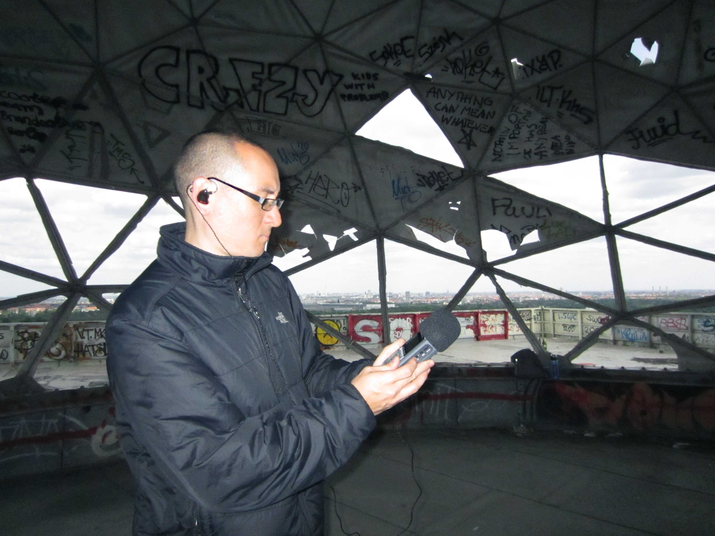
About Bose Corporation
Bose Corporation was founded in 1964 by Dr. Amar G. Bose, professor at the Massachusetts Institute of Technology. Today, the company is primarily known for acoustics; however, its research has resulted in products for non-audio fields. Bose inventions have improved the performance of:
- Loudspeakers
- Home entertainment systems
- Automotive music systems designed for the interior acoustics of each car model (first introduced by Bose)
- Noise reducing headsets for pilots and the public (first introduced by Bose)
- Sound in public spaces
- The production of sound for musicians requiring electronic amplification of their instruments
- Materials testing and durability simulation instruments for biomedical, industrial and commercial applications
- Driver suspension systems for heavy-duty trucks
Bose Contact:
Bose Professional Systems Division
508-614-6441
Bose_Professional_Systems@bose.com
pro.bose.com

