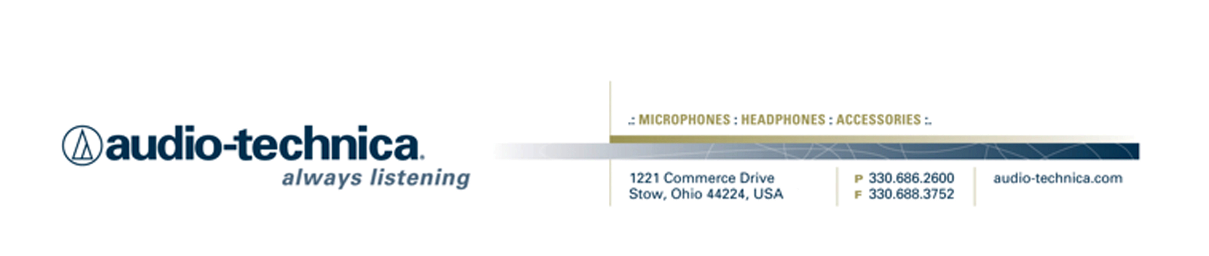
NEWS RELEASE
Contact: Clyne Media, Inc.
Tel: (615) 662-1616
Fax: (615) 662-1636

FOR IMMEDIATE RELEASE

Audio-Technica Hosts Livestreamed “Ask Me Anything” and Educational Mic Presentation Events at NAB 2014

STOW, OH, March 31, 2014 — Following successful booth events at other recent trade shows, Audio-Technica (Booth C1720), a leading innovator in transducer technology for over 50 years, is hosting 15 Livestream events at its booth at NAB 2014.

Some of the industry’s top audio experts will converge on the Audio-Technica booth on Monday, Tuesday and Wednesday during the show. In the morning, get answers to YOUR questions during 30-minute, Q&A-style “Ask Me Anything” (AMA) forums. Then in the afternoon, attend A-T’s popular educational Mic Presentations. All sessions will be livestreamed at www.livestream.com (free registration) and viewable at http://www.audio-technica.com/NAB2014 during and after the NAB show.

“Ask Me Anything” questions are fed to the presenters through a moderator during a 30-minute Q&A session. Questions can be submitted by individuals present at NAB booth C1720, online at Livestream.com, and via Twitter #ATliveNAB.

The session schedule is listed below, and additional details are available at the Audio-Technica booth or at www.audio-technica.com/NAB2014. (Note: this schedule is subject to change; updates will be made on this link.)

Audio-Technica NAB Event Schedule, Booth C1720:
Monday, April 7, 2014
- 10:00 a.m. Ask Me Anything with Dennis Baxter – EMMY® Award-winning sports and Olympic sound designer
- 11:00 a.m. Ask Me Anything with Michael Abbott – TV audio mixer & producer; work includes GRAMMY® and CMA Award shows
- 1:30 p.m. Mic Presentation with Fred Ginsburg, C.A.S. (Cinema Audio Society) – “Rigging Lavalier Microphones for Film/Video Production”
- 2:30 p.m. Mic Presentation with Robert Bigelow, Audio mixer/sound editor for film and TV; recent projects include NCIS New Orleans, Star-Crossed and Treme – “Mid-Side/Stereo Miking Demystified”
- 3:30 p.m. Mic Presentation with Dennis Baxter – “Sports Miking Techniques”

Tuesday, April 8, 2014
- 10:00 a.m. Ask Me Anything with Maureen Droney – Senior Executive Director, The Recording Academy® Producers & Engineers Wing®
- 11:00 a.m. Ask Me Anything with Lenise Bent – Audio mixer/engineer & producer for music and film, including DreamWorks productions
- 1:30 p.m. Mic Presentation with Fred Ginsburg – “Selection and Use of Boom Microphones”
- 2:30 p.m. Mic Presentation with Robert Bigelow – “Recording Live Music for Broadcast”
- 3:30 p.m. Mic Presentation with Fred Ginsburg – “When and How to Use Planted Microphones”

Wednesday, April 9, 2014
- 10:00 a.m. Ask Me Anything with Larry Estrin – Audio technology innovator, Founder of BEST Audio; work includes presidential debates, the Super Bowl, Olympics and Disney
- 11:00 a.m. Ask Me Anything with Robert Bigelow
- 1:30 p.m. Mic Presentation with Steve Savanyu – “Microphone Techniques for Digital SLR Cameras”
- 2:30 p.m. Mic Presentation with Fred Ginsburg – “Intro to Multi-track Location Dialogue Recording”
- 3:30 p.m. Mic Presentation with Fred Ginsburg – “Advanced Workflow for Multi-track Location Dialogue Recording”

For more information, please visit www.audio-technica.com.

…ends 427 words

Photo file: A-T_Livestream_Events.JPG

See more here:
- Audio-Technica Promotional Video: “Always Listening to the Music That Moves Us”
- Recording Basics Videos
- Drum Miking Videos
- Additional News Releases



Celebrating over 50 years of audio excellence worldwide, Audio-Technica is a leading innovator in transducer technology, renowned for the design and manufacture of microphones, wireless microphones, headphones, mixers, and electronics for the audio industry.

—For more information on the complete range of Audio-Technica products, contact
Karen Emerson, Audio-Technica U.S., Inc., 1221 Commerce Drive, Stow, OH 44224.
Tel: (330) 686-2600; Fax: (330) 688-3752; Web: www.audio-technica.com

Audio-Technica is exhibiting at Booth C1720 at the 2014 NAB Show in Las Vegas, NV.

