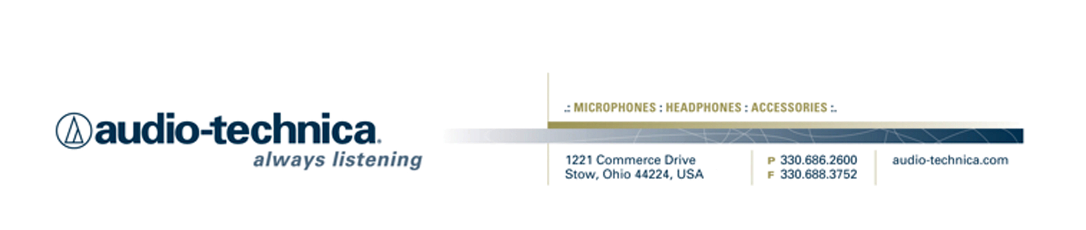
NEWS RELEASE
Contact: Clyne Media, Inc.
Tel: (615) 662-1616
Fax: (615) 662-1636

FOR IMMEDIATE RELEASE

Audio-Technica Microphones Employed by Recording Veteran Steve Smith on Northwest University’s Concert Choir

— Award-winning engineer chooses AT5040 and AT4047/SV mics for live recording of yearly choral concert, and continues to choose A-T mics in the classroom —

STOW, OH, April 1, 2014 — The Concert Choir at Kirkland, Washington’s Northwest University has a reputation as a premier performance ensemble, demonstrating a wide-ranging musicality on pieces from throughout the choral repertory. And they have an added ace up their sleeve in Steve Smith, an award-winning recording engineer and the Creative Director of Creatio, Northwest University’s innovative music business and recording arts degree tracks. At the Concert Choir’s recent annual concert at Seattle’s Benaroya Hall, Smith was tasked with recording and mixing the live performance, and he turned to microphones from Audio-Technica, a leading innovator in transducer technology for over 50 years. Although the recording will likely be used only for archival purposes and internal circulation rather than commercial release, Smith did not take any shortcuts, carefully miking the 100+ member choir, nine-piece brass ensemble and grand piano and mixing a stereo recording any classical label would be happy to release.

For the recording, Smith used five AT5040 Studio Vocal Microphones on the choir and one on the piano. Two AT4047/SV Cardioid Condenser Microphones were used on the brass ensemble. “I love the AT5040,” Smith states. “It’s super high quality. I’d put it up against anything. The AT5040 is extraordinarily transparent and beautiful-sounding.” And Smith’s AT4047/SV’s only scratch the surface of Creatio’s microphone arsenal, which includes nearly 40 A-T microphones.

Creatio is the only four-year accredited school in the Pacific Northwest to offer in-depth training in the recording arts and music industry business. Smith’s long list of credits includes achievements in recording engineering and producing, recording studio design and construction, motion picture and video game soundtrack recording, live sound installation and implementation, and audio production technology education curriculum – not to mention projects from such legends as Stevie Wonder, Garth Brooks, DC Talk, Donna Summer, Van Halen and countless others. As Creatio’s Creative Director, Director of the Recording Arts Technology Program, Chief Engineer of Creatio Studios and a principal instructor, Smith makes it a point of pride to go out of his way to impart his students with practical knowledge and nuanced listening skills. “I believe very strongly that educational institutions and music technology programs have an added importance in this day in age,” he muses. “People used to go to music stores to learn and listen – to A-B mics and signal processors and whatnot – but that is happening less frequently these days. Educational institutions are now the place where students learn both the formal science and art of recording, and that practical, real-world perspective. And we feel lucky that Audio-Technica places such a high level of importance on these programs as well.”

Smith continues, “In my classes, we compare microphone models and techniques with meticulous listening tests, and it’s great when a student can make a connection with a microphone. Our mic arsenal is deep and diverse, and Audio-Technica microphones continually impress the students. I have always loved them too. They are very consistent from mic to mic, with great quality control. I feel privileged to share microphones from Audio-Technica with tomorrow’s best engineers, who will be putting A-T mics to use for years to come.”

For more information, please visit www.audio-technica.com.
…ends 517 words

Photo file: NWU_Choir.JPG
Photo caption: The Concert Choir from Kirkland, Washington’s Northwest University, Bill Owen conducting, performing at their annual concert at Benaroya Hall in Seattle. At the concert, recording veteran Steve Smith used a combination of microphones from Audio-Technica to capture the live performance. Photo by John Vicory. (This photo is the property of John Vicory, and may be used by the press only for the purpose of one-time reproduction. Unauthorized use, alteration or reproduction of this photograph is strictly prohibited.)

See more here:
- Audio-Technica Promotional Video: “Always Listening to the Music That Moves Us”
- Recording Basics Videos
- Drum Miking Videos
- Additional News Releases



Celebrating over 50 years of audio excellence worldwide, Audio-Technica is a leading innovator in transducer technology, renowned for the design and manufacture of microphones, wireless microphones, headphones, mixers, and electronics for the audio industry.

—For more information on the complete range of Audio-Technica products, contact
Karen Emerson, Audio-Technica U.S., Inc., 1221 Commerce Drive, Stow, OH 44224.
Tel: (330) 686-2600; Fax: (330) 688-3752; Web: www.audio-technica.com

