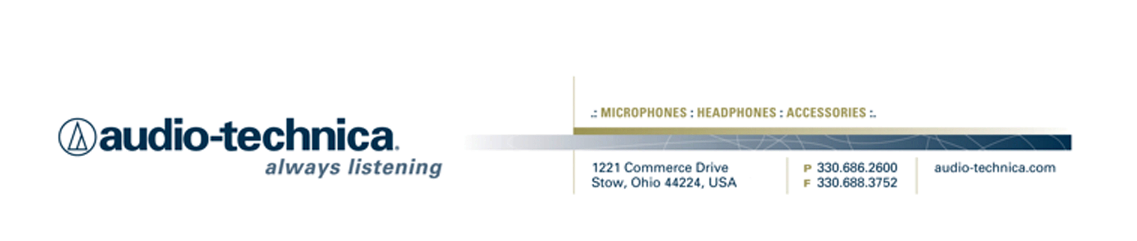
NEWS RELEASE
Contact: Clyne Media, Inc.
Tel: (615) 662-1616
Fax: (615) 662-1636

FOR IMMEDIATE RELEASE

Audio-Technica ES935SC6 Cardioid Condenser Gooseneck Microphones Help North Dakota Legislators Be Easily Seen and Clearly Heard

STOW, OH, June 8, 2015 — When Tricorne Audio, an AV systems integration company with offices in Fargo and Bismarck, North Dakota, was hired to completely renovate the audio systems in the state’s legislative chambers last year, the existing sound system was 17 years old and the microphones in it dated back to the upgrade before that. In other words, an upgrade was long overdue. As part of the system re-design, Tricorne needed to choose a new microphone that would be easy for legislators to use, with a user-accessible mute switch; have excellent sound and a high degree of speech intelligibility; and have a very minimal profile that would let lawmakers’ faces be visible during the live webcasts the legislature streams from its sessions. One microphone came through on all of those counts and more: the ES935SC6 cardioid condenser gooseneck microphone from Audio-Technica, a leading innovator in transducer technology for over 50 years. The ES935SC6 is part of A-T’s award-winning, contractor-exclusive Engineered Sound® line. Tricorne installed a total of 162 ES935SC6 microphones — 108 in the State House of Representatives and 54 in the State Senate — and they’ve been performing flawlessly ever since.

“The microphones that we found in use there when we came in were really more like CB mics, with push-to-talk buttons, like old cop-car radio mics from the 1960s,” said Dallas Anderson, Systems Designer working out of Tricorne’s Bismarck office. “It wasn’t going to be hard to improve on the audio quality of those, but we also had to make sure they were simple to use and extremely reliable, and have the kind of low profile that would work on a live-streamed broadcast.” As they put together the rest of the new audio system, which includes two Renkus-Heinz Iconyx® loudspeakers on each side of the rostrum and a Biamp Tesira® DSP processor for automated mixing and I/O management, they also tested several microphones to see how well each of these criteria were met. “The A-T microphone sounded the best — the audio was extremely clear — and it was the only short gooseneck available, which offered a really slim, low profile [7.77" long], perfect for on-camera use,” says Anderson. “Once they listened and looked, it was a done deal.”

The ES935SC6 is a miniature condenser microphone with a cardioid polar pattern and an integral mute switch/LED. It is designed for quality sound reinforcement, professional recording, television and other demanding sound pickup applications. The small-diameter gooseneck design permits highly flexible positioning while maintaining a smooth, well-contoured appearance. The A-T ES935SC6 is equipped with UniGuard® RFI-shielding technology, which offers outstanding rejection of radio frequency interference. That last point was particularly important, Anderson discovered, after noticing how many smartphones and tablets were regularly resting on legislators’ desks in close proximity to the microphones. “Having the shielding is very important in government installations these days, as you never want to hear that smartphone RFI buzz or crackle coming through the audio.” he says.

This was the first time that Tricorne Audio had ever used the A-T ES935SC6 but it was certainly not the last — Anderson says he’s used them since then in a number of house-of-worship installations, and they perform just as well there as they do in the North Dakota legislative chambers. “The sound is excellent,” he says. “It has a very flat frequency response and a very natural sound. And it has excellent gain-before-feedback characteristics. It’s just a great microphone for these kinds of applications.” But those old CB-type microphones weren’t just tossed out. Anderson says several veteran legislators asked to keep one, as mementos of an earlier era. “They were a piece of history,” says Anderson, “but now they have a better microphone to make new history with.”

For more information, please visit www.audio-technica.com.

…ends 619 words

Photo File 1: ND_HouseChamber.JPG
Photo Caption 1: The House Chamber at the North Dakota State Capitol, featuring ES935SC6 cardioid condenser gooseneck microphones from Audio-Technica. Photo courtesy of Tricorne Audio. © 2015. (This photo is the property of Tricorne Audio and may be used by the press only for the purpose of one-time reproduction. Unauthorized use, alteration or reproduction of these photographs is strictly prohibited.)

Photo File 2: ND_SenateChamber.JPG
Photo Caption 2: The Senate Chamber at the North Dakota State Capitol, featuring ES935SC6 cardioid condenser gooseneck microphones from Audio-Technica. Photo courtesy of Tricorne Audio. © 2015. (This photo is the property of Tricorne Audio and may be used by the press only for the purpose of one-time reproduction. Unauthorized use, alteration or reproduction of these photographs is strictly prohibited.)

Photo File 3: ND_SenateChamber_Closeup.JPG
Photo Caption 3: A closeup of a ES935SC6 cardioid condenser gooseneck microphone from Audio-Technica, installed at the Senate Chamber at the North Dakota State Capitol. Photo courtesy of Tricorne Audio. © 2015. (This photo is the property of Tricorne Audio and may be used by the press only for the purpose of one-time reproduction. Unauthorized use, alteration or reproduction of these photographs is strictly prohibited.)

Click here for ES935SC6 product profiles with downloadable high-res photos.

See more here:
- Audio-Technica Promotional Video: “Always Listening to the Music That Moves Us”
- Recording Basics Videos
- Drum Miking Videos
- Additional News Releases



Celebrating over 50 years of audio excellence worldwide, Audio-Technica is a leading innovator in transducer technology, renowned for the design and manufacture of microphones, wireless microphones, headphones, mixers, and electronics for the audio industry.

—For more information on the complete range of Audio-Technica products, contact
Karen Emerson, Audio-Technica U.S., Inc., 1221 Commerce Drive, Stow, OH 44224.
Tel: (330) 686-2600; Fax: (330) 688-3752; Web: www.audio-technica.com

— For further information regarding product availability and pricing in the United Kingdom, please contact Tom Harrold (tharrold@audio-technica.co.uk) or visit our media centre at www.eu.audio-technica.com/en/news/; in Germany, please contact Alexandra Bischof (abischof@audio-technica.de); in the rest of Europe, please contact Evangéline Pirot (epirot@audio-technica-europe.com).

