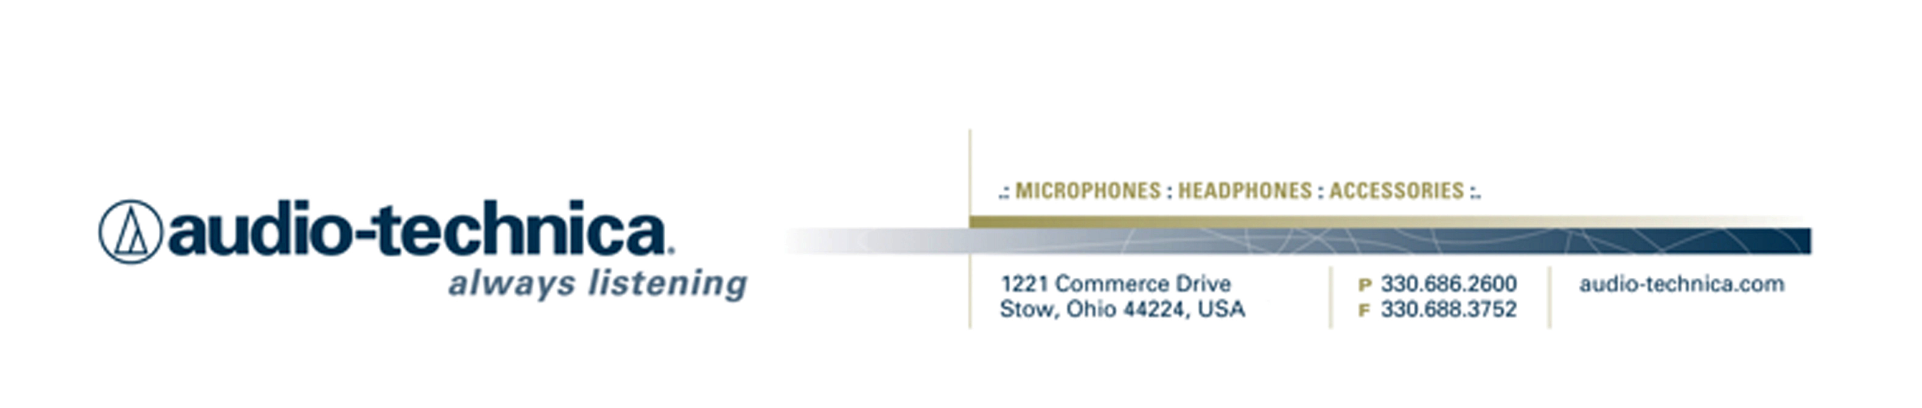
NEWS RELEASE
Contact: Clyne Media, Inc.
Tel: (615) 662-1616
Fax: (615) 662-1636

FOR IMMEDIATE RELEASE

The Audio-Technica BP40 Large-Diaphragm Dynamic Broadcast Microphone Chosen for Podcasts Including Matt Boudreau’s Working Class Audio and The Vocal Booth from the Pensado’s Place Team

— The BP40 lets “Working Class Audio” podcaster Matt Boudreau tell it straight from the heart while the celebrated hosts of Pensado’s Place hail it as a dynamic microphone that offers broadcast-caliber condenser-microphone sound —

NAB SHOW, LAS VEGAS, NV, April 18, 2016 — Podcasts often originate in garages, but the best ones these days are definitely not satisfied with low-rent sound anymore. That’s why the Audio-Technica (booth C7916) BP40 Large-Diaphragm Dynamic Broadcast Microphone has become the choice for leading podcasters who want their programs to go out on the Internet with broadcast-quality audio. These include the GRAMMY®-winner Dave Pensado, who along with manager/executive producer and co-host Herb Trawick, produces the highly popular Pensado’s Place YouTube series and the new The Vocal Booth internet radio show/podcast, and Matt Boudreau, who celebrates both the well-known and the lesser-known who toil in pro audio’s trenches with his weekly Working Class Audio podcast. Both shows have turned to the A-T BP40 as the microphone that offers them and their listeners broadcast-caliber sound quality in an affordable dynamic-mic package.

Pensado’s Place, which has been called “the Charlie Rose of audio,” is viewed in nearly 150 countries, with more than 500,000 monthly views and 132,000 unique visitors, including 17,000 students. Most recently, Pensado and Trawick introduced The Vocal Booth podcast, which will aggregate other content and bring new voices to the Pensado repertoire. In a recently recorded segment (BP40 video review), Pensado responds to Trawick’s queries about the BP40 by explaining, "The coolest thing about the mic is it sounds a lot like a condenser, but it's a dynamic microphone which works well in broadcast applications,” and by complimenting its “warm, round, dulcet, mellifluous tones.”

Matt Boudreau, on the Working Class Audio podcast (BP40 video review), gets up close and personal with a wide spectrum of audio engineers and record producers, delving deep into what it really takes to make a lifetime career out of making records, including topics like personal and professional finance and the work-life balance. He’s equally effusive about the A-T BP40, saying, “The first time I spoke into the BP40, I knew instantly I would be switching from my old standard to a new standard. I've heard my voice through all of the usual mics in this category and found the BP40 to be in a category all its own.” Working Class Audio, which has surpassed 15,000 downloads per month in the year and a half since Boudreau launched it, is characterized by his rich, ready-for-radio voice, something the BP40 seemed made for. He says, “I selected the BP40 for a number of reasons. It accentuates the low-mid characteristics of my voice, where the mic I was using before made them sound ‘woofy.’ Also, the BP40’s pickup pattern is hypercardioid, which removes the room from around my voice and keeps the focus on what I’m saying.” In doing so, Boudreau explains, the BP40 gives users a heightened level of confidence, which comes across as a more relaxed performance. “It inspires confidence in you,” says Boudreau, who puts the BP40 through an Apollo Audio mic pre with a touch of compression from a Universal Audio LA-2A compressor. “When I hear myself on headphones, that confidence lets me get out of my own way and lets what I’m saying come from the heart. I don't even have to think about it. In that way, the BP40 is more than a microphone — it’s a way to open up the door to the listener.”

The BP40 is included with the AT8483 mounting clamp and is available at a U.S. street price of $349.00. The AT8484 optional shock mount is available at a U.S. street price of $99.00.

For more information, please visit www.audio-technica.com.
…ends 574 words

Photo File 1: AT_Pensado.JPG
Photo Caption 1: Shown left to right: Herb Trawick and Dave Pensado, hosts of Pensado’s Place The Vocal Booth internet radio show/podcast, using Audio-Technica’s BP40 large-diaphragm dynamic microphone and ATH-M50x professional monitor headphones.

Photo File 2: AT_WKA.JPG
Photo Caption 2: Matt Boudreau of Working Class Audio podcast, using Audio-Technica’s BP40 large diaphragm microphone and ATH-M40x professional monitor headphones.

See more here:
- Audio-Technica BP40 Product Overview Video
- Recording Basics Videos
- Drum Miking Videos
- Additional News Releases



Celebrating over 50 years of audio excellence worldwide, Audio-Technica is a leading innovator in transducer technology, renowned for the design and manufacture of microphones, wireless microphones, headphones, mixers, and electronics for the audio industry.

—For more information on the complete range of Audio-Technica products, contact
Karen Emerson, Audio-Technica U.S., Inc., 1221 Commerce Drive, Stow, OH 44224.
Tel: (330) 686-2600; Fax: (330) 688-3752; Web: www.audio-technica.com

Audio-Technica is exhibiting at Booth C7916 at the 2016 NAB Show in Las Vegas, NV.

