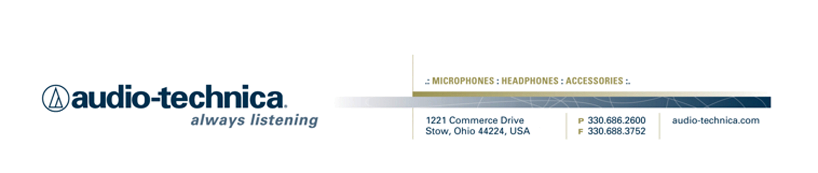
NEWS RELEASE
Contact: Clyne Media, Inc.
Tel: (615) 662-1616
Fax: (615) 662-1636

FOR IMMEDIATE RELEASE

Mike Johnston Chooses Audio-Technica Microphones for His Popular Mikeslessons.com Drumming Sessions

STOW, OH, December 10, 2015 — Products from Audio-Technica, a leading innovator in transducer technology for over 50 years, have been chosen by drummer Mike Johnston for use in his popular drum lesson videos on www.mikeslessons.com.

Johnston states, “Audio-Technica microphones were always the products I was seeing in studios when I was growing up, all the way to the current day. A-T is a name I associate with quality. One of the main reasons why I chose Audio-Technica over all of the other brands was their commitment to ‘honest’ sounds. I wanted a set of mics that made my students and fans feel like they were in the room with me, even if they were 3000 miles away watching me on YouTube. The set that I am using now is buttery smooth, and extremely honest without sounding harsh. When I hit my floor tom, it doesn’t sound sampled or processed. You really hear the timbre of the drum, and that to me is priceless.”

Among the Audio-Technica microphones Johnston is using are the ATM250 Hypercardioid Dynamic Instrument Microphone on bass drum, ATM650 Hypercardioid Dynamic Instrument Microphone on snare drum, ATM350 Cardioid Condenser Clip-On Microphone on toms, AT4047MP Multi-Pattern Condenser Microphone for overheads, and ATH-M50x Professional Monitor Headphones for electric drums – as a recommendation for his students’ practice sessions.

Looking forward, Johnston states, “Mikeslessons.com 3.0, which will come out in January, is a complete redesign of the way online drum lessons have been delivered in the past. I can’t say too much, but I can say that the focus in designing the new site has been motivation, accountability and inspiration. If I can create a website that will do those three things for my students, then I truly believe we will have finally leveraged technology to create better drummers.”

See Johnston’s Audio-Technica profile here: https://www.youtube.com/watch?v=fXCAlm6fmt4.

For more information, please visit www.audio-technica.com.
…ends 303 words

Photo File: MikeJohnston.JPG
Photo Caption: Mike Johnston

See more here:
- Audio-Technica Promotional Video: “Always Listening to the Music That Moves Us”
- Recording Basics Videos
- Drum Miking Videos
- Additional News Releases



Celebrating over 50 years of audio excellence worldwide, Audio-Technica is a leading innovator in transducer technology, renowned for the design and manufacture of microphones, wireless microphones, headphones, mixers, and electronics for the audio industry.

—For more information on the complete range of Audio-Technica products, contact
Karen Emerson, Audio-Technica U.S., Inc., 1221 Commerce Drive, Stow, OH 44224.
Tel: (330) 686-2600; Fax: (330) 688-3752; Web: www.audio-technica.com

