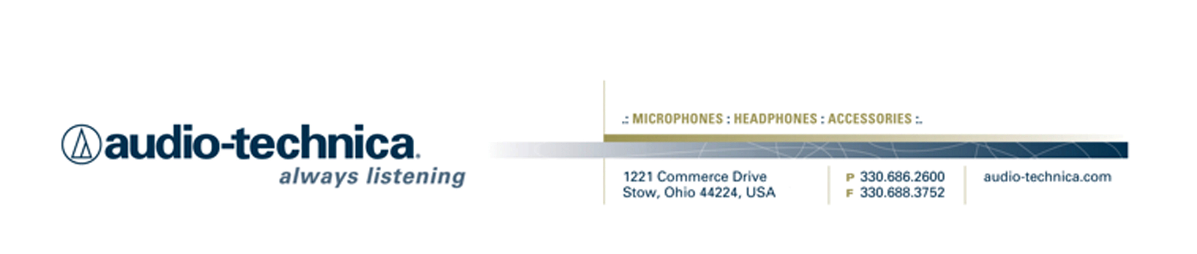
NEWS RELEASE
Contact: Clyne Media, Inc.
Tel: (615) 662-1616
Fax: (615) 662-1636

FOR IMMEDIATE RELEASE

Audio-Technica Introduces ATUC-50 Digital Wired Discussion System

— Offering intuitive operation and plug-and-play functionality, the ATUC-50 is ideal for corporate applications (including boardrooms and meeting rooms), government facilities, multilingual conference needs, hospitality (hotels, conventions, etc.), courts and judicial facilities, education, rental and more —

INFOCOMM, LAS VEGAS, NV, June 8, 2016 — Audio-Technica (booth C9520), a leading innovator in transducer technology for over 50 years, introduces the ATUC-50 Digital Wired Discussion System. Components include the ATUC-50CU Control Unit, ATUC-50DU Discussion Units, and the ATUC-M43H and ATUC-M58H Gooseneck Microphones.

The ATUC-50 system is designed for intuitive operation and plug-and-play functionality. The system provides 24-bit/48 kHz uncompressed digital audio for clear and intelligible communication that significantly increases meeting efficiency and effectiveness. While available at a cost-effective price point, the system offers superb power and flexibility, including multi-mode operation, 12-band feedback suppressor, ability to record a meeting directly to a mass storage device on the front of the control unit and interpretation channels. A choice of two gooseneck lengths is available: the ATUC-M43H 17" (430 mm) and ATUC-M58H 23" (580 mm) microphones, allowing for added flexibility in terms of positioning.

Employing standard Cat5 (and above) cables, a complete system can support up to 3 ATUC-50CU control units and 150 ATUC-50DU discussion units can be connected in either daisy chain or ring topology (for added redundancy) and controlled from any web browser with no need for additional software installation. Configuration via Web Remote Control is simple and quick, with settings able to be stored as presets for easy recall.

The user-friendly design of the ATUC-50 and its extensive feature set make it ideal for applications throughout the corporate sector (including boardrooms and meeting rooms), government facilities, multilingual conference needs, hospitality (hotels, conventions, etc.), courts and judicial facilities, education, rental and more.

The Audio-Technica ATUC-50 Wired Digital Discussion System is currently available. For more information, please visit www.audio-technica.com.

…ends 263 words

Photo File 1: ATUC-50DU_ATUC-M43H.JPG
Photo Caption 1: Audio-Technica's ATUC-50 Digital Wired Discussion System. Shown is the ATUC-50DU discussion unit with ATUC-M43H 17" gooseneck microphone.

Photo File 2: ATUC-50DU_ATUC-M43H_boardroom_in_background.JPG
Photo Caption 2: Audio-Technica's ATUC-50 Digital Wired Discussion System. Shown is the ATUC-50DU discussion unit with ATUC-M43H 17" gooseneck microphone.

Photo File 3: ATUC-50DU_ATUC-M43H_boardroom_close-up.JPG
Photo Caption 3: Audio-Technica's ATUC-50 Digital Wired Discussion System. Shown is the ATUC-50DU discussion unit with ATUC-M43H 17" gooseneck microphones.

Photo File 4: ATUC-50DU_ATUC-M43H_full_boardroom.JPG
Photo Caption 4: Audio-Technica's ATUC-50 Digital Wired Discussion System. Shown is the ATUC-50DU discussion unit with ATUC-M43H 17" gooseneck microphones.

Click here for ATUC-50 product profile with downloadable high-res photos.

See more here:
- Audio-Technica Promotional Video: “Always Listening to the Music That Moves Us”
- Additional News Releases



Celebrating over 50 years of audio excellence worldwide, Audio-Technica is a leading innovator in transducer technology, renowned for the design and manufacture of microphones, wireless microphones, headphones, mixers, and electronics for the audio industry.

—For more information on the complete range of Audio-Technica products, contact
Karen Emerson, Audio-Technica U.S., Inc., 1221 Commerce Drive, Stow, OH 44224.
Tel: (330) 686-2600; Fax: (330) 688-3752; Web: www.audio-technica.com

— For further information regarding product availability and pricing in Europe (excluding France and Germany), contact Tom Harrold (tharrold@audio-technica-europe.com). In Germany, contact Sandi Bischof (abischof@audio-technica.de); in France, contact Cynthia El Hakim (celhakim@audio-technica-europe.com).

Audio-Technica is exhibiting at Booth C9520 at the 2016 InfoComm Show in Las Vegas, NV.

