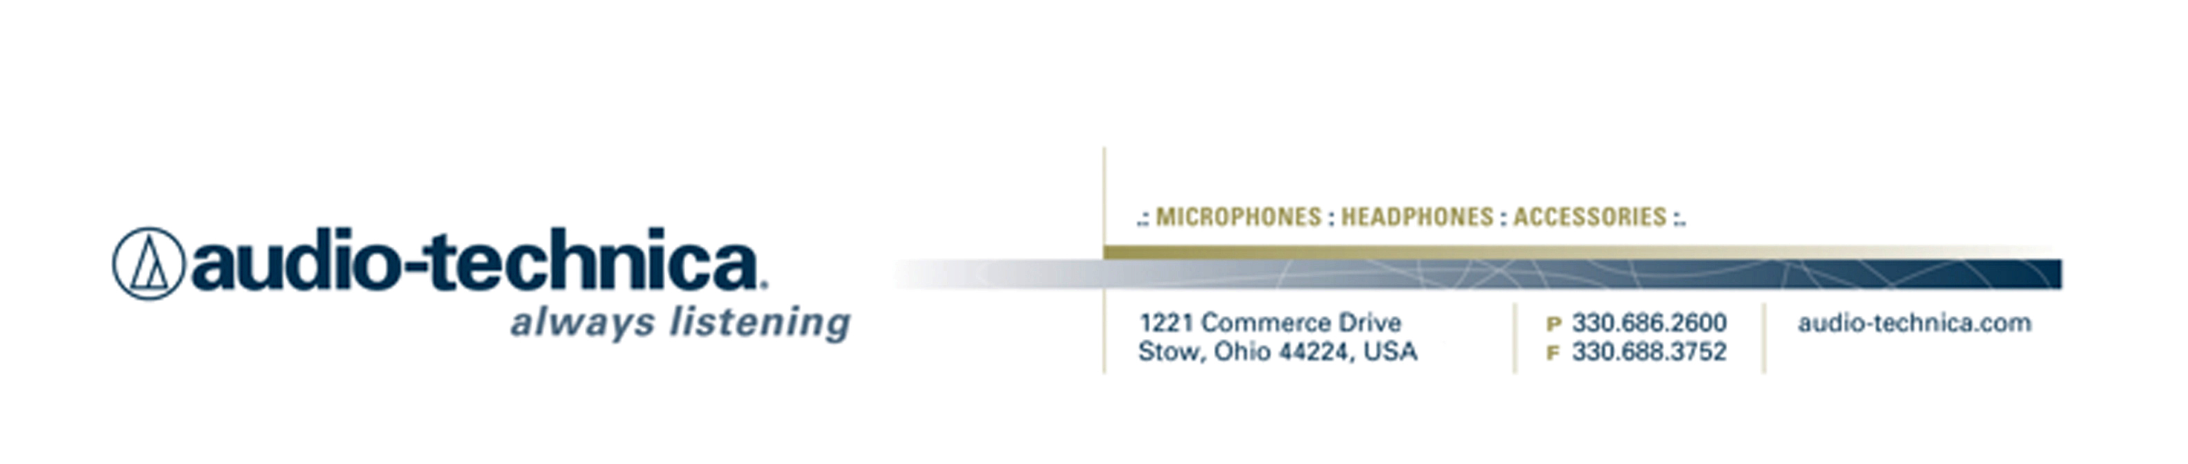
NEWS RELEASE
Contact: Clyne Media, Inc.
Tel: (615) 662-1616
Fax: (615) 662-1636

FOR IMMEDIATE RELEASE

Audio-Technica Offers AT2020USBi Cardioid Condenser USB Microphone

— Newest iteration of A-T’s acclaimed AT2020USB features 24-bit/96 kHz recording, and compatibility with iOS, Windows and Mac OS X —

INFOCOMM, ORLANDO, FL, June 17, 2015 — Audio-Technica (booth 917), a leading innovator in transducer technology for over 50 years, offers its AT2020USBi Cardioid Condenser USB Microphone featuring iOS compatibility. Combining high-resolution audio with increased connectivity options, the AT2020USBi cardioid condenser microphone adds a new level of sound-quality and convenience to Audio-Technica’s USB microphone line. Modeled after the critically acclaimed AT2020, this digital output mic features an A/D converter with a 24-bit/96 kHz sampling rate to deliver high-resolution articulation and intelligibility that’s perfect for home studio recording, field recording, podcasting and voiceover use.

The AT2020USBi brings high-resolution audio (24-bit/96 kHz) to A-T’s line of USB mics. The AT2020USBi works with both USB and Lightning cables (included), so users can employ it straight from the box to digitally capture audio on the device of their choice: PC, Mac or iOS. The integrated gain control adds to the convenience, allowing users to adjust the input level directly on the microphone.

AT2020USBi Features:

- Condenser microphone with digital output for convenient, high-resolution recording
- High-quality A/D converter with 24-bit/96 kHz sampling rate for superb, high-resolution audio
- Mic gain control allows you to adjust input level on the mic itself
- Smooth, extended frequency response ideally suited for podcasting, home studio recording, field recording and voiceover use
- Compatible with Windows 8, Windows 7, Vista, XP, 2000, Mac OS X and iOS
- Tripod desk stand with folding legs for secure and easily portable tabletop use
- Included USB and Lightning cables provide ready connectivity to computers and iOS devices

AT2020USBi Specifications:
- Element: Fixed-charge back plate, permanently polarized condenser
- Polar Pattern: Cardioid
- Frequency Response: 20 – 20,000 Hz
- Power Requirements: USB (5V DC); Lightning (3.3V DC)
- Bit Depth: 24 bit
- Sample Rate: Up to 96 kHz
- Controls: Mic gain control
- Weight: 13.2 oz (374 g)
- Dimensions: 6.38" (162.0 mm) long, 2.05" (52.0 mm) maximum body diameter
- Output Connector: Micro-HDMI
- Accessories Included: Pivoting stand mount for 5/8"-27 threaded stands; 5/8"-27 to 3/8"-16 threaded adapter; soft protective pouch; tripod desk stand; 10' (3.1 m) USB cable; 10' (3.1 m) Lightning cable

The AT2020USBi will be available summer 2015 with a U.S. estimated street price of $199.00. For more information, please visit www.audio-technica.com.

…ends 346 words

Photo Files: AT2020USBi_Photo1.JPG, AT2020USBi_Photo2.JPG, AT2020USBi_Photo3.JPG, AT2020USBi_Photo4.JPG

Click here for AT2020USBi product profile with downloadable high-res photos.

See more here:
- Audio-Technica Promotional Video: “Always Listening to the Music That Moves Us”
- Recording Basics Videos
- Drum Miking Videos
- Additional News Releases



Celebrating over 50 years of audio excellence worldwide, Audio-Technica is a leading innovator in transducer technology, renowned for the design and manufacture of microphones, wireless microphones, headphones, mixers, and electronics for the audio industry.

—For more information on the complete range of Audio-Technica products, contact
Karen Emerson, Audio-Technica U.S., Inc., 1221 Commerce Drive, Stow, OH 44224.
Tel: (330) 686-2600; Fax: (330) 688-3752; Web: www.audio-technica.com

— For further information regarding product availability and pricing in the United Kingdom, please contact Tom Harrold (tharrold@audio-technica.co.uk) or visit our media centre at www.eu.audio-technica.com/en/news/; in Germany, please contact Alexandra Bischof (abischof@audio-technica.de); in the rest of Europe, please contact Evangéline Pirot (epirot@audio-technica-europe.com).

Audio-Technica is exhibiting at booth 917 at the 2015 InfoComm Convention in Orlando, FL.

