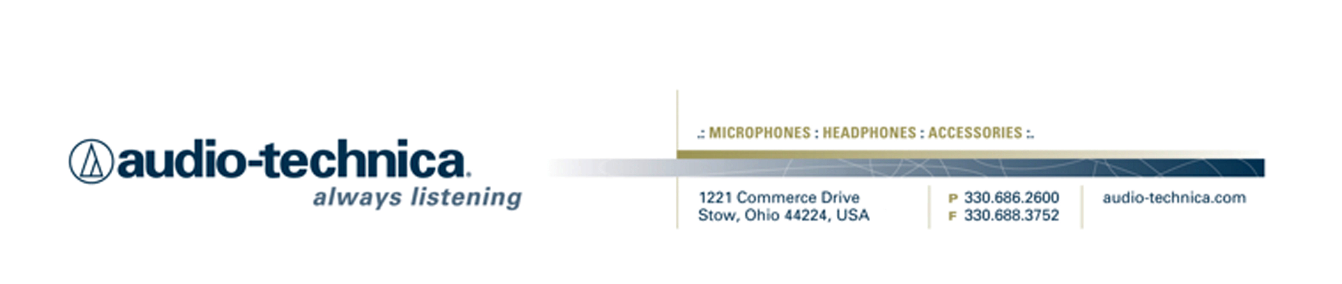
NEWS RELEASE
Contact: Clyne Media, Inc.
Tel: (615) 662-1616
Fax: (615) 662-1636

FOR IMMEDIATE RELEASE

Audio-Technica Offers Limited Edition Products
Celebrating Its 50th Anniversary

— Landmark occasion commemorated with special limited-edition anniversary products that pay tribute to “50 Years of Passionate Listening” —

INFOCOMM, LAS VEGAS, NV, June 13, 2012 — Audio-Technica (booth C10036), a leading innovator in transducer technology currently celebrating “50 Years of Passionate Listening,” is offering a number of limited edition products, all featuring a distinct Audio-Technica 50th Anniversary design and color scheme. The products include ATH-M50s/LE Professional Studio Monitor Headphones, ATM25/LE Hypercardioid Dynamic Instrument Microphone, AE4100/LE Cardioid Dynamic Handheld Microphone, AE5400/LE Cardioid Condenser Handheld Microphone, AE6100/LE Hypercardioid Dynamic Handheld Microphone, AT4050/LE Multi-pattern Condenser Microphone and AT4050URUSHI Multi-pattern Condenser Microphone. Representing just some of Audio-Technica’s offerings in their product line, these products are limited-edition versions of A-T’s ATH-M50s, AE4100, AE5400, AE6100, AT4050 and the legacy product ATM25.

The LE/Anniversary limited editions, feature A-T’s classic silver-colored metallic finish with blue accents, and the AT4050URUSHI sports a stunning traditional urushi lacquer finish with hand-painted Japanese maple leaves. The AE4100/LE, AE5400/LE, AE6100/LE, AT4050/LE, AT4050URUSHI and ATM25/LE all feature a unique anniversary serial number etched on the surface of each model. The AE5400/LE, AT4050/LE and AT4050URUSHI come with a specially designed, beautifully hand-crafted wooden carrying case.

Of special note is the ATM25/LE, a re-emergence of the classic ATM25 Hypercardioid Dynamic Instrument Microphone. Based on direct input from end-users and dealers, Audio-Technica chose its 50th anniversary to bring back a special edition of the classic ATM25. The new ATM25/LE is ideal for kick drum, toms and other highly dynamic instruments; handles very high SPL at close range; provides big, warm low-frequency response with excellent presence; offers very full sound on close-up vocals and dialogue; and features a multi-level grille and rugged construction.

The Audio-Technica Anniversary Models are currently available with U.S. MRSP’s as follows:

ATH-M50s/LE $209.00
AE4100/LE $329.00
AE5400/LE $629.00
AE6100/LE $329.00
AT4050/LE $995.00
AT4050URUSHI $2,495.00
ATM25/LE $489.00

For more information, please visit www.audio-technica.com.

…ends 283 words
Photo File: Anniversary_Products.JPG

Click here for ATH-M50s/LE, ATM25/LE, AE4100/LE, AE5400/LE, AE6100/LE, AT4050/LE and AT4050URUSHI product profiles and downloadable high-res photos.

Also see more here:
- 50th Anniversary Information and Video
- Lighthearted Company Tour of Audio-Technica USA Video
- Additional News Releases

Celebrating 50 years of audio excellence worldwide, Audio-Technica is a leading innovator in transducer technology, renowned for the design and manufacture of microphones, wireless microphones, headphones, mixers, and electronics for the audio industry.

—For more information on the complete range of Audio-Technica products, contact
Karen Emerson, Audio-Technica U.S., Inc., 1221 Commerce Drive, Stow, OH 44224.
Tel: (330) 686-2600; Fax: (330) 688-3752; Web: www.audio-technica.com

—For further information regarding product availability and pricing in the United Kingdom, please contact Harvey Roberts (hroberts@audio-technica.co.uk); in Germany, please contact Anja Groth (a.groth@audio-technica.de);
in the rest of Europe, please contact Evangéline Pirot (epirot@audio-technica-europe.com).

Audio-Technica is exhibiting at Booth C10036 during the 2012 InfoComm Show in Las Vegas, Nevada.

