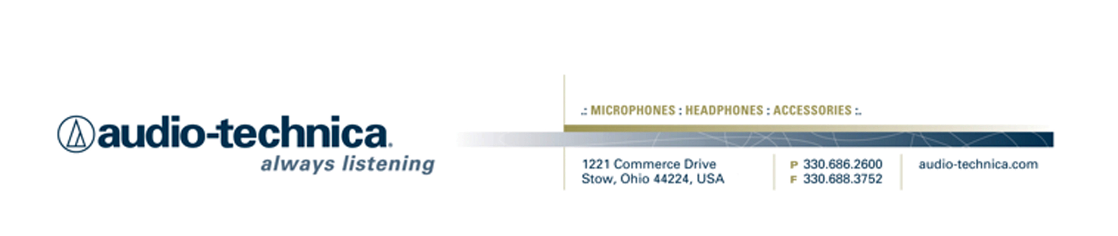
NEWS RELEASE
Contact: Clyne Media, Inc.
Tel: (615) 662-1616
Fax: (615) 662-1636

FOR IMMEDIATE RELEASE

Audio-Technica Offers System 10 Rebates

— Operating in the 2.4 GHz range, System 10 avoids TV and DTV interference, offering a cost-effective, high-fidelity wireless solution for houses of worship, musicians/hobbyists, karaoke, corporate applications and more —

GOVCOMM 13, WASHINGTON, D.C., December 4, 2013 — Audio-Technica (booth 222), a leading innovator in transducer technology for over 50 years, is offering rebates of up to $50.00 on its System 10 Digital Wireless systems. Systems purchased from an authorized U.S. Audio-Technica dealer between October 1, 2013, and December 31, 2013, will be eligible. Claims must be submitted by January 31, 2014.

End-users will receive rebates on qualifying System 10 purchases as follows:

Any 1 System - $10 Rebate
Any 2 Systems - $25 Rebate
Any 3 Systems - $50 Rebate

Users can register online at register at http://audio-technicaus.4myrebate.com with offer code AUD-10013. Alternatively, buyers may manually complete and mail in this System 10 Wireless Rebate 2013 Form with the required documents indicated.

For complete terms and conditions, please visit System 10 rebates here.

About System 10 Digital Wireless
System 10 offers high-fidelity digital wireless for performing musicians and presenters. Operating in the 2.4 GHz range, far from TV and DTV interference, System 10 offers advanced 24-bit operation and amazingly clear sound. System 10 wireless ensures clear communications by providing three levels of diversity assurance: frequency, time, and space. Frequency Diversity sends the signal on two dynamically allocated frequencies for interference-free communication. Time Diversity sends the signal in multiple time slots to maximize immunity to multipath interference. Finally, Space Diversity uses two antennas on each transmitter and receiver to maximize signal integrity.

Multiple system configurations are available, with handheld vocal microphone/transmitters and UniPak® body-pack transmitters designed for use with lavalier, headworn and instrument microphones as well as electric guitars.
System 10 Products and U.S. MSRP:
ATW-1101 UniPak® Transmitter System $489.95
ATW-1101/G Guitar System $524.95
ATW-1101/H Headworn Microphone System $614.95
ATW-1101/H92 Miniature Headworn Microphone System $664.95
ATW-1101/H92TH Miniature (beige) Headworn Microphone System $664.95
ATW-1101/L Lavalier Microphone System $614.95
ATW-1102 Handheld Microphone System $524.95
…ends 294 words

Photo File: System10.JPG

Click here for System 10 product profile and downloadable high-res photos.

See more here:
- Lighthearted Company Tour of Audio-Technica USA Video
- Additional News Releases

Celebrating over 50 years of audio excellence worldwide, Audio-Technica is a leading innovator in transducer technology, renowned for the design and manufacture of microphones, wireless microphones, headphones, mixers, and electronics for the audio industry.

—For more information on the complete range of Audio-Technica products, contact
Karen Emerson, Audio-Technica U.S., Inc., 1221 Commerce Drive, Stow, OH 44224.
Tel: (330) 686-2600; Fax: (330) 688-3752; Web: www.audio-technica.com

Audio-Technica is exhibiting at booth 222 at GovComm 13 in Washington, D.C.

