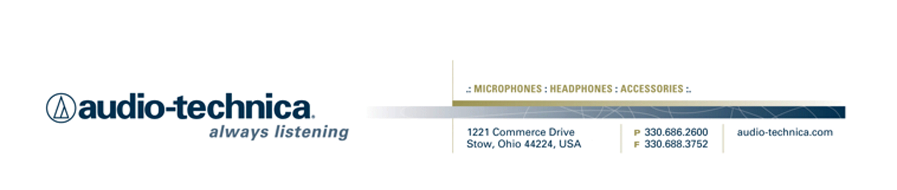
NEWS RELEASE
Contact: Clyne Media, Inc.
Tel: (615) 662-1616
Fax: (615) 662-1636

FOR IMMEDIATE RELEASE

Audio-Technica Holds Presentations by Industry Veterans at NAB

— Broadcast audio veteran Dr. Fred Ginsburg, TV audio engineer Robert Bigelow and Audio-Technica’s Steve Savanyu will impart practical information on broadcast recording and microphone techniques —

STOW, OH, March 26, 2012 — This year at NAB, on Monday, Tuesday and Wednesday (April 16-18, 2012), A-T’s booth C3010 will host five 30-minute audio instructional sessions throughout the day.

Dr. Fred Ginsburg, renowned industry veteran and specialist in production sound recording for motion pictures and video, will conduct two sessions each day. The first session will focus on microphone techniques and applications used for episodic television with a focus on multi-track recording, and the second session will be about techniques for rigging and attaching lavalier microphones to actors for film and video production.

Robert Bigelow, audio engineer for HBO’s Tremé will also present two sessions. First he will share his experiences of recording live music for broadcast on Tremé, and later provide a better understanding of Mid-Side stereo recording.

Steve Savanyu, Audio-Technica Director of Educational Services, will offer instructions on selecting and using microphones with DSLR cameras, including single- vs. dual-system recording.

These Audio-Technica instructional sessions will be held in NAB booth C3010 all three days (April 16-18, 2012) as follows:

10:00am—10:30am
Microphone Techniques for Episodic Television and Features, by Dr. Fred Ginsburg
Microphone techniques and applications used for television with a focus on multitrack recording.

11:00am—11:30am
Microphone Techniques for Digital SLR (single lens reflex) Cameras, by Steve Savanyu
Selecting and using microphones with DSLR cameras, including single vs. dual system recording.

1:30pm—2:00pm
Rigging Lavaliers and Wireless Microphones for Film and Video Production, by Dr. Fred Ginsburg
Techniques for rigging and attaching lavalier microphones to actors.

2:30pm—3:00pm
Recording Live Music for Broadcast, by Robert Bigelow
Robert Bigelow, audio engineer for HBO’s Tremé, shares his experience.

3:30pm—4:00pm
Mid-Side/Stereo Miking Demystified, by Robert Bigelow
Get a better understanding of Mid-Side stereo recording.

For more information, please visit www.audio-technica.com.
…ends 284 words

See more here:
- 50th Anniversary Information and Video
- Lighthearted Company Tour of Audio-Technica USA Video
- Additional News Releases



Celebrating 50 years of audio excellence worldwide, Audio-Technica is a leading innovator in transducer technology, renowned for the design and manufacture of microphones, wireless microphones, headphones, mixers, and electronics for the audio industry.

—For more information on the complete range of Audio-Technica products, contact
Karen Emerson, Audio-Technica U.S., Inc., 1221 Commerce Drive, Stow, OH 44224.
Tel: (330) 686-2600; Fax: (330) 688-3752; Web: www.audio-technica.com

—For further information regarding product availability and pricing in the United Kingdom, please contact Harvey Roberts (hroberts@audio-technica.co.uk); in Germany, please contact Anja Groth (a.groth@audio-technica.de);
in the rest of Europe, please contact Evangéline Pirot (epirot@audio-technica-europe.com).

