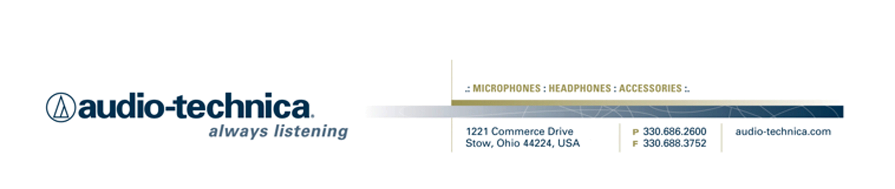
NEWS RELEASE
Contact: Clyne Media, Inc.
Tel: (615) 662-1616
Fax: (615) 662-1636

FOR IMMEDIATE RELEASE

Audio-Technica’s AT2020USBi Cardioid Condenser USB Microphone Is Ideal for Podcasting and Audio Capture On-the-Go

— Most recent iteration of A-T’s acclaimed AT2020USB features 24-bit/96 kHz recording, and compatibility with iOS, Windows and Mac OS X —

STOW, OH, August 1, 2016 — Audio-Technica, a leading innovator in transducer technology for over 50 years, now offers its AT2020USBi Cardioid Condenser USB Microphone, a product tailor-made for podcasters and others capturing audio directly on an iPad, tablet, smartphones PC, or other compatible device. “One of the mic’s main applications is podcasting,” notes Gary Boss, Audio-Technica Marketing Director. “You can set up a podcast station with your iPad or other device, and you’re good to go. Beyond podcasting, you can use the AT2020USBi to record studio-quality audio on-the-go on your phone, iPad or laptop, or for Skyping, voiceover and other day-to-day audio needs. It’s a cardioid directional microphone, so it’s going to be a huge upgrade over the on-board omnidirectional microphones generally found standard on these devices. For instance, if you’re doing an interview in a noisier environment, it’s a life-saver.”

Combining the ability to capture high-resolution audio with increased connectivity options, the AT2020USBi cardioid condenser microphone offers enhanced sound quality and convenience. Modeled after the critically acclaimed AT2020, this digital-output mic features an A/D converter with a 24-bit/96 kHz sampling rate to deliver high-resolution intelligibility and articulation. It also offers high-resolution audio (24-bit/96 kHz) capability and both a standard USB output and Lightning cable connection, making it a significant upgrade over comparable products. The integrated gain control adds to its convenience, allowing users to adjust the input level directly on the microphone. Gary Boss remarks, “The addition of truly high-res 24-bit audio and the Lightning connector put this mic in a league of its own. This is a tool that every podcaster or field recordist should have in his or her arsenal.”

AT2020USBi Features:
- Condenser microphone with digital output for convenient, high-resolution recording
- High-quality A/D converter with 24-bit/96 kHz sampling rate for superb, high-resolution audio
- Mic gain control allows users to adjust input level on the mic itself
- Smooth, extended frequency response ideally suited for podcasting, home studio recording, field recording and voiceover use
- Compatible with Windows 8, Windows 7, Vista, XP, 2000, Mac OS X and iOS
- Tripod desk stand with folding legs for secure and easily portable tabletop use
- Included USB and Lightning cables provide ready connectivity to computers and iOS devices

AT2020USBi Specifications:
- Element: Fixed-charge back plate, permanently polarized condenser
- Polar Pattern: Cardioid
- Frequency Response: 20 – 20,000 Hz
- Power Requirements: USB (5V DC); Lightning (3.3V DC)
- Bit Depth: 24-bit
- Sample Rate: Up to 96 kHz
- Controls: Mic gain control
- Weight: 12.3 oz (350 g)
- Dimensions: 6.38" (162.0 mm) long, 2.05" (52.0 mm) maximum body diameter
- Output Connector: Micro-HDMI
- Accessories Included: Pivoting stand mount for 5/8"-27 threaded stands; 5/8"-27 to 3/8"-16 threaded adapter; soft protective pouch; tripod desk stand; 14.9' (1.5 m) USB cable; Lightning cable

The AT2020USBi is now available with a U.S. street price of $199.00.

For more information, please visit www.audio-technica.com.

…ends 462 words

Photo file 1: AT2020USBi_Photo1.JPG
Photo caption 1: AT2020USBi Cardioid Condenser USB Mic Featuring iOS Compatibility

Photo file 2: AT2020USBi_Photo2.JPG
Photo caption 2: AT2020USBi Cardioid Condenser USB Mic Featuring iOS Compatibility

Photo file 3: AT2020USBi_Photo3.JPG
Photo caption 3: AT2020USBi Cardioid Condenser USB Mic Featuring iOS Compatibility

Photo file 4: AT2020USBi_Photo4.JPG
Photo caption 4: AT2020USBi Cardioid Condenser USB Mic Featuring iOS Compatibility

See more here:
- Audio-Technica Promotional Video: “Always Listening to the Music That Moves Us”
- Recording Basics Videos
- Drum Miking Videos
- Additional News Releases



Celebrating over 50 years of audio excellence worldwide, Audio-Technica is a leading innovator in transducer technology, renowned for the design and manufacture of microphones, wireless microphones, headphones, mixers, and electronics for the audio industry.

—For more information on the complete range of Audio-Technica products, contact
Karen Emerson, Audio-Technica U.S., Inc., 1221 Commerce Drive, Stow, OH 44224.
Tel: (330) 686-2600; Fax: (330) 688-3752; Web: www.audio-technica.com

