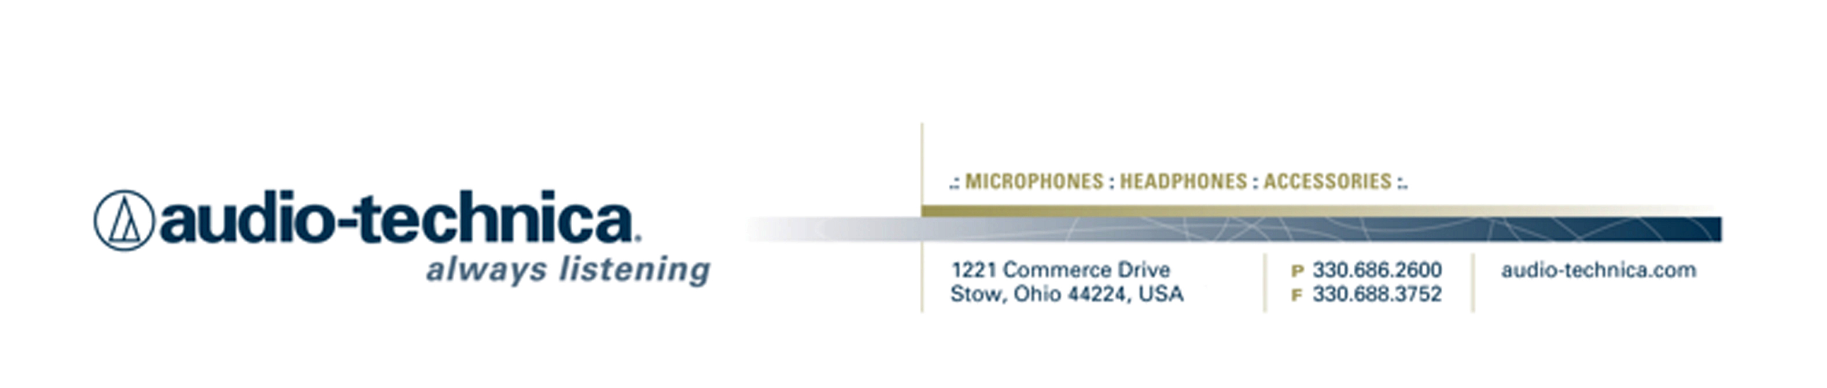
NEWS RELEASE
Contact: Clyne Media, Inc.
Tel: (615) 662-1616
Fax: (615) 662-1636

FOR IMMEDIATE RELEASE

Now Available for Streaming: Audio-Technica “Ask Me Anything” Sessions at 135th AES Convention

— Featuring industry insiders and friends of A-T, these AMA sessions proved to be informative and revelatory for an audience of in-person AES convention attendees as well as a worldwide online audience —

STOW, OH, December 4, 2013 — Audio-Technica, a leading innovator in transducer technology for over 50 years, has made available online the "Ask Me Anything" (AMA) sessions the company recently hosted at the 135th AES Convention in New York, NY. Sessions took place on Friday, October 18, and Saturday, October 19, at A-T’s exhibition booth on the convention floor.

The archived sessions, available on www.audio-technica.com/aes2013, include discussions with Joel Singer, GRAMMY® Award-winning engineer/mixer, co-founder and chief engineer of Music Mix Mobile; Jackie Green, VP R&D/Engineering at Audio-Technica; Frank Filipetti, GRAMMY® Award-winning music producer, engineer and mixer; Richie Castellano, musician and YouTube sensation; Richard Chycki, mixer, engineer and producer; Carl Tatz, TEC Award-nominated recording studio designer; Frank Wells, then-current President of AES; and Jimmy Douglass, GRAMMY® Award-winning recording engineer/record producer.

“Ask Me Anything” questions were submitted by individuals present at AES booth 2723, online at www.livestream.com, and by Twitter #ATliveAES – and then fed to the presenters through a moderator during the 30-minute Q&A sessions.

“We were extremely happy with the AMA sessions in the A-T booth at the AES show this year,” stated Gary Boss, Audio-Technica Marketing Director. “Not only was this a unique opportunity for both attendees at the show and those at home to ask insightful questions, but the content will be archived for a whole new audience to benefit from all of our presenters’ wisdom and insights. There were laughs, thought provoking answers and a few uncomfortable moments. Exactly the kind of scenario where we get to see the true genius behind our guests and understand why they are at the tops of their respective fields.”

Watch Audio-Technica “Ask Me Anything” sessions at www.audio-technica.com/aes2013.

…ends 318 words

Photo file: AMA_1_AES2013.JPG

Photo caption: Frank Filipetti, GRAMMY® Award-winning music producer, engineer and mixer, participates in Audio-Technica’s “Ask Me Anything” series at the 135th AES Convention. This session and others can be watched at www.audio-technica.com/aes2013.

Photo file: AMA_2_AES2013.JPG

Photo caption: Jackie Green, VP R&D/Engineering at Audio-Technica, participates in Audio-Technica’s “Ask Me Anything” series at the 135th AES Convention. This session and others can be watched at www.audio-technica.com/aes2013.

Photo file: AMA_3_AES2013.JPG

Photo caption: Jimmy Douglass, GRAMMY® Award-winning recording engineer and record producer, participates in Audio-Technica’s “Ask Me Anything” series at the 135th AES Convention. This session and others can be watched at www.audio-technica.com/aes2013.

See more here:
- Lighthearted Company Tour of Audio-Technica USA Video
- Additional News Releases

Celebrating over 50 years of audio excellence worldwide, Audio-Technica is a leading innovator in transducer technology, renowned for the design and manufacture of microphones, wireless microphones, headphones, mixers, and electronics for the audio industry.

—For more information on the complete range of Audio-Technica products, contact
Karen Emerson, Audio-Technica U.S., Inc., 1221 Commerce Drive, Stow, OH 44224.
Tel: (330) 686-2600; Fax: (330) 688-3752; Web: www.audio-technica.com

