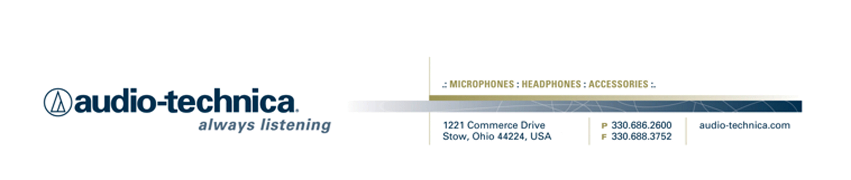
NEWS RELEASE
Contact: Clyne Media, Inc.
Tel: (615) 662-1616
Fax: (615) 662-1636

FOR IMMEDIATE RELEASE

Audio-Technica to Hold “Ask Me Anything” Sessions at 137th AES Convention

— Featuring industry insiders and friends of A-T, these AMA sessions are set to be informative and revelatory for an audience of in-person AES convention attendees as well as a worldwide online audience —

137th AES CONVENTION, LOS ANGELES, CA, October 10, 2014 — Audio-Technica, a leading innovator in transducer technology for over 50 years, announces that it will be hosting several "Ask Me Anything" (AMA) question-and-answer sessions at its exhibition booth (1301) at the 137th AES Convention in Los Angeles, CA. Sessions are scheduled for two days of the convention: Friday, October 10, and Saturday, October 11. Guests include Dave Pensado and Herb Trawick of Pensado’s Place, Joe Chiccarelli, Michael Beinhorn, Ryan Hewitt, Curt Bisquera, Joe Barresi, Matt McArthur and Frank Klepacki. Additional details are available at the Audio-Technica booth or www.audio-technica.com/AES2014.

Audio-Technica AMA participant schedule (Pacific time):

Friday, October 10:
- 1:00 Ryan Hewitt – GRAMMY® Award-Winning Engineer, Mixer, Producer (Red Hot Chili Peppers, Sheryl Crow, Avett Brothers)
- 2:00 Michael Beinhorn – Producer, Engineer (Hole, Soundgarden, Marilyn Manson)
- 3:00 Joe Barresi – Producer, Mixer, Engineer (Monster Magnet, Slipknot, Nine Inch Nails)
- 4:00 Matt McArthur – Executive Director of The Record Company

Saturday, October 11:
- 11:00 Joe Chiccarelli – GRAMMY Award-Winning Producer/Engineer (Elton John, U2, White Stripes)
- 1:00 Dave Pensado and Herb Trawick – Co-hosts of Pensado’s Place
- 3:00 Curt Bisquera – Drummer (Bonnie Raitt, Sarah McLachlan, soundtracks for Bourne Supremacy and Despicable Me)
- 4:00 Frank Klepacki – Audio Director, Engineer, Composer, Performer (film and TV work for Lucasarts, Hasbro, Top Gear, Pawn Stars, others)

“Ask Me Anything” questions are fed to the presenters through a moderator during a 30-minute Q&A session. Questions can be submitted by individuals present at AES booth 1301; online at www.livestream.com (free registration); and by Twitter #ATliveAES.

In addition, individuals may watch during and after the event at www.audio-technica.com/AES2014 (also accessible from A-T’s website or Facebook page).

“This is our second year featuring live-streaming ‘AMA’-style sessions at AES. Past sessions have proven to be both educational and wildly entertaining! With the ability to ‘virtually attend’ the event, people at home can get a true taste of the show and have the ability to ask some of the most famous and infamous professionals in our industry literally anything. Well you can asking anything, but they don’t officially have to answer everything,” joked Gary Boss, Audio-Technica Marketing director.

Full details are available at www.audio-technica.com/aes2014.
…ends 345 words

Photo file: AMA_AES2014.JPG

See more here:
- Audio-Technica Promotional Video: “Always Listening to the Music That Moves Us”
- Recording Basics Videos
- Drum Miking Videos
- Additional News Releases



Celebrating over 50 years of audio excellence worldwide, Audio-Technica is a leading innovator in transducer technology, renowned for the design and manufacture of microphones, wireless microphones, headphones, mixers, and electronics for the audio industry.

—For more information on the complete range of Audio-Technica products, contact
Karen Emerson, Audio-Technica U.S., Inc., 1221 Commerce Drive, Stow, OH 44224.
Tel: (330) 686-2600; Fax: (330) 688-3752; Web: www.audio-technica.com

Audio-Technica is exhibiting at booth 1301 at the 137th AES Convention in Los Angeles, CA.

