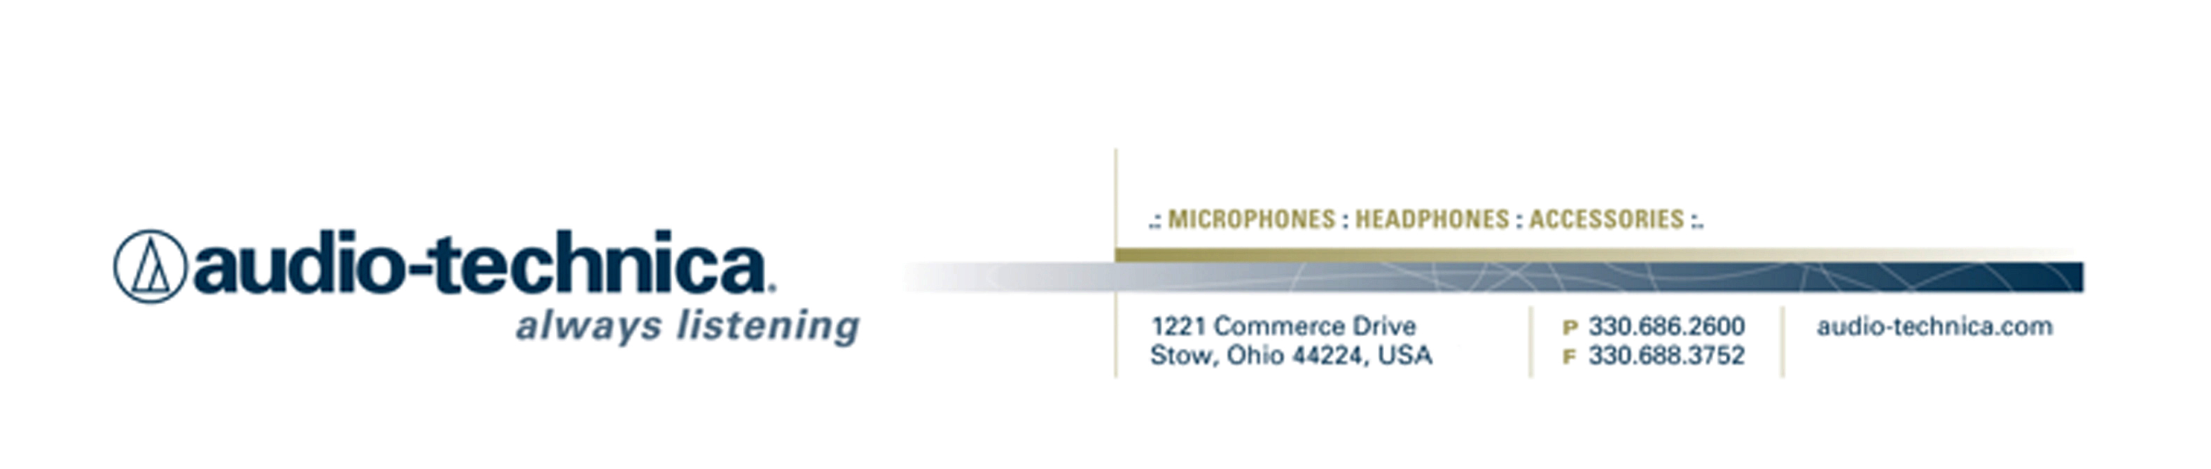
NEWS RELEASE
Contact: Clyne Media, Inc.
Tel: (615) 662-1616
Fax: (615) 662-1636

FOR IMMEDIATE RELEASE

Progressive Metal Pioneers Dream Theater and Engineer Richard Chycki Use Audio-Technica Mics in the Studio

135th AES Convention, New York, NY, October 18, 2013 — Audio-Technica (booth 2723), a leading innovator in transducer technology for over 50 years, is proud to be an integral part of the recording setup for progressive metal superstars Dream Theater as they recorded their self-titled twelfth studio set, which saw release on September 24 from Roadrunner Records.

The band’s engineer on this album and past projects, Richard Chycki (whose credits also include Rush, Aerosmith, Needtobreathe, Our Lady Peace and others), has been a longtime fan of Audio-Technica microphones. He says, “I regularly use several models of Audio-Technica mics for their sound quality as well as their innovative design, consistency and reliability. And I've used them for years, starting with a pair of AT4050's or AT4060's for the ambient portion of recordings. Regardless of the mic design, there was always a distinct open quality to all the Audio-Technica mics I've used, and they've performed very well in all applications. For the new Dream Theater album, by pairing the right mic with the source, we captured some pretty amazing audio with a minimum of outboard trickery. For instance, the AT5040 [Studio Vocal Microphone], with its amazing sensitivity and ultra-low noise floor, was an absolute joy to use, on acoustic guitar in particular. We also used AT4080 ribbon microphones as part of the main guitar tone.”

The full A-T mic list for the project included AT5040 Studio Vocal Microphones on all acoustic guitars and some vocal tracking; AT4080 Phantom-Powered Bidirectional Ribbon Microphones for electric guitars, rear ambience for drums and the strings room (in a Blumlein pair); AT4081 Phantom-powered Bidirectional Ribbon Microphones as spot mics for cellos and a string session; and AT4047/SV Cardioid Condenser Microphones as a spot mic for contrabass and a string session, as well as for “B-cabinet” electric guitars.

Chycki is particularly fond of Audio-Technica’s AT4080 and AT4081 ribbon microphones. He states, “We used an AT4080 for the rear drum kit ambience, placed very low behind [drummer Mike] Mangini. The AT4080 captures a lot of the low end push from the kit without a lot of excessive top end. Another AT4080 was used as a predominant part of John Petrucci's guitar tone. The AT4080 can take a lot of SPL, so it was placed close to the speaker cone and adjusted to find the driver's sweet spot. For the string sessions, I used a Blumlein pair of AT4080's about three meters above the players, as well as AT4081's as spot mics for the cellos.”

All in all, the A-T mics were a home run for the sessions. Chycki recalls, “I can say that John [Petrucci] had a very specific image of his guitar sound in his mind, describing its multi-layered depth as 'chocolate cake.' The AT4080 and AT4047/SV were very helpful in achieving our goal, and both John and I were very happy with the results.”

For more information, please visit www.audio-technica.com and www.dreamtheater.net.

…ends 478 words

Photo file 1: Chycki_AT4080_AT5040.JPG
Photo caption 1: Richard Chycki, engineer for Dream Theater’s new studio album, pictured with Audio-Technica’s AT4080 Phantom-Powered Bidirectional Ribbon Microphone and AT5040 Studio Vocal Microphone, both of which were employed for the sessions. Photo by Matthew Schieferstein. (This photo is the property of Matthew Schieferstein and may be used by the press only for the purpose of one-time reproduction. Unauthorized use, alteration or reproduction of this photograph is strictly prohibited.)

Photo file 2: DreamTheater_AT5040.JPG
Photo caption 2: Audio-Technica’s AT5040 Studio Vocal Microphone, used on sessions for the new Dream Theater album. Photo by Matthew Schieferstein. (This photo is the property of Matthew Schieferstein and may be used by the press only for the purpose of one-time reproduction. Unauthorized use, alteration or reproduction of this photograph is strictly prohibited.)

Photo file 3: DreamTheater_AT4080.JPG
Photo caption 3: Audio-Technica’s AT4080 Phantom-Powered Bidirectional Ribbon Microphone, used on sessions for the new Dream Theater album. Photo by Matthew Schieferstein. (This photo is the property of Matthew Schieferstein and may be used by the press only for the purpose of one-time reproduction. Unauthorized use, alteration or reproduction of this photograph is strictly prohibited.)

See more here:
- Lighthearted Company Tour of Audio-Technica USA Video
- Additional News Releases

Celebrating over 50 years of audio excellence worldwide, Audio-Technica is a leading innovator in transducer technology, renowned for the design and manufacture of microphones, wireless microphones, headphones, mixers, and electronics for the audio industry.

—For more information on the complete range of Audio-Technica products, contact
Karen Emerson, Audio-Technica U.S., Inc., 1221 Commerce Drive, Stow, OH 44224.
Tel: (330) 686-2600; Fax: (330) 688-3752; Web: www.audio-technica.com

Audio-Technica is exhibiting at booth 2723 at the 135th AES Convention in New York, NY.

