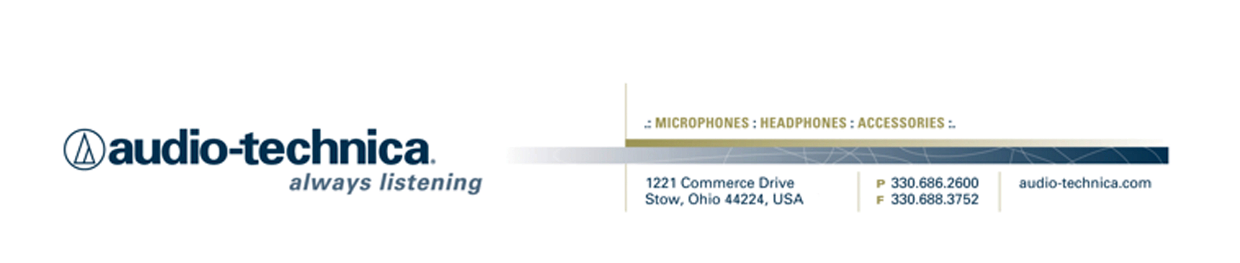
NEWS RELEASE
Contact: Clyne Media, Inc.
Tel: (615) 662-1616
Fax: (615) 662-1636

FOR IMMEDIATE RELEASE

Audio-Technica to Hold “Ask Me Anything” Sessions at 135th AES Convention

— Featuring industry insiders and friends of A-T, these AMA sessions are set to be informative and revelatory for an audience of in-person AES convention attendees as well as a worldwide online audience —

135th AES Convention, New York, NY, October 18, 2013 — Audio-Technica (booth 2723), a leading innovator in transducer technology for over 50 years, announces that, for the first time, it will be hosting several "Ask Me Anything" (AMA) question-and-answer sessions at its exhibition booth (2723) at the 135th AES Convention in New York, NY. Sessions are scheduled for two days of the convention: Friday, October 18, and Saturday, October 19. The session schedule is listed below, and additional details are available at the Audio-Technica booth or www.audio-technica.com/aes2013. (Note: this schedule is subject to change; updates will be made on this link).

Friday, October 18, 2013 (all times EDT):
1:00-1:30 -- Joel Singer, GRAMMY® Award-winning engineer/mixer, co-founder and chief engineer of Music Mix Mobile.
2:00-2:30 -- Jackie Green, VP R&D/Engineering at Audio-Technica.
3:00-3:30 -- Frank Filipetti, GRAMMY® Award-winning music producer, engineer and mixer.
4:00-4:30 -- Richie Castellano, musician and YouTube sensation.

Saturday, October 19, 2013 (all times EDT):
1:00-1:30 -- Richard Chycki, mixer, engineer and producer.
2:00-2:30 -- Carl Tatz, TEC Award-nominated recording studio designer.
3:00-3:30 -- Frank Wells, President of AES.
4:00-4:30 -- Jimmy Douglass, GRAMMY® Award-winning recording engineer/record producer.

“Ask Me Anything” questions are fed to the presenters through a moderator during a 30-minute Q&A session. Questions can be submitted by individuals present at AES booth 2723; online at www.livestream.com (free registration); and by Twitter #ATliveAES.

In addition, individuals may watch during and after the event at www.audio-technica.com/aes2013 (also accessible from A-T’s website or Facebook page).

“We are very much looking forward to the AMA sessions at the AES Convention,” stated Gary Boss, Audio-Technica Marketing Director. “This will be a wonderful opportunity to hear comments on a wide variety of topics from some of the leaders in their fields in an informal, no-holds-barred setting. And with the online presence, people who could not make the convention in person can get a taste of what the show has to offer and interact with these experts. We hope that this series of events will truly enhance the AES Convention experience for all who participate, and be the beginning a great tradition moving forward.”

Full details are available at www.audio-technica.com/aes2013.
…ends 348 words

Photo file: AMA_AES2013.JPG

Photo caption: Audio-Technica’s “Ask Me Anything” series at the 135th AES Convention.

See more here:
- Lighthearted Company Tour of Audio-Technica USA Video
- Additional News Releases

Celebrating over 50 years of audio excellence worldwide, Audio-Technica is a leading innovator in transducer technology, renowned for the design and manufacture of microphones, wireless microphones, headphones, mixers, and electronics for the audio industry.

—For more information on the complete range of Audio-Technica products, contact
Karen Emerson, Audio-Technica U.S., Inc., 1221 Commerce Drive, Stow, OH 44224.
Tel: (330) 686-2600; Fax: (330) 688-3752; Web: www.audio-technica.com

Audio-Technica is exhibiting at booth 2723 at the 135th AES Convention in New York, NY.

