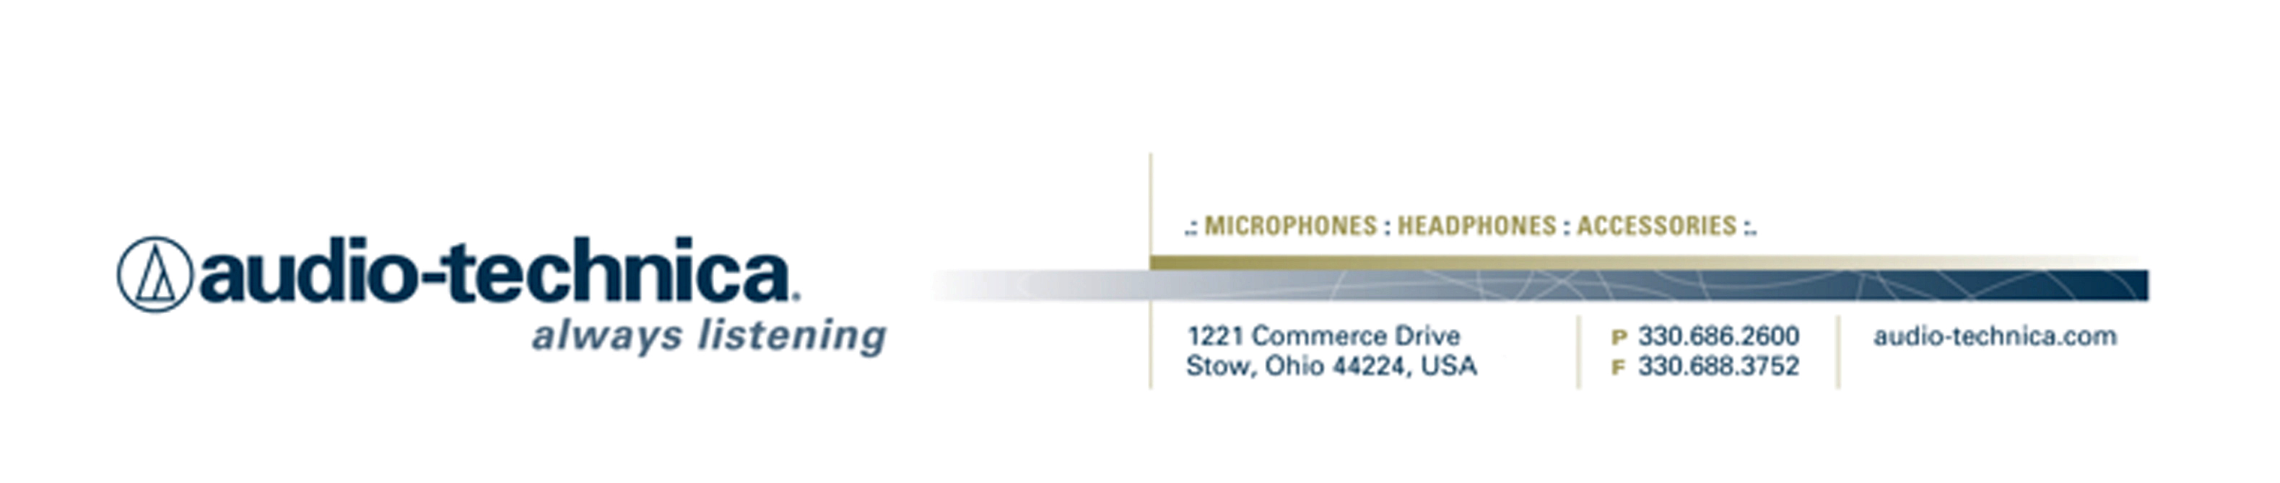
NEWS RELEASE
Contact: Clyne Media, Inc.
Tel: (615) 662-1616
Fax: (615) 662-1636

FOR IMMEDIATE RELEASE

Robert C. Bigelow and Audio-Technica Keep the Music Real for HBO Hit Series Treme

— Treme’s use of live music in the show is unique on television, and Bigelow relies on A-T microphones to capture the sounds of street musicians, parades and club shows —

— A-T further supports Bigelow’s educational efforts as a teacher of recording and mixing techniques at the University of New Orleans, providing microphones and other support materials —

133rd AES CONVENTION, SAN FRANCISCO, CA, October 27, 2012 — When viewers of HBO’s hit series Treme watch a parade of street musicians leading a crowd through New Orleans’ French Quarter or listen as a blues trumpet wails late into the night in a jazz club, they’re not hearing music dubbed in later in post production. They’re hearing that musician play those actual notes. That’s what sets the work that the show’s Music Recordist, Robert C. Bigelow, has done for the last three seasons of the program, distinct from most music in television drama. On Treme, the music is as real as can be because it’s recorded on site as the show is shot, and Bigelow chooses microphones from Audio-Technica to capture Treme’s music.

“The big challenge for Treme is that the music you hear on the show is what we film live on location,” says Bigelow. “Most television shows will shoot to pre-recorded music and mix it in later; on this show, we record the musicians playing live in front of the camera, so you’re hearing the real thing. This really sets Treme apart from any other drama on television.”

Bigelow says Audio-Technica offers him what no other microphone manufacturer can: the ability to capture a huge palette of sound using just a few key microphones. He uses the A-T BP4027 and BP4029 Stereo Shotgun Microphones to create the ambient sound foundation for the show’s music. “They give me the big picture and context for the music, and we build the package on them,” he explains. A-T’s ATM350 Cardioid Condenser Clip-on Microphones are used for the brass instruments in parades and club scenes. “They’re incredibly versatile and I’ll use them on instruments from a trombone to a piano,” he says. “They’re very easy to hide – unlike other clip-on mics, I can just take the capsule of the 350 and attach it to the horn, yet they still give me full-range sound.” One very cool trick Bigelow has developed is to tape the 350 to the back of a shirt collar of a musician in a marching band to record the sound of the horns that are behind him.

Bigelow uses several microphones from A-T’s Artist Elite® wireless Series, including the AE5100 Cardioid Condenser Instrument Microphone and AE4100 Cardioid Dynamic Handheld Microphone, on both vocals and instruments, and the ATM450 Cardioid Condenser Instrument Microphone for nearly invisible miking of guitar amps and pianos, as well as overheads for drum kits. “The 450 has a really low profile so it’s great for capturing a little guitar amp on a street corner, and on drum overheads it’s got a pristine high end with absolutely no sibilance – crisp highs with no shrillness,” he raves. “The real beauty of this is that I’m able to capture the entire range of music for this show with just a few key microphones. You don’t need a big microphone closet to do this show.”

In addition to his groundbreaking work on Treme, Bigelow also heads a mentoring program in audio recording for film/TV at the University of New Orleans, helping the school further develop its film/TV production program. And A-T is a big part of that, too, providing microphones for classes and educational support materials for students. “One of the nice things about A-T microphones when it comes to teaching is that A-T mics are a great value without giving up any performance, so they’re the microphones that students can build their own tool kits with affordably, and those microphones will stay with them for the rest of their careers,” he says. “And it’s great that I’m able to teach using the very same microphones that I’m using on a multi-million-dollar film production. These are really the only microphones that can truly do it all.”

For more information, please visit www.audio-technica.com.
…ends 625 words

Photo File: AT_Bigelow.JPG

See more here:
- 50th Anniversary Information and Video
- Lighthearted Company Tour of Audio-Technica USA Video
- Additional News Releases

Celebrating 50 years of audio excellence worldwide, Audio-Technica is a leading innovator in transducer technology, renowned for the design and manufacture of microphones, wireless microphones, headphones, mixers, and electronics for the audio industry.

—For more information on the complete range of Audio-Technica products, contact
Karen Emerson, Audio-Technica U.S., Inc., 1221 Commerce Drive, Stow, OH 44224.
Tel: (330) 686-2600; Fax: (330) 688-3752; Web: www.audio-technica.com

Audio-Technica is exhibiting at Booth 705 during the 133rd AES Convention in San Francisco, CA.

