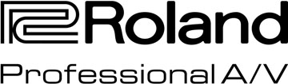

For Release: Immediate

Press Contact: Company Contact:
Robert Clyne Christian Delfino
President VP Sales and Marketing
Clyne Media, Inc. Roland Professional A/V
(615) 662-1616 (323) 215-2111
Robert@clynemedia.com Christian.Delfino@roland.com

Nashville Pros Get Hands-on with the Roland Professional A/V Experience

Los Angeles, CA, February 29, 2016 — Roland Professional A/V, in cooperation with its southeast regional rep HWPco, recently took over two rooms at the SoundCheck Nashville rehearsal facility for two days of hands-on demonstrations of its audio and video production solutions. A bit of snow and freezing rain was slowing Nashville traffic but encouraged early arrivals, with the first of a steady stream of A/V professionals arriving from two states away well before the official start of the first day. Across both days, over 50 media pros participated, from live sound, recording, broadcast and system integration market sectors.

The Roland M-5000 Live Mixing Console was the featured audio hardware, with three desks on hand; HWPco personnel and Roland live audio products sales engineer Brian Belcher were available to guide the tours of the desk, though the M-5000’s intuitive workflow requires a small level of explanation. The M-5000 is based on the OHRCA platform, which opens a new generation of live sound solutions for audio professionals. “OHRCA” stands for “Open, High Resolution, Configurable Architecture.” The M-5000 delivers 128 freely definable audio paths, supporting multiple audio format protocols and offering pristine 96 kHz sound quality throughout the system. The original 28-fader configuration of the M-5000 was also available for test drive at the event, as was the smaller-footprint, but equally capable, 20-fader M-5000C compact configuration of the console.

Veteran FOH engineer Martin Frey, currently Production Manager and FOH for award-winning American country act Lonestar, attended the event to check out the M-5000. Frey comments that one has to “actually drive one on the track to get a super good feel of how she handles live; however, I mixed some recorded live tracks and listened to an SM58. I tried all of the EQ options, dynamics and some FX. [There’s] cool Roland modeled FX onboard (remember the SDE-3000?).” From this initial hands-on experience with the M-5000, Frey offers this bullet point summation: “Very easy to navigate, well thought-out layout and very easy to customize both I/O patch and surface. Tons of interface options!”

On the video side, the featured products included the V-1200HD Hybrid Engine 2 M/E Switcher and Processor for Broadcast and Live Events, along with the V-1200HDR control surface and software control tools. Also shown was the portable, compact V-1HD video switcher, the 8-in x 4-out XS-84H Multi-Format AV Matrix Switcher and the all-in-one VR-3EX AV mixer. The video product tours conducted by Roland and HWPco pros, hosted by Roland Pro A/V division National Sales Manager Jeremy Engel, were a “but wait, there’s more!” affair, as the demos revealed that the depth of capability and function in each of the devices excels in both feature sets and value.

Visit http://www.hwpco.com/ and http://proav.roland.com/ for more info.

---------

Photo file 1: RolandProAV-Experience-main.JPG
Photo caption 1: Roland sales personnel and product specialists, along with members of the team from southeast U.S. rep firm HWPco, gathered at SoundCheck Nashville for two days of hands-on demonstrations of Roland’s most recently released professional A/V products. Pictured standing from left to right are Jeremy Engel, National Sales Manager, Roland Pro A/V; Jay Wanamaker, President and CEO, Roland U.S.; Kevin Duthu, Territory Manager, HWPco; Brooks Platts, Territory Manager/Product Specialist, HWPco and Brian Belcher, Sales Engineer, Roland Pro A/V. Seated (left to right) are Norman Miller, Territory Manager, HWPco; Chris Adler Product Specialist, HWPco and Becca Sanders, Inside Support, HWPco.

Photo file 2: RolandProAV-Experience-main-alt.JPG
Photo caption 2: Roland sales personnel and product specialists, along with members of the team from southeast U.S. rep firm HWPco, gathered at SoundCheck Nashville for two days of hands-on demonstrations of Roland’s most recently released professional A/V products. Pictured standing from left to right are Norman Miller, Territory Manager, HWPco; Brian Belcher, Sales Engineer, Roland Pro A/V; Kevin Duthu, Territory Manager, HWPco; Jay Wanamaker, President and CEO, Roland U.S.; Jeremy Engel, National Sales Manager, Roland Pro A/V and Brooks Platts Territory Manager/Product Specialist, HWPco. Seated are Chris Adler Product Specialist, HWPco (left) and Becca Sanders, Inside Support, HWPco.

Photo file 3: BrianBelcher.JPG
Photo caption 3: Roland live audio products sales engineer, Brian Belcher, preps an M-5000 console for the next demo during the Roland Pro A/V Experience in Nashville.

About Roland Professional A/V
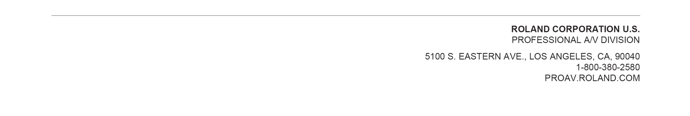
Roland’s professional A/V division is dedicated to providing solutions in support of audio and video professionals demanding excellence in both performance and functionality. Through the development and support of video and audio products, we endeavor to improve workflow and maximize creative possibilities in a variety of markets including Broadcast, Corporate, Education, Legal, Live Production, Sports, Theater, Theme Park, Videography, Visual Performance, Worship. Roland is headquartered in Los Angeles, California. For more information: http://proav.roland.com.

