

For Release: Immediate

Press Contact: Company Contact:
Robert Clyne Christian Delfino
President VP Sales and Marketing
Clyne Media, Inc. Roland Professional A/V
(615) 662-1616 (323) 215-2111
Robert@clynemedia.com Christian.Delfino@roland.com

Roland Debuts Its V-1HD High-Definition Video Switcher

Compact, portable, easy-to-use mixer offers 4-channel HD video switching, built-in compositing effects, multichannel audio mixing and more

Los Angeles, CA, November 16, 2015 — Roland today announces the introduction of its V-1HD Video Switcher, an easy-to-use, compact and portable switcher that can accommodate up to four HDMI audio/video sources with resolutions up to 1080p and features a host of professional compositing effects and creative video switching capabilities.

“The new V-1HD is ideal for supporting both live events and presentations, as well as small broadcast setups for enterprise video users, K-12 schools and house-of-worship environments. It is also an amazing creative tool for visual artists or musicians who want to add video switching to their performances, create YouTube videos, mix content for online streaming and more,” said Christian Delfino, Vice President of Sales and Marketing for the Roland Professional A/V Division. “It’s the most affordable 4-channel HD video switcher that includes a hardware interface, video FX and audio mixing/FX, making it a complete portable video switching and control solution.” The V-1HD can also be controlled by the companion PC/Mac or iPad application when connected by USB.

The Roland V-1HD provides switching for up to four HDMI A/V sources including cameras, computers, tablets, smartphones and even Blu-ray players, thanks to its HDCP copy protection support. Its high-definition output can be switched between 720p (from 720p inputs), 1080i or 1080p. In either 1080i or 1080p output mode, the V-1HD can accept both 1080p and 1080i input signals simultaneously, allowing use with a range of sources. It has a 12-channel audio mixer for mixing stereo audio from HDMI and external stereo audio sources and its dedicated microphone input. The V-1HD includes two HDMI program and preview outputs and a stereo audio output.

The V-1HD gives users an array of compositing effects, including picture-in-picture and keying, allowing for graphic insets plus titling and green screen capabilities. The V-1HD is ideal for live event video switching, thanks to its advanced transition and filter effects – more than 30 effects and transition types including mix, cut, full additive mix (FAM), non-additive mix (NAM), wipe and other performance effects. The V-1HD also has output fade, BPM Sync and Auto-Scan functions. The A and B video busses each have controls for effects assignment and parameter control. The output can be switched A/B or in PGM/PST mode where the B buss is used for signal preview. The preview output can be set to a multiview mode, where all inputs are displayed with colored borders indicating the program and preview selections, or in a full-screen mode. The preview output can be used for additional, menu-driven set-up control, or as a second output for applications such as a simultaneous webcast or recording output.
The 12-channel audio mixer offers 3-band parametric EQ, reverb, up to 500ms delay for accurate lip-sync, a compressor/gate on the mic input and level/multiband EQ on the master mix. A headphone output facilitates audio monitoring and the V-1HD supports mono or stereo plug-in-powered microphones.

The V-1HD features a clean, intuitive control layout with multi-function buttons and knobs and a large T-handled T-Fader for key and transition operations. Its rugged construction ensures long-term reliability even under the most demanding conditions of portable and professional use.

The Roland V-1HD High-Definition Video Switcher will be available in December 2015 at a suggested retail price of $995.

To learn more about the V-1HD, visit http://proav.roland.com/v1hd.

For more information, please visit http://proav.roland.com/.

---------
Photo file 1: v1hd_front.JPG
Photo caption 1: Roland V-1HD Video Switcher.

Photo file 2: v1hd_software.JPG
Photo caption 2: A screen cap from Roland V-1HD Video Switcher software.

Photo file 3: v1hd_rear.JPG
Photo caption 3: The rear panel of the Roland V-1HD Video Switcher.

Photo file 4: v1hd_right.JPG
Photo caption 4: The right side panel of the Roland V-1HD Video Switcher.

Photo file 5: v1hd_left.JPG
Photo caption 5: The left side panel of the Roland V-1HD Video Switcher.

About Roland Professional A/V
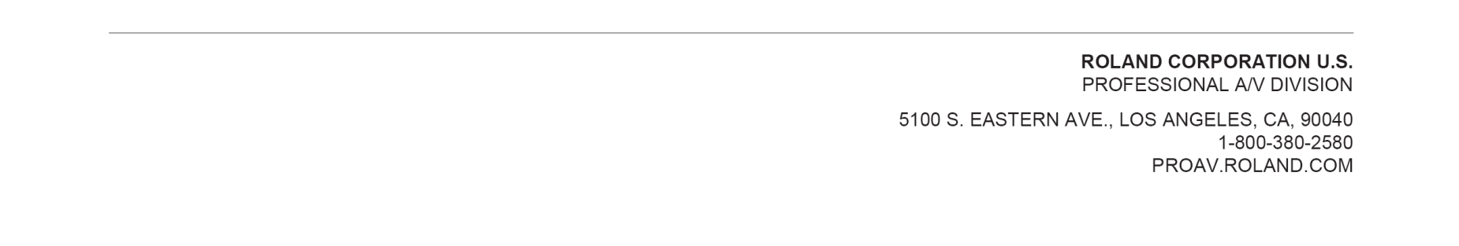
Roland’s professional A/V division is dedicated to providing solutions in support of audio and video professionals demanding excellence in both performance and functionality. Through the development and support of video and audio products, we endeavor to improve workflow and maximize creative possibilities in a variety of markets including Broadcast, Corporate, Education, Legal, Live Production, Sports, Theater, Theme Park, Videography, Visual Performance, Worship. Roland is headquartered in Los Angeles, California. For more information: http://proav.roland.com.

