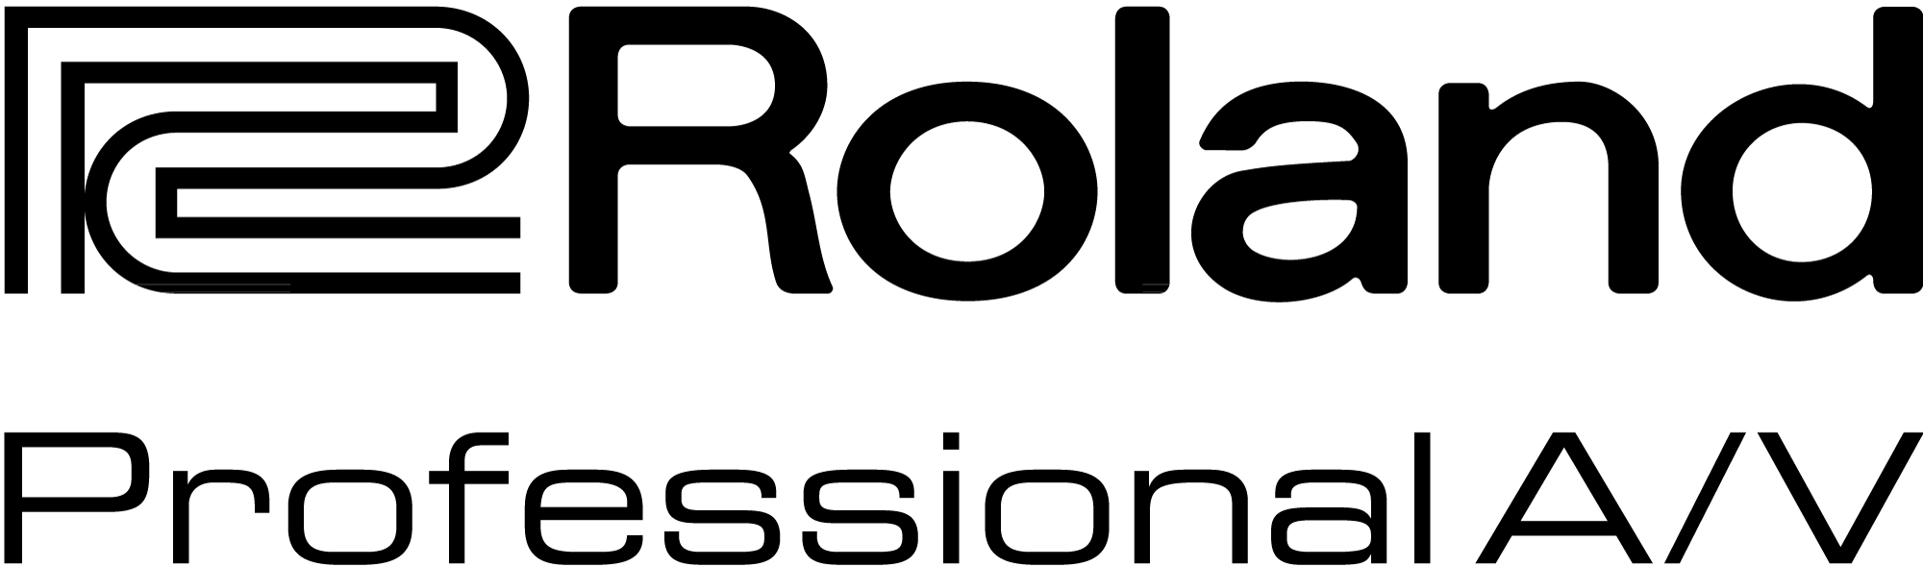

For Release: Immediate

Press Contact: Company Contact:
Robert Clyne Rob Read
President Marketing Communications Mgr.
Clyne Media, Inc. Roland Professional A/V
(615) 662-1616 (323) 215-2122
robert@clynemedia.com Rob.read@rolandus.com

Roland Professional A/V Division Holds Two-Day Rep Training Event at CenterStaging Rehearsal Studio in Burbank, CA

Los Angeles, CA, June 8, 2015 — Roland’s Professional A/V division recently held a two-day training event for the new M-5000 Live Digital Mixing Console at CenterStaging rehearsal studio in Burbank, California. The hands-on training was designed to equip Roland’s independent U.S. sales network, along with Pro A/V sales teams from Latin America and Canada, with in-depth knowledge of the M-5000’s design and operation to support end users in the field. CenterStaging pro audio staff members participated in the M-5000 hands-on training in preparing for M-5000 placements at the rehearsal facility.

A portion of the training also covered video system design, featuring the Roland V-1200HD and integration with the Roland M-5000. Additionally, Roland provided training on the recently released version 2.0 software update for the Roland XS Series AV Matrix rack mount switchers. The updated software features uninterrupted output mode switching, cross dissolve switching, PGM/PST operation mode, enhanced customization Picture-in-Picture capabilities and a new customizable iPad app for wireless touch control.

Roland will be demonstrating these new products later this month at the InfoComm Show in Orlando, Booth #853.
---------

Photo file: Roland_RepTraining.JPG
Photo caption: Members of Roland’s independent U.S. sales network, along with Pro A/V sales teams from Latin America and Canada, gathered at CenterStaging rehearsal studio in Burbank, California, for a hands-on training session on Roland’s most recently released professional A/V products.

About Roland Professional A/V
Roland’s professional A/V division is dedicated to providing solutions in support of audio and video professionals demanding excellence in both performance and functionality. Through the development and support of video and audio products, we endeavor to improve workflow and maximize creative possibilities in a variety of markets including Broadcast, Education, Legal, Live Production, Sports, Theater, Theme Park, Videography, Visual Performance, Worship. Roland is headquartered in Los Angeles, California.



