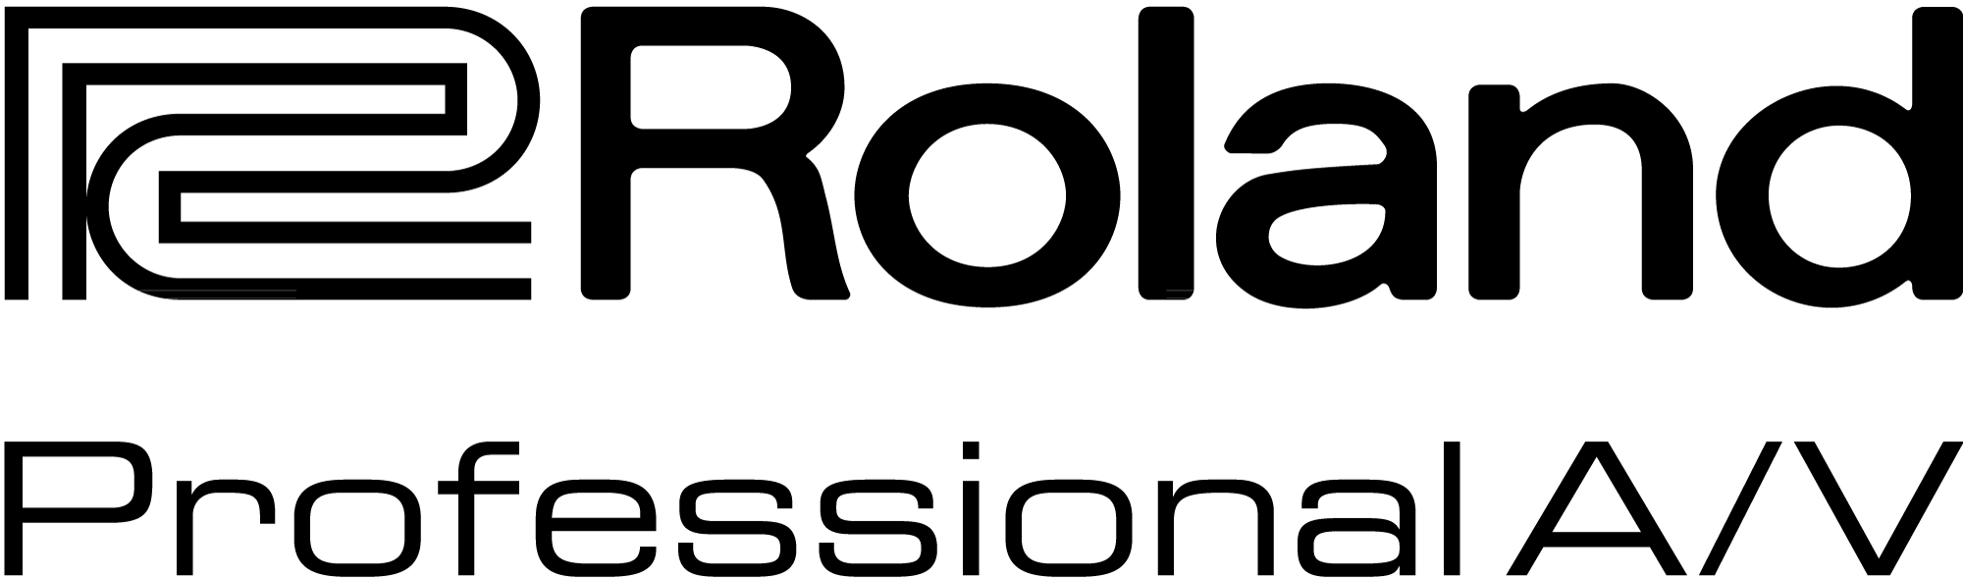

For Release: Immediate

Press Contact: Company Contact:
Robert Clyne Rob Read
President Marketing Communications Mgr.
Clyne Media, Inc. Roland Professional A/V
(615) 662-1616 (323) 215-2122
robert@clynemedia.com Rob.read@rolandus.com

Roland’s M-5000 Live Mixing Console Finds Early Adopter in Lincoln, Nebraska-Based Multimedia Firm Inspirmedia Productions

Longtime Roland Professional A/V user Inspirmedia makes the move to higher channel count and unprecedented interoperability with the M-5000, recently brought to market

Los Angeles, CA, June 26 2015 — Established around 15 years ago as an outgrowth of founder Phil Grimpo’s work in house-of-worship A/V, Lincoln, Nebraska-based firm Inspirmedia has significantly expanded its service portfolio in the years since. Grimpo and his team are at-home providing live A/V for church services and larger worship events (notably including youth conferences), concerts, corporate events and beyond; all magnitude of video, graphics and lighting production; consulting, training and sales; and much more – either locally or nationwide.

A relatively steady element of the firm’s gear arsenal and consulting has been products from Roland Professional A/V division, including the Roland M-200i, M-400 and M-480 48-channel Live Mixing Consoles. “I really dove in deep with Roland on those boards,” notes Grimpo. “Most jobs that I would spec, I’d say, ‘You should really consider the Roland board, and Roland’s complete ecosystem.’ We used both the M-400 and M-480 boards in my main church gig, and they are very user-friendly, and they could easily be reconfigured for different setups or applications without hassle. I really liked the workflow offered by these Roland products.”

There was one main roadblock, however, that made Grimpo wish for something larger: “I would say that our main limitation with those boards was channel count, even in smaller churches which had praise bands, so when I heard that the M-5000 Live Mixing Console was coming out, with up to 128 audio paths, I was immediately very excited.” Grimpo called his rep and put in an order as soon as he could. “The M-5000 wasn’t officially available yet – there was no official pricing yet, even, when we put in our P.O. But our rep did his magic, and I believe we got one of the first production units, if not THE first, in the world.”

Grimpo and his team are often approached by attendees of these various events for advice. “Consulting work is a big part of what we do. People almost always come up to us after an event and wonder what it would take to put something like the rig we had just used, into their church. And I’m not a rep for any particular brand or product, but I know what works for the job, and I love getting people in front of different products to A/B them for themselves. Lately, I just cannot get enough people in front of this Roland M-5000 console. It’s been impressing everyone immediately. I recently had a client ask if I had any boards other than Roland M-480. When I told him we had the Roland M-5000 he immediately reconsidered and is planning on using that for his event.”

The Roland M-5000 Live Mixing Console is the first product based on the O.H.R.C.A. platform, which opens a new generation of live sound solutions for audio professionals. “O.H.R.C.A.” stands for “Open, High Resolution, Configurable Architecture,” and the M-5000 reflects this by delivering freely definable audio paths, supporting multiple audio formats protocols and offering pristine 96 kHz sound quality throughout the system. The Roland M-5000’s internal mix architecture is not fixed and can be freely defined for mixing channels, AUXs, Matrices, subgroup buses, and MIX-MINUS buses within a range of up to 128 audio paths, allowing users to create a console structure to suit the needs of the application.

The M-5000 has two built-in REAC ports, plus two expansion card slots with seven expansion card options including Dante™, MADI, Waves SoundGrid®, or more REAC ports, as well as audio embedded over video protocols. The back panel includes 16x16 analog I/O, 4x4 AES/EBU, a 16x16 USB audio interface, connection for control via an iPad connected or wireless, and control ports including footswitches, GP I/O, RS-232C and MIDI. All of this capability enables the console to see up to 300 inputs and 296 outputs, all at 96kHz and even more at 48kHz.

Inspirmedia’s typical live production setup includes the Roland M-5000 at FOH, two S-2416 Digital Snake Stage Units for remote I/O and the R-1000 48-Track Recorder/Player for multi-channel recording and playback.

“It is hard to sum up what makes the M-5000 special,” Grimpo notes. “The ability, with the expansion cards, to interface with Dante, MADI, SoundGrid, etc., is very exciting and unprecedented as far as I am concerned. And if you compare it to products from other manufacturers, you notice several things. First, the M-5000 is far less ‘noisey’ compared to other boards, which is obvious with headphones. It looks better, and the visual interface is brighter and more readable and the workflow more intuitive. Getting around the board is really easy once you get the hang of it. And one of the things that I love about this board is it works with all of the existing Roland hardware that’s out there. It’s backwards-compatible and future-proof at the same time.”

Grimpo has big plans for the M-5000: “Corporate events, larger stadium gigs, worship conferences – the M-5000 is going to be a key part of our audio workflow moving forward.”

For more information on the Roland M-5000, visit http://proAV.roland.com/OHRCA/.

---------
Photo file 1: RolandProAV_Inspirmedia_Photo1.JPG
Photo caption 1: The M-5000 Live Mixing Console from the Roland Professional A/V Division, put to use at a recent event in Lincoln, Nebraska, by A/V firm Inspirmedia. Photo courtesy of Inspirmedia. © 2015.

Photo file 2: RolandProAV_Inspirmedia_Photo2.JPG
Photo caption 2: An audio engineer from Inspirmedia operates the Roland Professional A/V Division’s new M-5000 Live Mixing Console at a recent event in Denver. Photo courtesy of Inspirmedia. © 2015.

Photo file 3: RolandProAV_Inspirmedia_Photo3.JPG
Photo caption 3: An audio engineer from Inspirmedia operates the Roland Professional A/V Division’s new M-5000 Live Mixing Console at a recent event in Denver. Photo courtesy of Inspirmedia. © 2015.

Photo file 4: RolandProAV_Inspirmedia_Photo4.JPG
Photo caption 4: A band performs at a recent event in Denver, with Nebraska-based firm Inspirmedia providing A/V services and components, including Roland Professional A/V components such as the R-1000 48-Track Recorder/Player and S-2416 Digital Snake Stage Unit, both visible in the rack. Photo courtesy of Inspirmedia. © 2015.

Photo file 5: RolandProAV_Inspirmedia_Photo5.JPG
Photo caption 5: At a recent event in Denver, Nebraska-based firm Inspirmedia provided A/V services and components, including Roland Professional A/V components such as the R-1000 48-Track Recorder/Player and S-2416 Digital Snake Stage Unit, both visible in the rack. Photo courtesy of Inspirmedia. © 2015.

About Roland Professional A/V

Roland’s professional A/V division is dedicated to providing solutions in support of audio and video professionals demanding excellence in both performance and functionality. Through the development and support of video and audio products, we endeavor to improve workflow and maximize creative possibilities in a variety of markets including Broadcast, Education, Legal, Live Production, Sports, Theater, Theme Park, Videography, Visual Performance, Worship. Roland is headquartered in Los Angeles, California.

