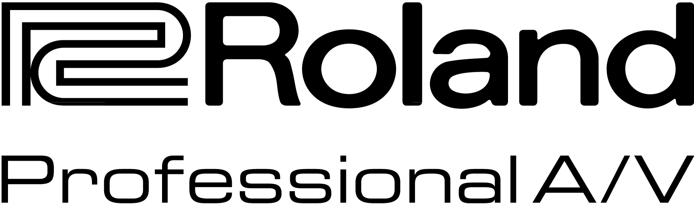

For Release: Immediate

Press Contact: Company Contact:
Robert Clyne Rob Read
President Marketing Communications Mgr.
Clyne Media, Inc. Roland Professional A/V
(615) 662-1616 (323) 215-2122
robert@clynemedia.com Rob.read@rolandus.com

Now Available: Roland XI-Dante Expansion Interface Card for M-5000 Live Audio Mixing Console

New XI card expands I/O capabilities of the M-5000 Live Sound Mixing Console

InfoComm, Orlando, FL, June 17, 2015 — Roland Pro A/V (Booth #853) announces the availability of XI-Dante, an XI-Expansion Interface card that extends the audio I/O capabilities of the M-5000 Live Sound Mixing Console. The new XI-Dante is one of seven expansion cards offered as part of the open architecture of the O.H.R.C.A. mixing platform found in the Roland M-5000. The XI-Dante card future-proofs the M-5000 by enabling it to interoperate with the growing number of manufacturers’ products that are Dante™ compatible.

The Dante digital audio transport protocol delivers multi-channel, low-latency, uncompressed audio over an Ethernet network. When used with the M-5000, the XI-Dante card offers a primary and a secondary port, plus a control port. It also supports 64 bidirectional audio channels at 48 kHz or 32 bidirectional channels at 96 kHz. Running digital audio through the M-5000 via the XI-Dante card eliminates common analog challenges such as interference from other electrical equipment, signal degradation over long cable runs, and more.

The XI-Dante card also expands the flexibility of the new V-1200HD Broadcast and Live Video Production Switcher by enabling it to operate in a wider range of broadcast and live production applications. When installed in a V-1200HD expansion slot, the XI-Dante card supports 16 bidirectional audio channels at 48 kHz.

For more information, visit http://proav.roland.com.

---------

Photo file: Roland_XI-Dante.JPG
Photo caption: Roland’s new XI-Dante expansion interface card.

About Roland Professional A/V

Roland’s professional A/V division is dedicated to providing solutions in support of audio and video professionals demanding excellence in both performance and functionality. Through the development and support of video and audio products, we endeavor to improve workflow and maximize creative possibilities in a variety of markets including Broadcast, Education, Legal, Live Production, Sports, Theater, Theme Park, Videography, Visual Performance, Worship. Roland is headquartered in Los Angeles, California.

