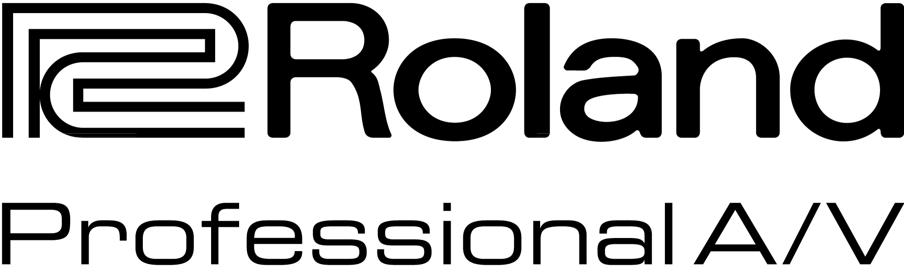

For Release: Immediate

Press Contact: Company Contact:
Robert Clyne Rob Read
President Marketing Communications Mgr.
Clyne Media, Inc. Roland Professional A/V
(615) 662-1616 (323) 215-2122
robert@clynemedia.com Rob.read@rolandus.com

Roland Professional A/V Displays V-1200HD Multi-Format Video Switcher

InfoComm, Orlando, FL June 17, 2015 — The Roland Pro A/V (booth #853) V-1200HD Multi-Format Video Switcher is a Hybrid 2 M/E switcher that combines the features of a production switcher with the power of a presentation switcher.

Users can switch and control functions on the Roland V-1200HD using the dedicated V-1200HDR Control Surface or free downloadable Remote Control Software (RCS). Users can also connect up to four compatible control devices on a network to separate out switcher functions by M/E’s, keying, or audio mixing.

Multiple M/E configurations can be selected from 1 M/E to 1.5 M/E and 2 M/E to meet the needs of any live production. Inputs include 10x 3G-SDI and 4x HDMI with 6x 3G-SDI Outputs and 2x HDMI outputs. Scalers on HDMI inputs 3 & 4 and HDMI outputs support SD through HD resolutions.

The V-1200HD has a powerful built-in 16-channel audio mixer that can be expanded via Roland’s XI-Expansion cards. An intuitive user interface with assignable cross-points and on-screen names ensures maximum flexibility for live production or broadcast.

The Roland V-1200HD will be demonstrated at Roland’s InfoComm booth #853.

---------

Photo File 1: Roland_V-1200HD_Photo1_Components.JPG
Photo Caption 1: Roland’s new V-1200HD Broadcast and Live Video Production Switcher (right, rear), along with the V-1200HDR Control Surface (foreground) and video monitor.

Photo File 2: Roland_V-1200HD_Photo2_Rear.JPG
Photo Caption 2: The rear panel of Roland’s new V-1200HD Broadcast and Live Video Production Switcher.

Photo File 3: Roland_V-1200HDR_ControlSurface_Photo1.JPG
Photo Caption 3: The V-1200HDR Control Surface for Roland’s new V-1200HD Broadcast and Live Video Production Switcher.

Photo File 4: Roland_V-1200HDR_ControlSurface_Photo2.JPG
Photo Caption 4: The V-1200HDR Control Surface for Roland’s new V-1200HD Broadcast and Live Video Production Switcher.

About Roland Professional A/V
Roland’s professional A/V division is dedicated to providing solutions in support of audio and video professionals demanding excellence in both performance and functionality. Through the development and support of video and audio products, we endeavor to improve workflow and maximize creative possibilities in a variety of markets including Broadcast, Education, Legal, Live Production, Sports, Theater, Theme Park, Videography, Visual Performance, Worship. Roland is headquartered in Los Angeles, California.

