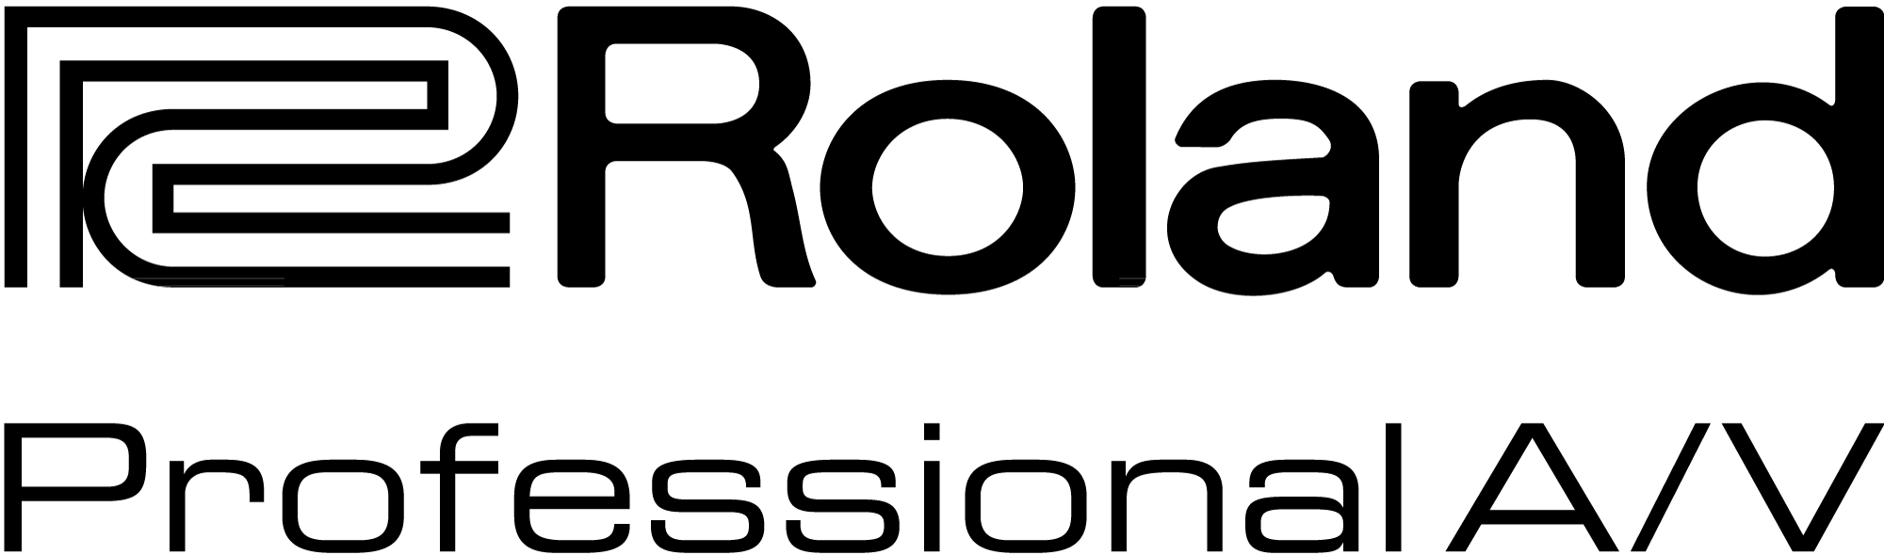

For Release: Immediate

Press Contact: Company Contact:
Robert Clyne Rob Read
President Marketing Communications Mgr.
Clyne Media, Inc. Roland Professional A/V
(615) 662-1616 (323) 215-2122
robert@clynemedia.com Rob.read@rolandus.com

Roland Pro A/V Displays High Resolution, Multi-Channel Digital Snakes

Fixed, modular, and expandable multi-channel digital audio transfer systems are showcased at InfoComm

InfoComm, Orlando, FL, June 17, 2015 — Roland Pro A/V (booth #853) digital snakes offer high audio quality and reliability for concerts, corporate events, houses of worship and other installations, by coupling pro-quality preamps with REAC (Roland Ethernet Audio Communication) transmission technology. Digital signal transmission provides immunity to the hums, buzzes and general impedance and capacitive losses that plague analog snakes.

Roland digital snakes offer future-proof stability, via their compatibility with the expandable, open-architecture M-5000 Live Mixing Console, which is part of a loyalty rebate upgrade program being offered by Roland through August 31, 2015. Current users of any Roland digital snake system with V-Mixer consoles can now enjoy higher sound quality at 24-bit 96 kHz simply by integrating to the M-5000 console. For more information about the program, please visit: http://proav.roland.com/rebate.

Current models in the Roland Pro A/V line of digital snakes include:

- S-4000S – a modular, reconfigurable system delivering 40 channels of high quality audio at up to 24-bit/96kHz, all over Cat5e cables. Features include remote controllable XR-1 pro-quality mic preamps, and redundant Ethernet ports and splits using standard Ethernet hardware.

- S-1608 – a fixed, compact version of the modular system. Easy to use and quick to install, this 16-input-by-8-output point-to-point solution offers the highest quality audio signal available in a compact system.

- S-2416 – a stage unit offering newly developed 24-input-by-16-output analog and 8-input-by-8-output digital mic preamps. Two REAC ports enable cascading of an additional snake for expanded I/O or for a fully redundant, zero-loss audio back-up solution.

- S-0808 – a compact, 8in/8out, lightweight snake that can run on battery-power, embedded-powered over REAC, or power over Ethernet (PoE), making it ideal for location sound, festivals, floor pockets, remote broadcasts and other portable applications.

For more information, visit http://proav.roland.com.

---------

Photo file 1: Roland_S-2416_diag_right.png
Photo caption 1: Roland S-2416 24 x 16 Digital Snake

Photo file 2: Roland_S-0808_front.jpg
Photo caption 2: Roland S-0808 8 x 8 Battery Powered Digital Snake

About Roland Professional A/V
Roland’s professional A/V division is dedicated to providing solutions in support of audio and video professionals demanding excellence in both performance and functionality. Through the development and support of video and audio products, we endeavor to improve workflow and maximize creative possibilities in a variety of markets including Broadcast, Education, Legal, Live Production, Sports, Theater, Theme Park, Videography, Visual Performance, Worship. Roland is headquartered in Los Angeles, California.


