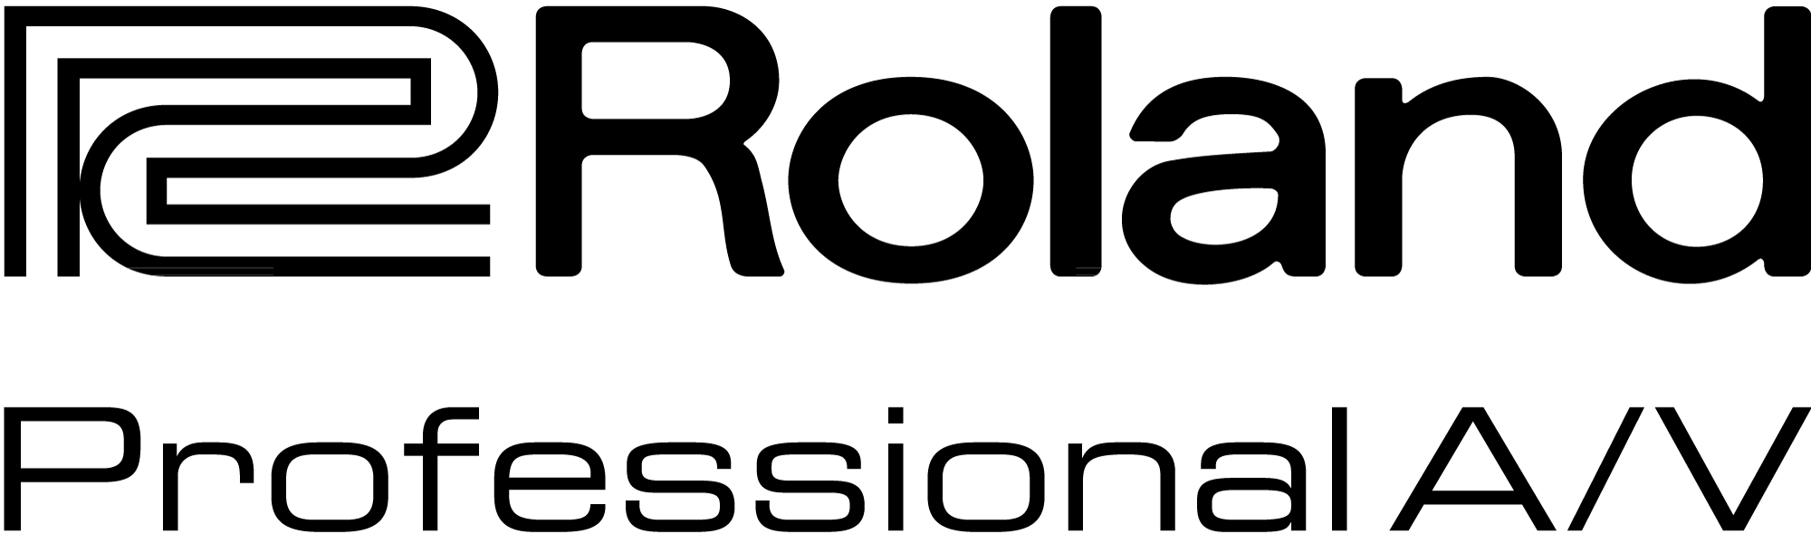

For Release: Immediate

Press Contact: Company Contact:
Robert Clyne Rob Read
President Marketing Communications Mgr.
Clyne Media, Inc. Roland Professional A/V
(615) 662-1616 (323) 215-2122
robert@clynemedia.com Rob.read@rolandus.com

Roland's New Pro A/V Offerings Bridge Audio and Video for Integrators

New products offer open architecture, expandability and flexibility

InfoComm, Orlando, FL, June 17, 2015 — Roland Pro A/V (Booth #853) is showcasing a variety of contractor and system integrator solutions that bridge the gap between audio and video tasks, allowing integrators to work seamlessly between the two mediums.

The M-5000 Live Mixing Console, based on Roland’s acclaimed O.H.R.C.A. platform (Open High Resolution Configurable Architecture), is ideal for any application demanding power and flexibility. O.H.R.C.A. brings extreme configurability to live mixing consoles by providing a mix engine of 128 freely definable audio paths. It offers one of the most open audio architectures currently available, with support for Dante™, MADI, Waves SoundGrid®, and REAC audio protocols, in addition to audio delivery over video using SDI, DVI and SFP cabling.

The Roland V-1200HD Multi-Format Video Switcher is a Hybrid 2 M/E switcher and processor for live events that combines the features of a production switcher with the power of a presentation switcher. Users can switch and control functions on the Roland V-1200HD using the dedicated V-1200HDR Control Surface or free downloadable Remote Control Software (RCS). Users can also connect up to four compatible control devices on a network to separate out switcher functions by M/E’s, keying or audio mixing.

Roland’s new XI-Expansion Interface Cards significantly expand the audio and video I/O capabilities of the V-1200HD and M-5000. The cards offer a high level of flexibility and integration across both audio and video configurations, and future-proof the M-5000 and V-1200HD by enabling them to interoperate with any equipment supporting the REAC, Dante™, MADI, SDI, Waves SoundGrid®, DVI and SFP digital audio and video transport protocols.

Also being shown is a powerful new version 2.0 update for the Roland XS Series Multi-Format Matrix Switchers. The switchers are designed for live production and fixed installations requiring high-quality integrated video and audio conversion and switching. They enable processing and switching of digital or analog video sources to multiple outputs simultaneously. New 2.0 features include uninterrupted output mode switching, cross dissolve switching, PGM/PST operation mode, enhanced customization Picture-in-Picture capabilities and a new customizable iPad app for wireless touch control.

The series is very adaptable, supporting eight HDMI, RGB/Component/S-video/Composite inputs and HDMI or HDBaseT outputs with scalers to support picture-in-picture, resizing, rotating and flipping. Audio can be embedded into outputs via 8 stereo audio inputs (2 mic) and/or HDMI audio, as well as de-embedded on output. Additional features include iPad control, EDID emulation and HDCP management.

For more information, visit http://proav.roland.com.

---------
Photo file 1: Roland_M5000_angle_left.JPG
Photo caption 1: Roland’s new M-5000 Live Mixing Console.

Photo file 2: Roland_V-1200HD_Photo1_Components.JPG
Photo caption 1: Roland’s new V-1200HD Broadcast and Live Video Production Switcher (right, rear), along with the V-1200HDR Control Surface (foreground) and video monitor.

Photo file 3: Roland_XI-Dante.JPG
Photo caption 2: Roland’s new XI-Dante expansion interface card.

Photo file 4: Roland_XS-84H.JPG
Photo caption: Roland XS-84H 8-in x 4-out Multi-Format Matrix Switcher

About Roland Professional A/V
Roland’s professional A/V division is dedicated to providing solutions in support of audio and video professionals demanding excellence in both performance and functionality. Through the development and support of video and audio products, we endeavor to improve workflow and maximize creative possibilities in a variety of markets including Broadcast, Education, Legal, Live Production, Sports, Theater, Theme Park, Videography, Visual Performance, Worship. Roland is headquartered in Los Angeles, California.



