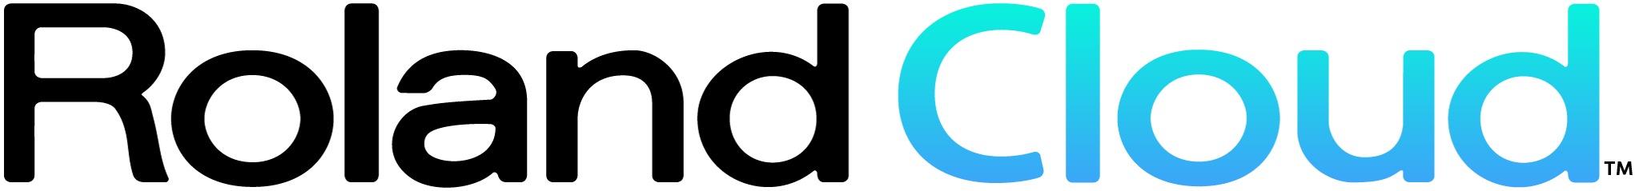
Press Release

Roland Virtual Sonics - 1118 1st Street, Suite 301, Snohomish, WA 98290
www.rolandcloud.com

FOR IMMEDIATE RELEASE
Press Contact:
Lisa Mungo
lisa@rolandvirtualasonics.com

Roland Cloud Announces Play 2-4 Life Holiday Promo

Seattle, WA, December 10, 2018 - Roland Cloud is celebrating the holidays with a special promotion!

Purchase a one-year subscription to Roland Cloud for $199. Enjoy our suite of synths and drum machines like the TR-808 and the newly released JX-3P. Plus, access new instruments as soon as they become available. The best part is, even if you don’t renew, keep using TWO instruments* for as long as they’re available in the catalog. From the Jupiter-8 to the Juno-106, and many others—the choice is yours and you have a year to decide!

With a Roland Cloud subscription, users receive:

- Unlimited access to all instruments in Roland Cloud including the 808, 909, Juno 106, Jupiter-8, and many more
- Frequent new instrument releases like the JX-3P and others
- Continual product updates and fixes

As part of Team Roland Cloud, users receive:

- Membership to a worldwide community of music makers and producers
- Opportunities to share your tracks on Roland Cloud’s social platforms
- Events, contests, and special offers
- Informative, inspiring content like user stories, artist spotlights, articles, playlists and more

Why wait?

*If you do not renew your Roland Cloud subscription, you may choose two instruments that will remain available to you. This includes all updates and upgrades for these instruments for as long as they remain active in Roland Cloud.

Details & Disclaimers

This is a limited time offer (ends December 31st, 2018) for an annual subscription. It requires twelve months of paid continuous use or an annual paid subscription.

This is NOT a permanent license to a title currently available in Roland Cloud's catalog. This is continuous play access to selected instruments. All policies, mechanisms, updates, login, and maintenance requirements stay in effect. Roland Cloud reserves the right to review its catalog selections at any time and does not guarantee your selected titles will remain active in perpetuity.

Promotion Terms & Conditions
- For your selected entitlement use rights, you must maintain an active membership even if you do not renew your Roland Cloud subscription.
- By maintaining membership, you have access to all updates and enhancements for your selected entitlements.
- By maintaining your membership, you gain access to all value-added materials, such as tutorials, events, special offers, and all Team Roland Cloud content.
- You will maintain access to the selected entitlements only for as long as Roland Cloud continues to offer and support that entitlement.
- Roland Cloud reserves the right to periodically assess its catalog selections.
- Your selected entitlement use rights are not transferable, descendible, or inheritable.
- Condition: This offer requires payment for twelve months of subscription, without a free trial period.
- Payment for this offer must be processed for the entitlements to be activated.
- Refunds: If the subscriber cancels within 14 days, they will receive a full refund and access to the selected entitlements will be revoked.
- By participating in this promotion you agree to all Roland Cloud's Legal Policies including: 2018 Holiday Promotion Policy, Privacy Policy, End User License Agreement and Terms of Use

More Information

Visit: https://www.rolandcloud.com/Promo-Details

Photo file: Keep24Life_banner_v2-6.jpg
Photo caption: Roland Cloud is celebrating the holidays with a special promotion: purchase a one-year subscription to Roland Cloud for $199

About Roland Virtual Sonics

Roland Virtual Sonics LLC. represents the joint venture between Roland Corporation and Seattle based Virtual Sonics. Roland Cloud represents a cloud-based suite of high-fidelity instruments, connected services and software for modern music creators and producers. Roland Cloud revolutionizes the current musical ecosystem by leveraging the cloud to connect musical artists to their sounds, their workflow and most-importantly, each other.

Flowing from Roland Cloud are a myriad of new, high-fidelity virtual instruments. Roland Cloud delivers innovation on all fronts, from the revolutionary and cutting-edge way digital instruments are captured to the way they are delivered to popular digital workstations. As an ecosystem, Roland Cloud's community of music and media creators can expect the ability to express their creative aspirations in intuitive ways never before imagined.

