

FOR RELEASE: IMMEDIATE

Press Contact: Company Contact:
Robert Clyne Rob Read
President Marketing Communications Mgr.
Clyne Media, Inc. Roland Professional A/V
(615) 662-1616 (323) 215-2122
robert@clynemedia.com Rob.read@roland.com

Roland Professional A/V Appoints HWPco to Represent Southeast U.S.

Los Angeles, CA, July 24, 2015 — Roland’s Professional A/V Division is pleased to announce the appointment of HWPco as the new manufacturer’s representative firm for their professional audio and video product lines in Tennessee, Alabama, Georgia and the Carolinas.

HWPco is an award-winning firm experienced in serving the needs of resellers, systems integrators, contractors, architects, engineers, designers and consultants in the Southeastern U.S. HWPco is headquartered outside of Atlanta, GA.

“HWP Company is a reputable and proven Pro A/V sales firm that shares Roland’s passion for sales and customer support,” said Christian Delfino, Vice President of Sales and Marketing for Roland Professional A/V division, commenting on the announcement. “They are a very strong team of dynamic industry professionals, and we are confident that their experience with audio and video technology in systems integration and live event production is ideally suited to helping us continue to grow our business in the territory.”

HWPco principals Trey Gunter and Marcus Myers are excited to be representing Roland’s professional AV line at a time when great new products like the Roland M-5000 live mixing console and Roland V-1200HD switcher are new to the market. Gunter, Director of Sales, says, “We are impressed with their top-notch products, combined with great support and service, which will no doubt lead to success.”

About HWPco
HWP Company was founded in 1970 as a manufacturer’s representative in the Southeast U.S. They represent multiple manufacturers across a myriad of disciplines within the categories of Audio, Video, Infrastructure and Security. Their mission is to bring high-quality products and solutions, coupled with technical expertise, to industry partners and customers. To provide the highest level of support in the marketplace, HWPco is structured into three separate divisions: AVL Systems, AVL Retail and Security. HWPco is headquartered in Flowery Branch, GA.

---------
Photo file: HWPco.JPG
Photo caption: The team at HWPco, the recently-appointed manufacturer’s representative firm for Roland Professional A/V division’s product lines in Tennessee, Alabama, Georgia and the Carolinas. © 2015.

About Roland Professional A/V
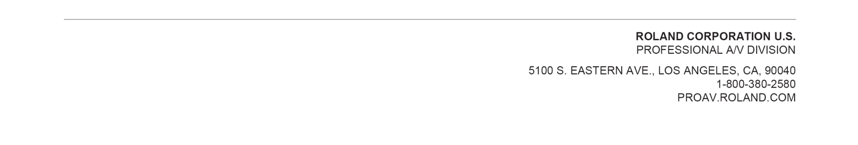
Roland’s professional A/V division is dedicated to providing solutions in support of audio and video professionals demanding excellence in both performance and functionality. Through the development and support of video and audio products, we endeavor to improve workflow and maximize creative possibilities in a variety of markets including Broadcast, Education, Legal, Live Production, Sports, Theater, Theme Park, Videography, Visual Performance, Worship. Roland is headquartered in Los Angeles, California. For more information: http://proav.roland.com.

