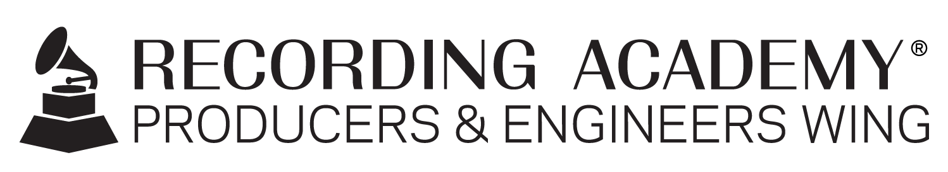

Recording Academy® Producers & Engineers Wing® TO HOST "SONGS THAT CHANGED MY LIFE" INDUSTRY PANEL AT Audio Engineering Society's NEW YORK 2023 CONVENTION

LEADING PRODUCERS AND ENGINEERS SHARE THEIR THOUGHTS ON SONGS THAT WERE EITHER CAREER MILESTONES OR INSPIRATIONAL TOUCHSTONES IN THEIR LIVES

Santa Monica, Calif. (OcT. 23, 2023) — The Recording Academy® Producers & Engineers Wing® will host a featured panel discussion event, "Songs That Changed My Life," on Fri, Oct. 27, 2023, at 11:30 a.m. EDT during the Audio Engineering Society's New York 2023 Convention at the Jacob Javits Center in room 1E10. Special guests will include audio luminaries Bob Clearmountain, Jimmy Douglass, Ann Mincieli, Cheryl Pawelski, and Andrew Scheps, along with Maureen Droney, Vice President of the Recording Academy Producers & Engineers Wing, who will serve as moderator. Panelists will offer an in-depth analysis of key songs and recordings that have made a transformative, and indelible, impact on the way that they approach their own projects and careers.

Session Description:
"Some songs are hits, some we just love, and some have changed our lives. Our panelists break down the DNA of their favorite tracks and explain what moved them, what grabbed them, and why these songs left a life-long impression. Back by popular demand, this presentation is guaranteed to make you feel good about being in the recording business."

"We are excited to bring back this popular event to the AES Convention with a new lineup of producers and engineers to share their own unique stories," said Droney. "With so many innovative sounds and styles marking our evolution as industry creatives, we find it important to share these origin stories and moments of influence that impact what we hear to this day."

The Producers & Engineers Wing, along with Iron Mountain Entertainment Services (IMES), will also host a cocktail reception honoring Women In The Mix® & Friends at their booth (#632) on Wed, Oct. 25, at 3:30 p.m. EDT, featuring special industry guests who will each host half-hour sessions throughout the show.

about the recording academy
The Recording Academy represents the voices of performers, songwriters, producers, engineers, and all music professionals. Dedicated to ensuring the recording arts remain a thriving part of our shared cultural heritage, the Academy honors music's history while investing in its future through the GRAMMY Museum®, advocates on behalf of music creators, supports music people in times of need through MusiCares®, and celebrates artistic excellence through the GRAMMY Awards® — music's only peer-recognized accolade and highest achievement. As the world's leading society of music professionals, we work year-round to foster a more inspiring world for creators.

For more information about the Recording Academy and its Producers & Engineers Wing, please visit grammy.com and recordingacademy.com or @ProdEngWing on Instagram. For breaking news and exclusive content, follow @RecordingAcad on Twitter, "like" Recording Academy on Facebook, and join the Recording Academy's social communities on Instagram, YouTube, TikTok, and LinkedIn. For media assets, please visit recordingacademy.com/press-room/press-kits.

# # #

contacts

Chrissy Dudash / Britta Purcell
Recording Academy
chrissy.dudash@recordingacademy.com / britta.purcell@recordingacademy.com

Robert Clyne
Clyne Media, Inc.
T. 615.662.1616
robert@clynemedia.com

