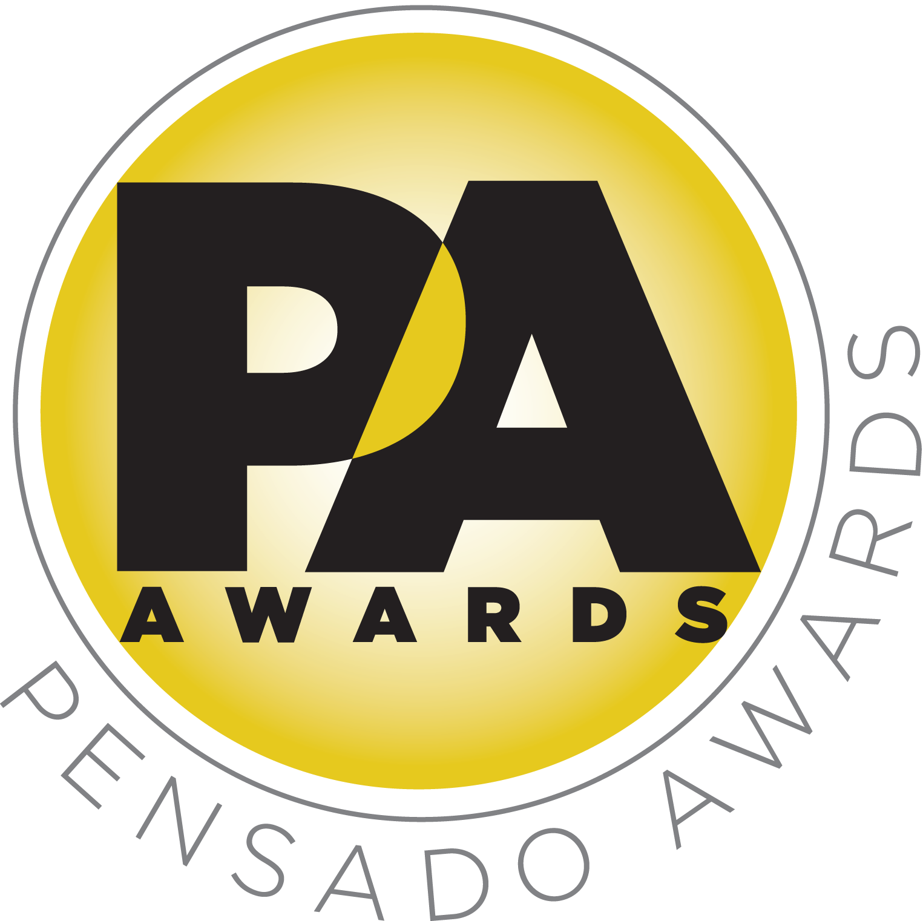

Legendary Producer/Engineer/Mixer Chris Lord-Alge to Be Honored with Pensado Giant Award

— Chris Lord-Alge to receive the Pensado Giant Award, which acknowledges an industry leader for their contributions and achievements in the field of record-making —

LOS ANGELES, CA, August 5, 2016 — The third annual Pensado Awards (taking place on Saturday, August 20, 2016, at Sony Pictures Studios, 10202 W. Washington Blvd., Culver City, CA 90232), dubbed by insiders as the must-attend audio event of the year, recently announced its nominees, but one category already has a winner: the Pensado Giant Award this year will be presented to legendary producer, engineer and mixer Chris Lord-Alge (Pink, Foo Fighters, Avril Lavigne, Green Day). This award acknowledges an industry leader for their contributions and achievements in the field of record-making. Past recipients include famed engineer/producers Bruce Swedien and Al Schmitt, who received this award in 2015 and 2014, respectively.

Chris Lord-Alge (CLA) is a five-time GRAMMY®-winning mixing engineer with a long career including work with some of the biggest and most diverse names in music: from Sugarhill Gang to Sugarland, from Michael Bublé to Green Day, from Tina Turner to Bruce Springsteen, from Muse to Rise Against, to Steven Tyler and Stevie Nicks and many more. He is also a musician, a producer and the creator of essential modeled plug-ins and software for the next generation of audio professionals. With a love for music and a determination that is unstoppable, Lord-Alge has rightly earned his status as one of the today's top mixing, engineering and producing minds.

CLA has been a guest on Pensado’s Place, a co-host at previous Pensado Awards ceremonies, and a collaborator with Penwick Media (the producers of Pensado's Place and other industry-leading audio-related media) on other projects. CLA returns this year as co-hosts, alongside singer-songwriter/actress/fashion designer Taryn Manning (electronic duo Boomkat, 8 Mile, Orange Is the New Black), drummer Samantha Maloney (Hole, Mötley Crüe, Peaches), recording/mix engineer MixedByAli (Kendrick Lamar, Dr. Dre, Robin Thicke) and mastering engineer Gavin Lurssen (Tom Waits, Sheryl Crow, T-Bone Burnett). The musical theme of the evening will be “Celebrate the Guitar”; underscoring that theme will be three live performers throughout the ceremony: Phil X (Triumph, Bon Jovi) on electric guitar, Michael “Fish” Herring (Prince, Celine Dion, Christina Aguilera) on acoustic guitar and Ethan Farmer (Aretha Franklin, Janet Jackson, Justin Timberlake) on bass guitar.

Herb Trawick stated, “CLA’s legendary career speaks for itself, but I also consider him part of the Pensado’s Place family and a personal friend. He is a gifted, hard-working individual, and we couldn’t be prouder to honor the man and his career on August 20.”

Created by Herb Trawick and Dave Pensado of Penwick Media, the awards were founded as a means of acknowledging talented music producers, engineers, mixers and their work, serving as a grand opportunity for the best pros, amateurs, brands and press to come together as one community to celebrate the uncelebrated. The awards will be held outdoors under the stars in Calley Park in the middle of the Sony Pictures Studios lot. A VIP reception will be held on the complex’s Main Street area, and an afterparty will take place in the Sony Commissary, which is connected to the park. Tickets for the live ceremony are available for $50.00 here.

###

Photo file: CLA.JPG
Photo caption: Chris Lord-Alge, 2016 Pensado Giant honoree and co-host of the Pensado Awards

About The Pensado Awards
The Pensado Awards are a natural outgrowth of the ethos behind Pensado’s Place. In recent years, developments in music and technology have changed the landscape for producers, songwriters, engineers and musicians, encouraging artists and composers of all types to hone their craft. From the self-taught basement amateur to the seasoned industry producer, all manner of music professionals are discovering new methods of working and novel ways to reach fans. The science and art of music-making are in a rapid state of flux, with exciting opportunities awaiting among the talented figures in and out of the spotlight – the people who are currently engineering the next sound that will move the world in the music, film, television and digital realms. Over 100,000 albums and millions of songs are released every year, not to mention the hundreds of thousands of concerts put on worldwide, but the awards often end up in the hands of a lucky select group. So the brilliance and hard work of all those producers, songwriters, DJ’s, engineers, mixers, live wizards and behind-the-scenes technicians in audio often go unnoticed. The Pensado Awards, founded as a means of acknowledging these talented individuals and their work, are a grand opportunity for the best pros, amateurs, brands and press to come together as one community to celebrate the uncelebrated.

About Pensado’s Place
The hour-long weekly web series Pensado’s Place was created over five years ago. Co-hosted by legendary mix engineer Dave Pensado (Beyoncé, Christina Aguilera, Kelly Clarkson, Mariah Carey, Elton John, Michael Jackson and more) and show creator Herb Trawick, Pensado’s Place includes interviews with top music industry artists, engineers, producers, mixers, and record executives, as well as in-depth tutorials in production, engineering and mixing. Pensado’s Place has positioned itself as “the most influential show for audio engineers,” mixers and producers (Forbes Magazine). Pensado’s Place is more than just a show, as it highlights the very best in the industry of music, gaming, sound identity on film, and audio equipment, with a presence in live events. As a leading educational resource, Pensado’s Place is helping build the next generation of audio greats. http://www.pensadosplace.tv/.

CONTACTS:
Pensado Awards Contact:
Shevy Shovlin / Pensado Awards / Business Development Manager / 313-590-0886 / info@pensadoawards.com

PR Contacts:
Robert Clyne / Clyne Media / 615-662-1616 / Robert@clynemedia.com / www.clynemedia.com/
Lisa Roy / Rock & Roy / 310-463-1563 / lisaroyaudio@mac.com

