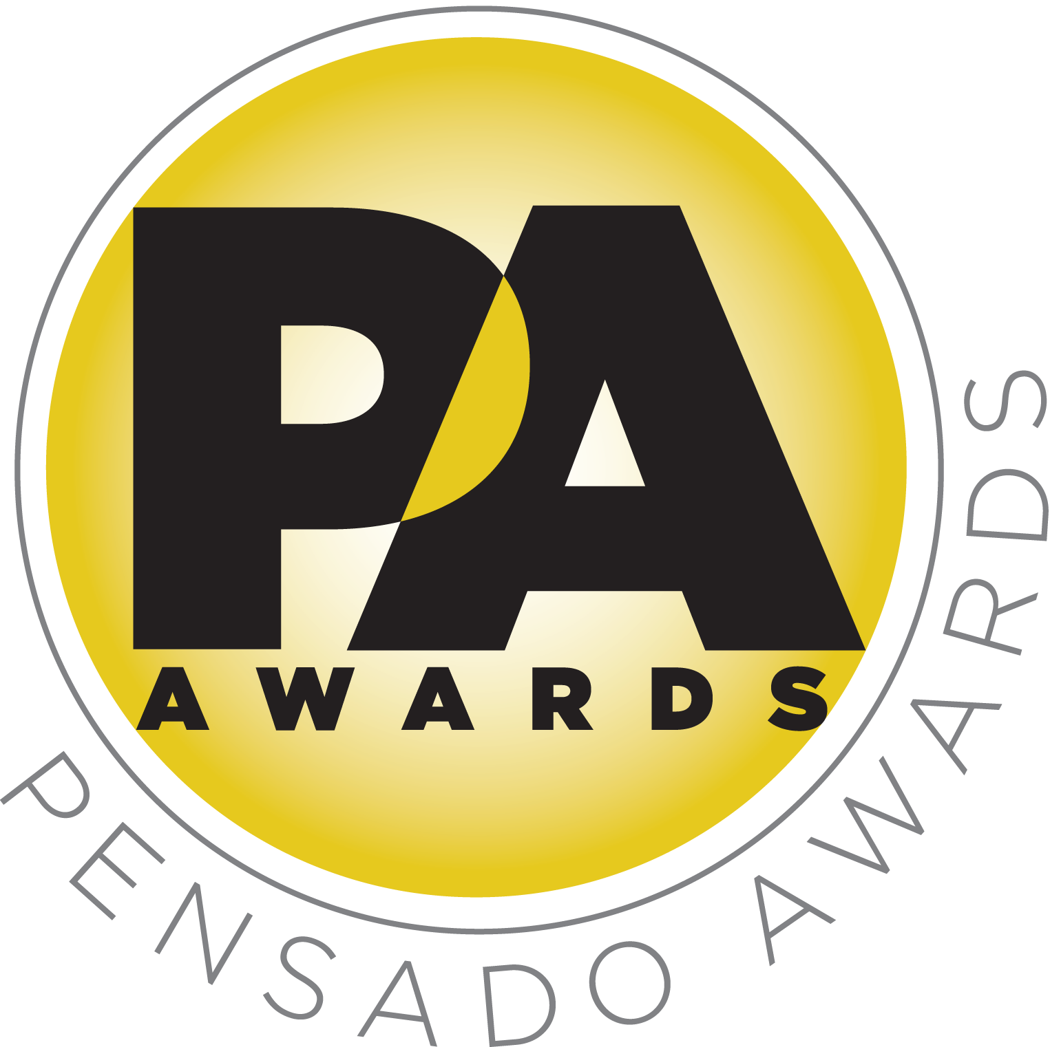

Initial Sponsors Announced for Inaugural Pensado Awards

Leading manufacturers and organizations pledge their support for new awards show

Additional sponsors to be announced shortly

LOS ANGELES, CA, May 12, 2014 — The first round of sponsors has been announced for the inaugural Pensado Awards, an upcoming award show acknowledging today’s emerging brand of music professional and “recognizing the faces behind the sound.” Created by the producers of the acclaimed online video series Pensado’s Place, the Pensado Awards are set to take place June 28, 2014, at the Fairmont Miramar in Santa Monica, California, and broadcast online globally one week later. Co-hosting will be producer-engineers Chris Lord-Alge (Muse, Pink, Foo Fighters, Avril Lavigne, Green Day, Daughtry, Paramore, Black Eyed Peas), Marcella Araica (Britney Spears, Madonna, Pink, Duran Duran, Keri Hilson) and Young Guru (Jay Z, Beyonce, Mariah Carey), with additional co-hosts to be announced soon.

The list of title sponsors comprises some of the most prominent names in professional audio, M.I. and audio education, including Audio-Technica, Avid, The Blackbird Academy, Recording Connection, Slate Media Technology and Vintage King. Supporting sponsors include Barefoot Sound, Ideaplex, Indaba Music, iZotope, Morris Light and Sound and Studio 202. Additional sponsors are being added at a rapid rate, and a complete list will be announced soon.

Herb Trawick, the Co-host/Executive Producer and Creator of Pensado’s Place, as well as Manager and Advisor to Co-host Dave Pensado, stated, “We are pleased to have our initial round of sponsors in place. They are all leaders in their fields, and we are honored that they believe in our dream.”

Dave Pensado (Co-host of Pensado’s Place, GRAMMY®-winning mix engineer, Teacher) echoed Trawick’s sentiments: “It is encouraging that so many industry icons that we respect highly have taken a vested interest in the Pensado Awards. We look forward to celebrating with them at the ceremony and beyond!”

In recent years, developments in music and technology have changed the landscape for producers, songwriters, engineers and musicians, encouraging artists and composers of all types to hone their craft. The Pensado Awards acknowledges these talented individuals and their work, with unique categories including OMG! Mix of the Year; Game Changer Producers Award; Songwriters Break Thru Award; Unique Project Studio (Global); Break Thru Mixer Award; Best Non-English Song (Global); Best Tracking Engineer; Outstanding Achievement in Sound for Film, Television & Gaming; Pensado Giant Award (industry legend); Master of Mastering; Live/FOH Award; AIR Award (Best Assistant, Intern or Runner); Outstanding Brand; Spin Doctor DJ Award; Dave Pensado Educators Award; and Herb Trawick Visionary Award.

About Pensado’s Place
The hour-long weekly web series Pensado’s Place was created nearly four years ago. Co-hosted by legendary mix engineer Dave Pensado (Beyoncé, Christina Aguilera, Kelly Clarkson, Mariah Carey, Elton John, Michael Jackson and more) and show creator Herb Trawick, the show includes interviews with top music industry artists, engineers, producers, mixers, and record executives, as well as in-depth tutorials in production, engineering and mixing. Pensado’s Place has positioned itself as “the most influential show for audio engineers,” mixers and producers (Forbes Magazine) in just three years. Pensado’s Place is more than just a show, as it highlights the very best in the industry of music, gaming, sound identity on film, and audio equipment, with a presence in live events. As a leading educational resource, Pensado’s Place is helping build the next generation of audio greats.

Opportunities are still available to join the over 100 leading music makers and manufacturers, representatives from 75 countries and over 100 schools who are already active supporters of and participants in the inaugural Pensado Awards. Three sponsorship packages are available. To support the Awards, please visit http://pensadoawards.com/sponsorship_info.html.

# # #

CONTACTS:

Pensado Awards Contact:
Shevy Shovlin / Pensado Awards / Chief Marketing Partner, Advertising and Promotions / 313-590-0886 / info@pensadoawards.com

PR Contacts:
Robert Clyne / Clyne Media / 615-662-1616 / Robert@clynemedia.com / www.clynemedia.com/
Lisa Roy / Rock & Roy / 310-463-1563 / lisaroyaudio@mac.com

