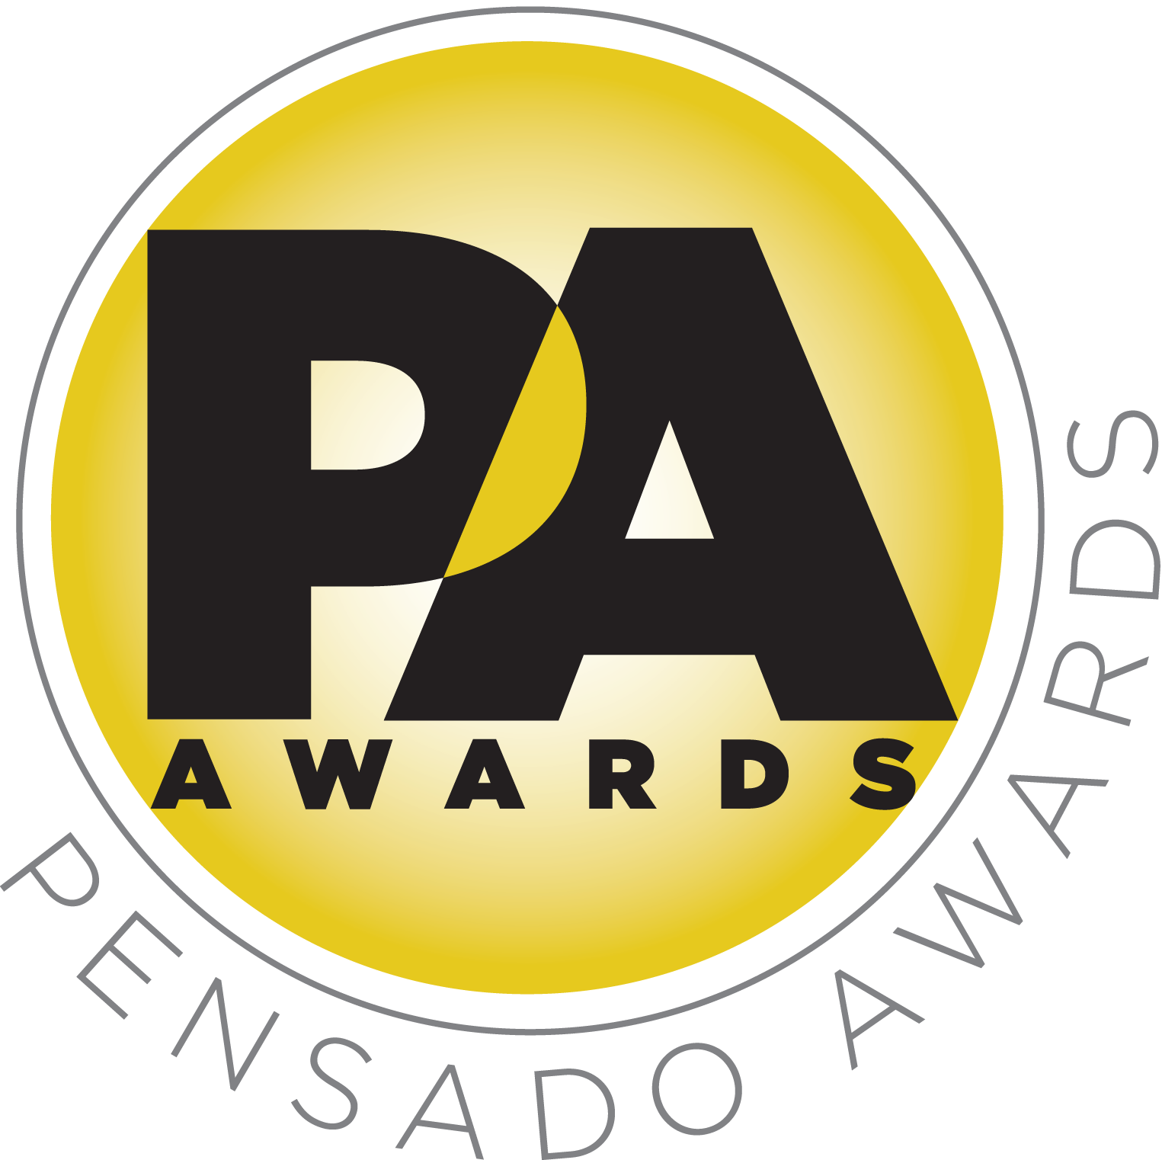

Pensado Awards Announces Nominees

Dozens of talented individuals fill 16 categories, from up-and-comers to established names

LOS ANGELES, CA, June 20, 2014 — The Pensado Awards, an upcoming award show acknowledging today’s emerging brand of music professional and “recognizing the faces behind the sound,” has announced its nominees. Created by the producers of the acclaimed online video series Pensado’s Place, the Pensado Awards are set to take place June 28, 2014, at the Fairmont Miramar in Santa Monica, California, and broadcast online globally one week later. Co-hosting will be singer-songwriter Lisa Loeb along with producer-engineers Chris Lord-Alge (Muse, Pink, Foo Fighters, Avril Lavigne, Green Day, Daughtry, Paramore, Black Eyed Peas), Marcella Araica (Britney Spears, Madonna, Pink, Duran Duran, Keri Hilson) and Young Guru (Jay Z, Beyoncé, Mariah Carey).

In recent years, developments in music and technology have changed the landscape for producers, songwriters, engineers and musicians, encouraging artists and composers of all types to hone their craft. The Pensado Awards acknowledges these talented individuals and their work, with awards in 16 categories. A few key highlights include Game Changer Producer of the Year (nominees: Ariel Rechtshaid, Mike Will Made It, Dann Huff, Alex da Kid, Avicii); Break Thru Songwriter (Joel Little/Lorde, “Royals”; Kendrick Lamar, “Swimming Pools”; Pharrell Williams, “Happy”; Dan Reynolds, “Radioactive”; Josh Kear, “Goodbye Town”); Spin Doctor DJ Award (DJ Ali, DJ Snake, MAKJ, Steve Angello, TJR); and Outstanding Achievement in Sound for Film, Television and Gaming (Leon Pendarvis, Saturday Night Live; Alan Meyerson, Call of Duty/The Amazing Spider-Man 2; Robert Duncan, Castle; Will Files, Star Trek Into Darkness; Nick Wiswell, Forza 5). Other categories include OMG! Mix of the Year; Unique Project Studio; Break Thru Mixer; Best Non-English Song; Tracking Engineer; Pensado Giant Award; Master of Mastering; Live/FOH; AIR Award (Best Assistant, Intern or Runner); Outstanding Brand; Dave Pensado Educator Award; and Herb Trawick Visionary Award. A full list of nominees can be found at http://pensadoawards.com/award_categories.html.

Herb Trawick, the Co-host/Executive Producer and Creator of Pensado’s Place, as well as Manager and Advisor to Co-host Dave Pensado, stated, “We are getting very close to the awards show date, and we are pleased to unveil our nominees. They represent a diverse cross-section of our industry, from studio employees to viral stars to established names. Each is a vital piece of the music industry machine, and we are excited to honor each one of them.”

Dave Pensado (Co-host of Pensado’s Place, GRAMMY®-winning mix engineer, Teacher) added: “It is a real pleasure to see these names gathered as one list, and we are very eager to start handing out our megaphone trophies on June 28.”

About Pensado’s Place
The hour-long weekly web series Pensado’s Place was created nearly four years ago. Co-hosted by legendary mix engineer Dave Pensado (Beyoncé, Christina Aguilera, Kelly Clarkson, Mariah Carey, Elton John, Michael Jackson and more) and show creator Herb Trawick, Pensado’s Place includes interviews with top music industry artists, engineers, producers, mixers, and record executives, as well as in-depth tutorials in production, engineering and mixing. Pensado’s Place has positioned itself as “the most influential show for audio engineers,” mixers and producers (Forbes Magazine) in just three years. Pensado’s Place is more than just a show, as it highlights the very best in the industry of music, gaming, sound identity on film, and audio equipment, with a presence in live events. As a leading educational resource, Pensado’s Place is helping build the next generation of audio greats.

Opportunities are still available to join the over 100 leading music makers and manufacturers, representatives from 75 countries and over 100 schools who are already active supporters of and participants in the inaugural Pensado Awards. Three sponsorship packages are available. To support the Awards, please visit http://pensadoawards.com/sponsorship_info.html.

# # #

Photo File: PensadoAwards_Logo.JPG

CONTACTS:

Pensado Awards Contact:
Shevy Shovlin / Pensado Awards / Chief Marketing Partner, Advertising and Promotions / 313-590-0886 / info@pensadoawards.com

PR Contacts:
Robert Clyne / Clyne Media / 615-662-1616 / Robert@clynemedia.com / www.clynemedia.com/
Lisa Roy / Rock & Roy / 310-463-1563 / lisaroyaudio@mac.com

