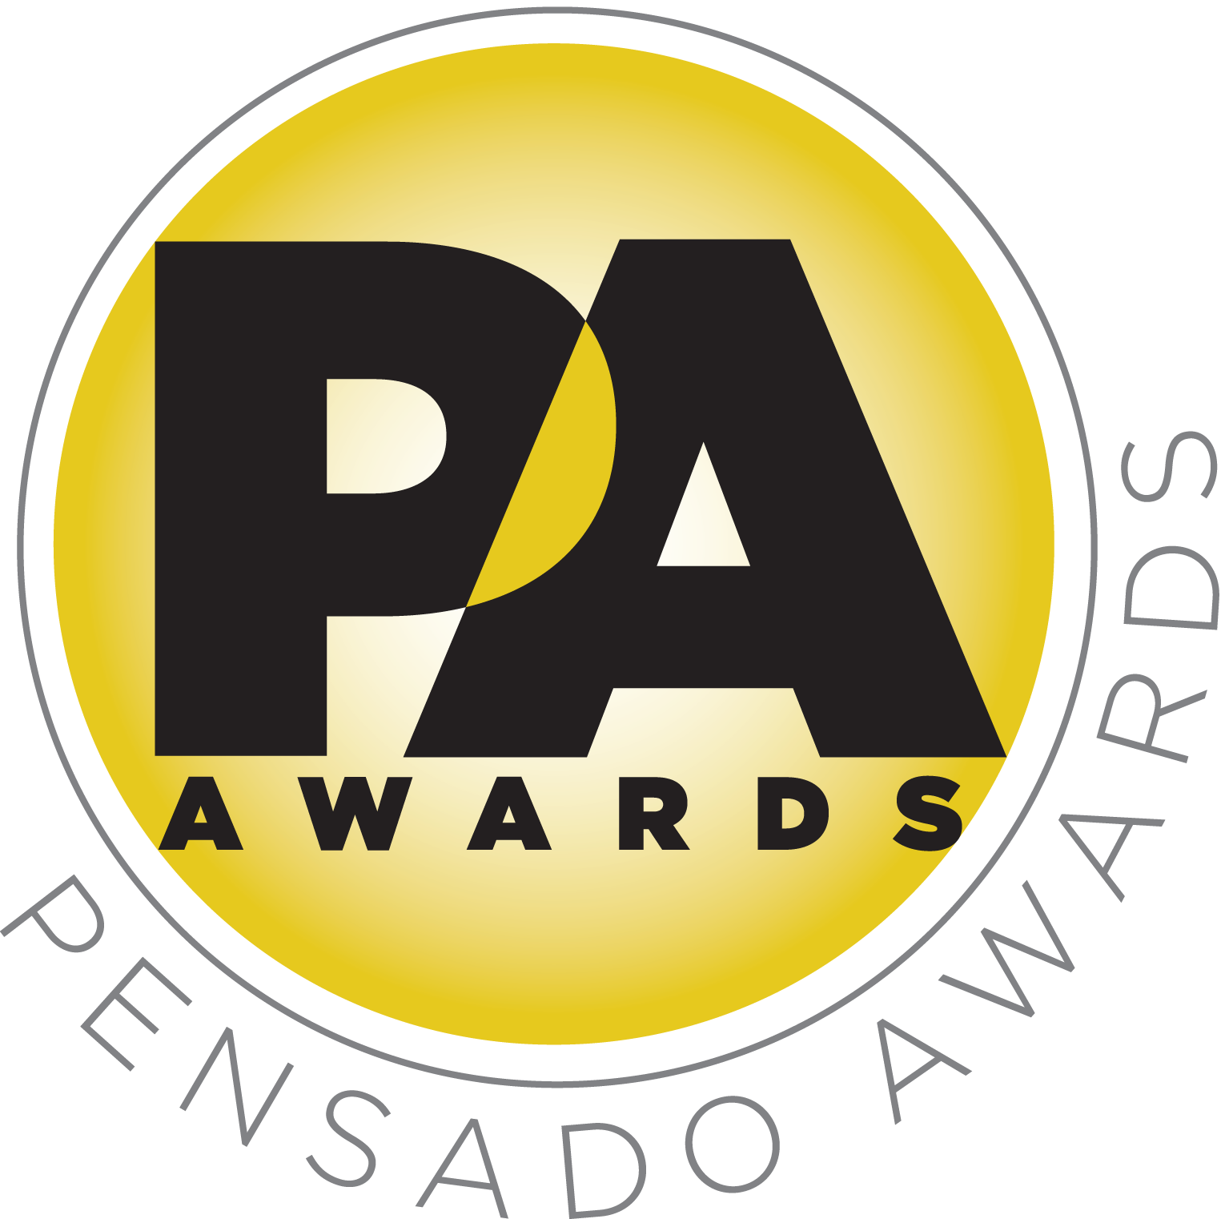

Chris Lord-Alge, Marcella Araica and Young Guru to Co-Host Pensado Awards

Acclaimed producer-engineers are the first co-hosts announced for inaugural awards show

Leading audio manufacturer sponsors to be announced shortly

LOS ANGELES, CA, May 7, 2014 — Three co-hosts have been announced for the inaugural Pensado Awards, an award show acknowledging today’s emerging brand of music professional and “recognizing the faces behind the sound.” Created by the producers of the acclaimed online video series Pensado’s Place, the Pensado Awards are set to take place June 28, 2014, at the Fairmont Miramar in Santa Monica, California, and broadcast online globally one week later. Co-hosting will be producer-engineers Chris Lord-Alge (Muse, Pink, Foo Fighters, Avril Lavigne, Green Day, Daughtry, Paramore, Black Eyed Peas), Marcella Araica (Britney Spears, Madonna, Pink, Duran Duran, Keri Hilson) and Young Guru (Jay Z, Beyoncé, Mariah Carey), with additional co-hosts to be announced soon.

Herb Trawick, the Co-host/Executive Producer and Creator of Pensado’s Place, as well as Manager and Advisor to Co-host Dave Pensado, stated, “The Pensado Awards have grown from a simple idea to a full-blown production. Our dream is really coming to fruition! We are very excited to have Chris, Marcella and Young Guru on board as co-hosts, with more names to come in the weeks ahead.”

Dave Pensado (Co-host of Pensado’s Place, GRAMMY®-winning mix engineer, Teacher) stated, “We have had so many talented personalities featured on Pensado’s Place, and we are lucky to have these three as our newly-announced co-hosts. Each of them brings a unique perspective to the art of music-making, and together they represent the best of what the recording industry can offer the world.”

Pensado Award categories include OMG! Mix of the Year; Game Changer Producers Award; Songwriters Break Thru Award; Unique Project Studio (Global); Amateurs Best/Mix Recording (Global); Best Non-English Song (Global); Best Tracking Engineer; Outstanding Achievement in Sound for Film, Television & Gaming; Giant Award (industry legend); Master of Mastering; Live/FOH Award; AIR Award (Best Assistant, Intern or Runner); Outstanding Brand; Spin Doctor DJ Award; Dave Pensado Educators Award; and Herb Trawick Visionary Award.

Lord-Alge stated, “Dave Pensado and Herb Trawick are like The Tonight Show of the audio world, bringing the men and women behind the board in front of the camera with the Pensado’s Place program. It's an honor to be sharing their audience as part of the Pensado Awards, and my co-hosts and I look forward to participating in this special night.”

The Pensado Awards, announced to the industry mid-April, continues to gain momentum with support from leading industry figures and manufacturers. An extensive list of sponsors will be announced in the coming weeks.

About Chris Lord-Alge:
Chris Lord-Alge is a five-time GRAMMY®-winning engineer with a long career including work with some of the biggest and most diverse names in music: from Sugarhill Gang to Sugarland, from Michael Bublé to Green Day, from Tina Turner to Bruce Springsteen, from Muse to Rise Against and many more. He is also a musician, a producer and the creator of essential modeled plug-ins and software for the next generation of audio professionals. With a love for music and a determination that is unstoppable, Lord-Alge has rightly earned his status as one of the today’s top engineering and producing minds.

About Marcella Araica:
Marcella “Ms. Lago” Araica is one of the most noted females consistently working in the male-dominated field of Music Engineering. Immediately upon graduating from a top recording program, she earned a prestigious internship at The Hit Factory in Miami, Florida. Seeing her dedication and superior skills, super-producer Timbaland placed her in prime position in the studio with Missy Elliott, and Araica has never looked back. Just embarking upon her early 30’s, Marcella has recorded and/or mixed songs for such artists as Beyoncé, Britney Spears, Madonna, Nelly Furtado, Usher, Joe Jonas and Missy Elliot, and collaborated with producers Timbaland, Danja and Polow Da Don. Credited for mixing over one hundred chart-topping tunes, her numerous prestigious accomplishments and coveted partnerships have set an astonishingly high bar in the music industry. She has been honored with two ASCAP (American Society of Composer, Authors, and Publishers) awards for her work on Keri Hilson’s single “Knock You Down,” and P!nk’s song “Sober,” as well as an ASCAP Rhythm and Soul Award.

About Young Guru:
Gimel “Young Guru” Keaton has resoundingly earned his reputation as one of the most renowned recording and mixing engineers in music today and a respected ambassador for hip-hop music and culture. Heralded most for sonically shaping some of Hip-Hop’s brightest talents and revered as “The Sound of New York,” Young Guru has established himself as consistently in-demand: mixing 10 of Jay-Z's albums, and DJing on Jay-Z’s legendary Carnegie Hall and Barclays Center shows. On several recordings, Jay himself offers verbal acknowledgements of Guru’s importance, an immensely respectful testament to Guru’s exceptional skills behind the boards. Other credits include work with Beyoncé, Rihanna, Ludacris, Ghostface Killah, Freeway, Cam'ron, Redman & Method Man, Mariah Carey, Pete Rock, Fabolous, Talib Kweli, Bone Thugs-N-Harmony, T.I. and others. He has also served as an A&R for Roc-A-Fella Records and Def Jam Recordings. Young Guru is now also elevating the discourse of audio engineering philosophy, science and technology, emerging onto the lecture circuit as one of the subject’s most distinguished and dignified speakers.

About Pensado’s Place
The hour-long weekly web series Pensado’s Place was created nearly four years ago. Co-hosted by legendary mix engineer Dave Pensado (Beyoncé, Christina Aguilera, Kelly Clarkson, Mariah Carey, Elton John, Michael Jackson and more) and show creator Herb Trawick, the show includes interviews with top music industry artists, engineers, producers, mixers, and record executives, as well as in-depth tutorials in production, engineering and mixing. Pensado’s Place has positioned itself as “the most influential show for audio engineers,” mixers and producers (Forbes Magazine) in just three years. Pensado’s Place is more than just a show, as it highlights the very best in the industry of music, gaming, sound identity on film, and audio equipment, with a presence in live events. As a leading educational resource, Pensado’s Place is helping build the next generation of audio greats.

Opportunities are still available to join the over 100 leading music makers and manufacturers, representatives from 75 countries and over 100 schools who are already active supporters of and participants in the inaugural Pensado Awards. Three sponsorship packages are available. To support the Awards, please visit http://pensadoawards.com/sponsorship_info.html.

# # #
Photo files: CLA.JPG, MarcellaAraica.JPG, YoungGuru.JPG

CONTACTS:

Pensado Awards Contact:
Shevy Shovlin / Pensado Awards / Chief Marketing Partner, Advertising and Promotions / 313-590-0886 / info@pensadoawards.com

PR Contacts:
Robert Clyne / Clyne Media / 615-662-1616 / Robert@clynemedia.com / www.clynemedia.com/
Lisa Roy / Rock & Roy / 310-463-1563 / lisaroyaudio@mac.com

