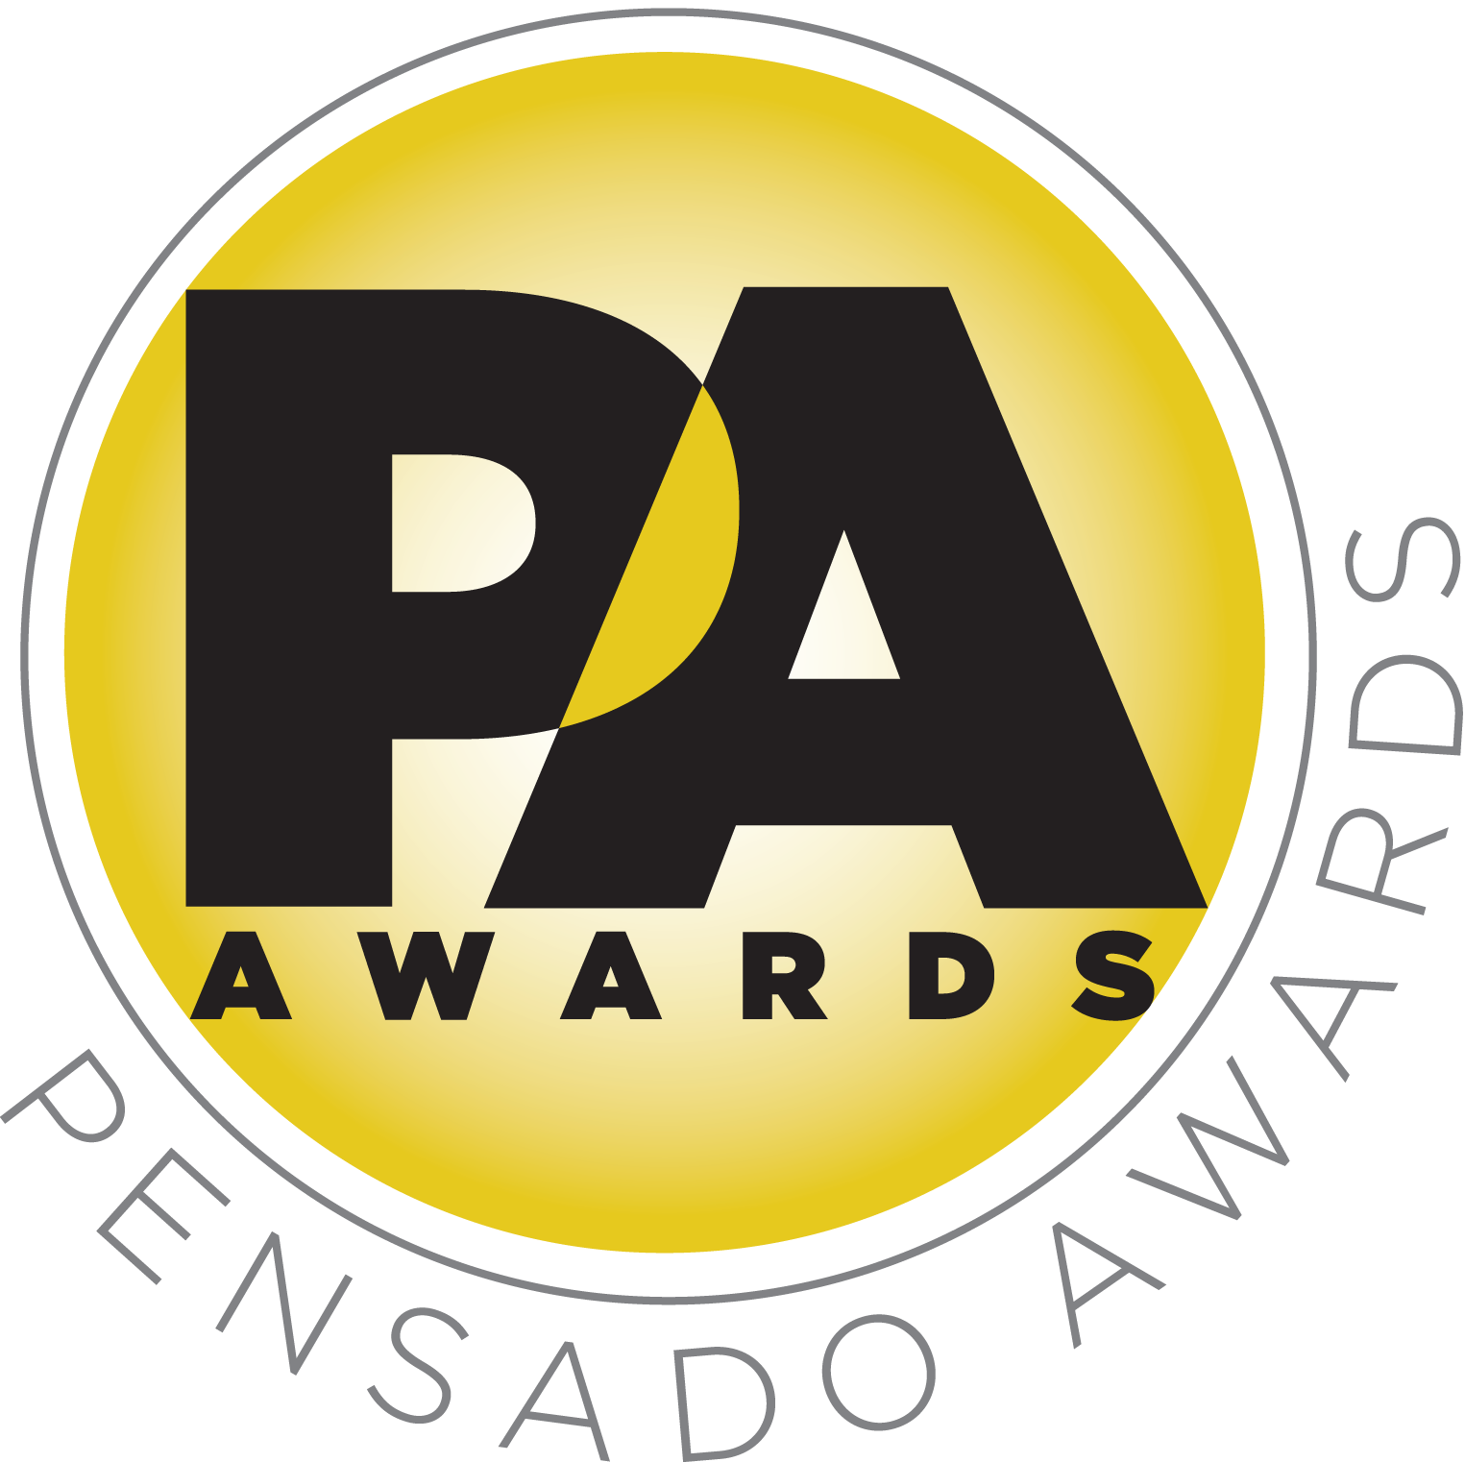

Inaugural Pensado Awards to Honor Today’s New Brand of Music Professional

— Live ceremony on June 28 and global online broadcast will “recognize the faces behind the sound” —

LOS ANGELES, CA, April 17, 2014 — For the past several years, the acclaimed online video series Pensado’s Place has celebrated the evolving landscape of music and technology and given a voice to its leaders and innovators, and now the producers of that program have created the Pensado Awards, a new award show intended to acknowledge today’s emerging brand of music professional and to “recognize the faces behind the sound.” The live show will take place on June 28, 2014, at the Fairmont Miramar in Santa Monica, California, and will be followed one week later by a global online broadcast. Scheduled to co-host are award-winning producer-engineers Chris Lord-Alge (Muse, Pink, Foo Fighters, Avril Lavigne, Green Day, Daughtry, Paramore, Black Eyed Peas), Marcella Araica (Britney Spears, Madonna, Pink, Duran Duran, Keri Hilson) and Young Guru (Jay Z, Beyonce, Mariah Carey), with additional co-hosts to be announced soon.

The Pensado Awards are a natural outgrowth of the ethos behind Pensado’s Place. In recent years, developments in music and technology have changed the landscape for producers, songwriters, engineers and musicians, encouraging artists and composers of all types to hone their craft. From the self-taught basement amateur to the seasoned industry producer, all manner of music professionals are discovering new methods of working and novel ways to reach fans. The science and art of music-making are in a rapid state of flux, with exciting opportunities awaiting among the talented figures in and out of the spotlight – the people who are currently engineering the next sound that will move the world in the music, film, television and digital realms. Over 100,000 albums and millions of songs are released every year, not to mention the hundreds of thousands of concerts put on worldwide, but the awards often end up in the hands of a lucky select group. So the brilliance and hard work of all those producers, songwriters, DJ’s, engineers, mixers, live wizards and behind-the-scenes technicians in audio often go unnoticed – until now! The Pensado Awards, founded as a means of acknowledging these talented individuals and their work, are a grand opportunity for the best pros, amateurs, brands and press to come together as one community to celebrate the uncelebrated.

Herb Trawick, the Co-host/Executive Producer and Creator of Pensado’s Place, as well as Manager and Advisor to Co-host Dave Pensado, stated, “We are very thrilled about the opportunity to put on an awards show that is by the people and for the people. And we are just as excited to have Chris Lord-Alge, Marcella Araica and Young Guru – and other names to be announced soon – on board as our hosts, and all of our Pro Committee artists and sponsor partners. The buzz has been electric, and we are already talking about making this an annual event.”

“As an engineer and mixer myself, I am acutely aware that so many of the most talented people in the industry never get the recognition they deserve,” stated Dave Pensado (Co-host of Pensado’s Place, GRAMMY®-winning mix engineer, Teacher). “We have founded these awards to acknowledge amateurs and professionals for their craft. We hope you join in the celebration, either in person or online.”

Working behind the scenes to make the Pensado Awards a reality are the producers from Pensado’s Place and a group of top industry PR/marketing professionals. Leading the charge are Pensado and Trawick, along with Pensado Awards producer Karen Dunn of KMD Productions (Producer of the TEC Awards at NAMM for 29 years and various other Pro Audio Events). Rounding out the Pensado Awards Team are social media guru Will Thompson, PR professionals Clyne Media and Lisa Roy, Lead Agent Shevy Shovlin and Business Development manager Khaila Stewart.

Pensado Award categories include OMG! Mix of the Year; Game Changer Producers Award; Songwriters Break Thru Award; Unique Project Studio (Global); Amateurs Best/Mix Recording (Global); Best Non-English Song (Global); Best Tracking Engineer; Outstanding Achievement in Sound for Film, Television & Gaming; Giant Award (industry legend); Master of Mastering; Live/FOH Award; AIR Award (Best Assistant, Intern or Runner); Outstanding Brand; Spin Doctor DJ Award; Dave Pensado Educators Award; and Herb Trawick Visionary Award.

The Pensado Awards Pro Committee is made up of artists, engineers, producers and industry notables (many of whom have been featured guests on Pensado’s Place), who together will serve as the judging panel for the awards. The committee in currently being assembled and is confirmed to include Andrew Scheps (Lana Del Rey, Red Hot Chili Peppers), Jimmy Douglass (Pharrell, Justin Timberlake), John McBride (Martina McBride, The Blackbird Academy), Manny Marroquin (Bruno Mars, Imagine Dragons), Trina Shoemaker (Queens of the Stone Age, Sheryl Crow, Emmylou Harris), Young Guru (Jay-Z, Alicia Keys, Kanye West), Zoe Thrall (Studio Director at the Studio at the Palms) and others.

Opportunities are still available to join the over 100 leading music makers and manufacturers, representatives from 75 countries and over 100 schools who are already active supporters of and participants in the inaugural Pensado Awards. Three sponsorship packages are available. To support the Awards, please visit http://pensadoawards.com/sponsorship_info.html.
# # #
Photo file: Trawick_Pensado.JPG
Photo caption: Pictured L-R: Herb Trawick (Co-host/Executive Producer and Creator of Pensado’s Place) and Dave Pensado (Co-host of Pensado’s Place, GRAMMY®-winning mix engineer, Teacher). Photo by Zan Nakari (www.zanphotos.com).

About Pensado’s Place
The hour-long weekly web series Pensado’s Place was created nearly four years ago. Co-hosted by legendary mix engineer Dave Pensado (Beyoncé, Christina Aguilera, Kelly Clarkson, Mariah Carey, Elton John, Michael Jackson and more) and show creator Herb Trawick, the show includes interviews with top music industry artists, engineers, producers, mixers, and record executives, as well as in-depth tutorials in production, engineering and mixing. Pensado’s Place has positioned itself as “the most influential show for audio engineers,” mixers and producers (Forbes Magazine) in just three years. Pensado’s Place is more than just a show, as it highlights the very best in the industry of music, gaming, sound identity on film, and audio equipment, with a presence in live events. As a leading educational resource, Pensado’s Place is helping build the next generation of audio greats.

CONTACTS:

Pensado Awards Contact:
Shevy Shovlin / Pensado Awards / Chief Marketing Partner, Advertising and Promotions / 313-590-0886 / info@pensadoawards.com

PR Contacts:
Robert Clyne / Clyne Media / 615-662-1616 / Robert@clynemedia.com / www.clynemedia.com/
Lisa Roy / Rock & Roy / 310-463-1563 / lisaroyaudio@mac.com

