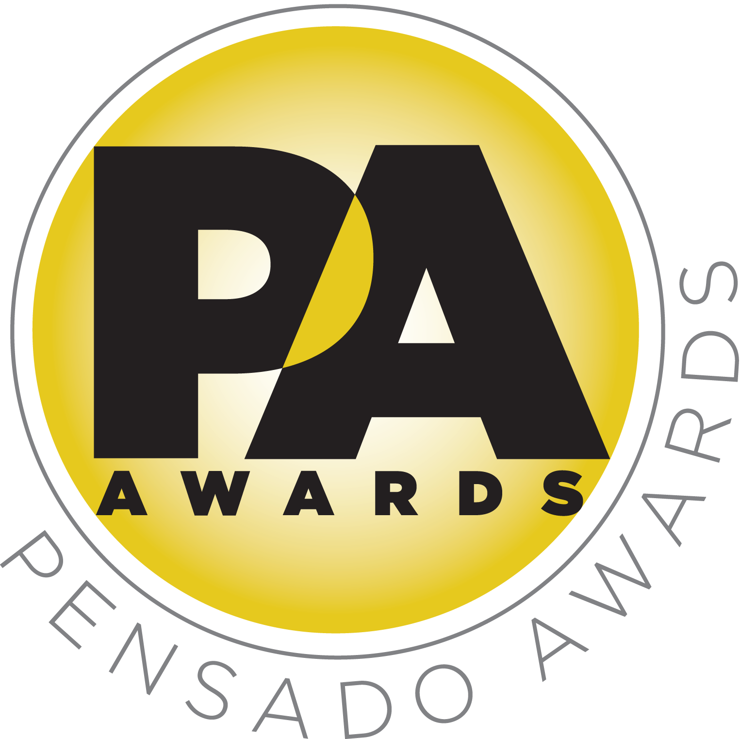

Sponsor Partners Come Out to Support Second Annual Pensado Awards

Awards ceremony took place on Sunday, August 30, 2015, with over 700 top industry professionals and celebrities in attendance

AfterMaster® Audio Labs served as presenting sponsor, along with a roster of title and premium sponsors made up of prominent names in professional audio, M.I. and audio education

LOS ANGELES, CA, September 9, 2015 — The Sony Pictures Studios in Culver City, CA was the place to be on Sunday, August 30, 2015, as the Pensado crew rolled in for the live ceremony of the second annual Pensado Awards, an award show created by the producers of the acclaimed online video series Pensado’s Place. Among the over 700 in attendance, including industry leaders and celebrities, were representatives from the list of sponsors, all of whom pledged their support to Pensado Awards in the weeks leading up to the ceremony.

AfterMaster® Audio Labs served as Presenting Sponsor for the ceremony. Title Sponsors were Audio-Technica, AVID, Blackbird Academy, iZotope, Recording Radio Film Connection (RRF), and Vintage King Audio. Premium Sponsors were Augspurger, Barefoot Sound, Bedrock L.A., Burl Audio, Hal Leonard, McDSP, The Recording Academy® Producers & Engineers Wing, Studio 202, SUBPAC, Ultimate Ears, and 3DEXCITE. Media Sponsors included Music Connection, Urban Buzz, Jam in the Van, SonicScoop and Recording Revolution. An “AfterMaster Lounge” in the Rita Hayworth Dining Room hosted VIP guests and influencers throughout the evening.

Herb Trawick, Co-host/Executive Producer and Creator of Pensado’s Place, as well as the Manager and Advisor to Co-host Dave Pensado, states, “This second annual ceremony was a unanimous success, and we have our sponsors to thank. We have been blessed to have the support of some of the leading brands in the industry. These are manufacturers, vendors and educational institutions with goals very close to our own – namely, furthering the science of sound and the art of recording. We thank them for their support.”

“On behalf of the entire AfterMaster team I can say it was a true honor to be a part of the second annual Pensado Awards,” says Larry Ryckman, Co-Founder and CEO of AfterMaster. “We are big supporters of Herb and Dave and were proud to support the show along with our respective friends and colleagues nominated for awards. We look forward to continuing to support our industry and Pensado Place for many years to come.”

The Pensado Awards are a natural outgrowth of the ethos behind Pensado’s Place. From the self-taught basement amateur to the seasoned industry producer, all manner of music professionals are discovering new methods of working and novel ways to reach fans and these awards are here to honor them. The awards highlight the brilliance and hard work of all those producers, songwriters, DJ’s, engineers, mixers, live wizards and behind-the-scenes technicians in audio that often go unnoticed. The Pensado Awards unites the best pros, amateurs, brands and press to come together as one community to celebrate the uncelebrated. A full list of nominees and winners can be found at http://pensadoawards.com/award_categories_2015.html.

###

Photo file: PensadoAwards15_Sponsors.JPG
Photo caption: Representatives from sponsor partners at the second annual Pensado Awards. Photo by Maury Phillips / WireImage.com. © 2015.

About Pensado’s Place
The hour-long weekly web series Pensado’s Place was created over four years ago. Co-hosted by legendary mix engineer Dave Pensado (Beyoncé, Christina Aguilera, Kelly Clarkson, Mariah Carey, Elton John, Michael Jackson and more) and show creator Herb Trawick, Pensado’s Place includes interviews with top music industry artists, engineers, producers, mixers, and record executives, as well as in-depth tutorials in production, engineering and mixing. Pensado’s Place has positioned itself as “the most influential show for audio engineers,” mixers and producers (Forbes Magazine) in just three years. Pensado’s Place is more than just a show, as it highlights the very best in the industry of music, gaming, sound identity on film, and audio equipment, with a presence in live events. As a leading educational resource, Pensado’s Place is helping build the next generation of audio greats. http://www.pensadosplace.tv/.

CONTACTS:
Pensado Awards Contact:
Shevy Shovlin / Pensado Awards / Business Development Manager / 313-590-0886 / info@pensadoawards.com

PR Contacts:
Robert Clyne / Clyne Media / 615-662-1616 / Robert@clynemedia.com / www.clynemedia.com/
Lisa Roy / Rock & Roy / 310-463-1563 / lisaroyaudio@mac.com

