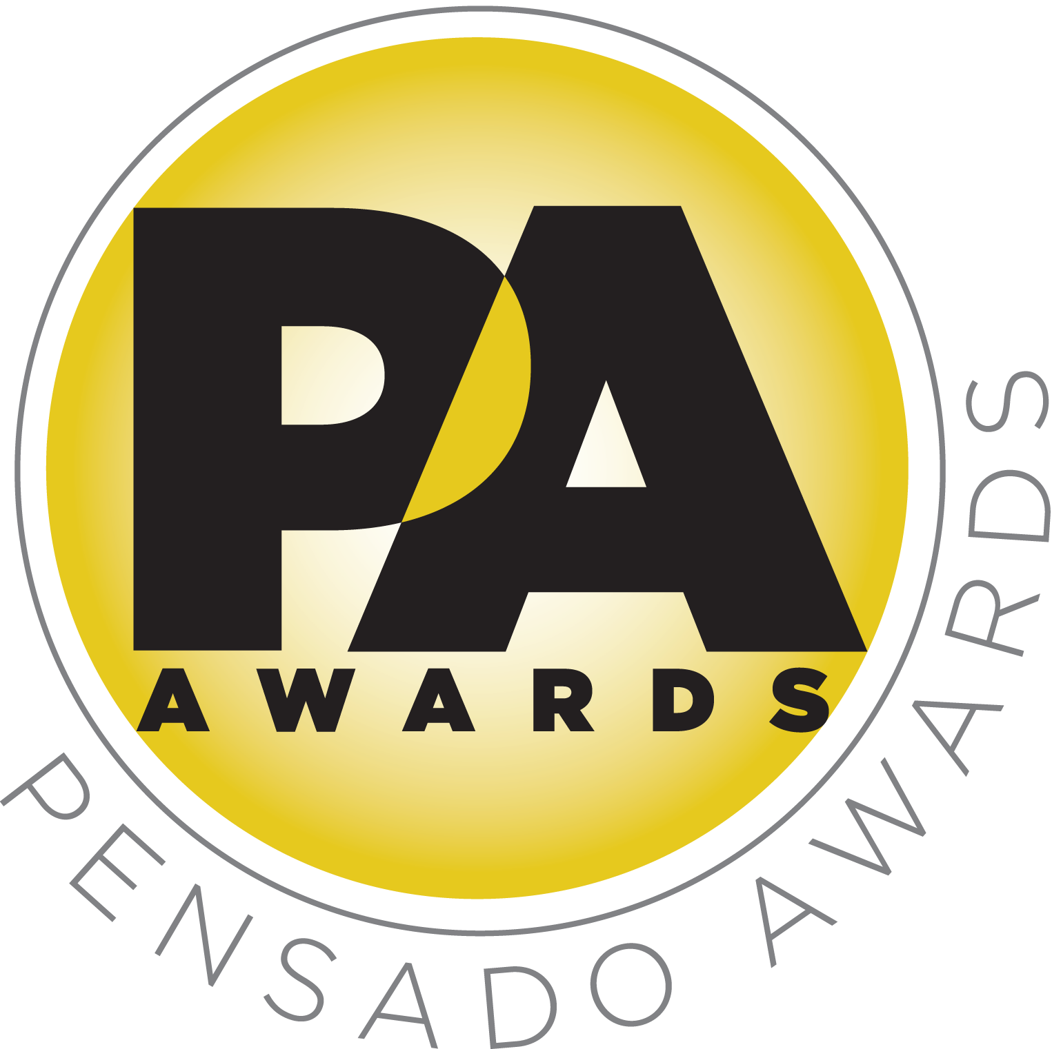

Sponsors Announced for Second Annual Pensado Awards

Awards show, set for Sunday, August 30, 2015, will once again “recognize the faces behind the sound”

LOS ANGELES, CA, August 10, 2015 — The list of sponsors have been announced for the second annual Pensado Awards, an award show created by the producers of the acclaimed online video series Pensado’s Place. This year’s festivities will take place on Sunday, August 30, 2015, at Sony Pictures Studios, 10202 W. Washington Blvd., Culver City, CA 90232. A video production of the ceremony will follow and be posted on the Pensado’s Place YouTube channel. Tickets for the live ceremony are available for $50.00 at http://pensadoawards.com/.

AfterMaster® Audio Labs is serving as presenting sponsor for the upcoming ceremony. Title Sponsors are Audio-Technica, AVID, Blackbird Academy, Hal Leonard, iZotope, Recording Radio Film Connection (RRF), Studio 202 and Vintage King Audio. Premium Sponsors are Augspurger, Barefoot Sound, Bedrock L.A., Burl Audio, SAE Institute, SUBPAC and 3DEXCITE.

This year’s awards ceremony will be held under the stars in Calley Park, which is located in the center of the Sony Pictures Studios lot. The night will kick off with a VIP reception on the complex’s Main Street area Theatre followed by an afterparty at the Sony Commissary, which is connected to Calley Park. An “AfterMaster Lounge” in the Rita Hayworth Dining Room will host VIP guests and influencers throughout the evening.

Herb Trawick, Co-host/Executive Producer and Creator of Pensado’s Place, as well as the Manager and Advisor to Co-host Dave Pensado, states, “We have been blessed to have the support of some of the leading brands in the industry. These are manufacturers, vendors and educational institutions with goals very close to our own – namely, furthering the science of sound and the art of recording. We thank them for their support. We would not be able to hold the Pensado Awards without them.”

The Pensado Awards are a natural outgrowth of the ethos behind Pensado’s Place. From the self-taught basement amateur to the seasoned industry producer, all manner of music professionals are discovering new methods of working and novel ways to reach fans and we are here to honor them. At the awards we highlight the brilliance and hard work of all those producers, songwriters, DJ’s, engineers, mixers, live wizards and behind-the-scenes technicians in audio that often go unnoticed. The Pensado Awards unites the best pros, amateurs, brands and press to come together as one community to celebrate the uncelebrated.

###

About Pensado’s Place
The hour-long weekly web series Pensado’s Place was created nearly four years ago. Co-hosted by legendary mix engineer Dave Pensado (Beyoncé, Christina Aguilera, Kelly Clarkson, Mariah Carey, Elton John, Michael Jackson and more) and show creator Herb Trawick, Pensado’s Place includes interviews with top music industry artists, engineers, producers, mixers, and record executives, as well as in-depth tutorials in production, engineering and mixing. Pensado’s Place has positioned itself as “the most influential show for audio engineers,” mixers and producers (Forbes Magazine) in just three years. Pensado’s Place is more than just a show, as it highlights the very best in the industry of music, gaming, sound identity on film, and audio equipment, with a presence in live events. As a leading educational resource, Pensado’s Place is helping build the next generation of audio greats. http://www.pensadosplace.tv/

Photo File: PensadoAwards_Statuette.JPG

CONTACTS:
Pensado Awards Contact:
Shevy Shovlin / Pensado Awards / Business Development Manager / 313-590-0886 / info@pensadoawards.com

PR Contacts:
Robert Clyne / Clyne Media / 615-662-1616 / Robert@clynemedia.com / www.clynemedia.com/
Lisa Roy / Rock & Roy / 310-463-1563 / lisaroyaudio@mac.com

