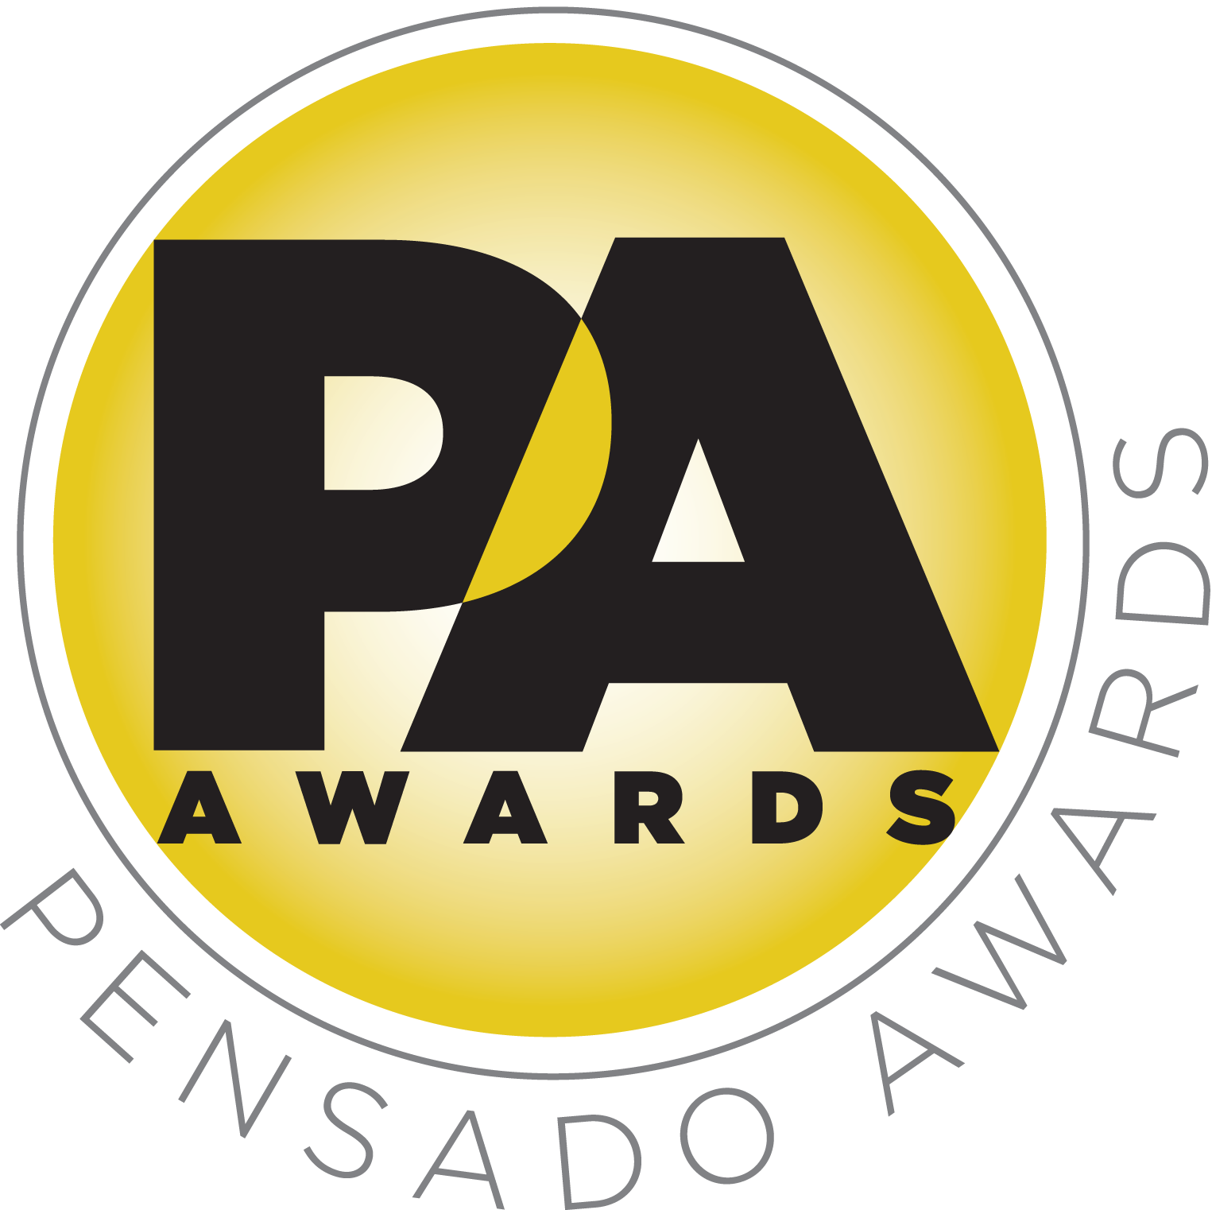

Second Annual Pensado Awards Hailed as Success; Winners Announced

Awards ceremony took place on Sunday, August 30, 2015, with over 700 top industry professionals and celebrities in attendance

Winners announced in 16 categories; awards ceremony will be available for online streaming in the coming weeks

LOS ANGELES, CA, September 1, 2015 — The live ceremony for the second annual Pensado Awards, an award show created by the producers of the acclaimed online video series Pensado’s Place, took place on Sunday, August 30, 2015, at Sony Pictures Studios in Culver City, CA. The event attendees read like a who’s-who of the audio community, with over 700 in attendance, including prominent TV personality, producer and musician Randy Jackson (American Idol, Journey, etc.), producer Young Guru (Jay Z, Beyoncé, Mariah Carey), legendary producer Quincy Jones, producer/recording artist Dave Stewart, legendary producer/engineer Al Schmitt, vocalist Patti Austin, songwriter and vocalist Siedah Garrett and more. A video production of the ceremony will be posted soon through Pensado’s Place online channels.

At the ceremony, the following winners were announced:
- Live / FOH: Fred Archambault, for Last Call with Carson Daly
- Master of Mastering: Gavin Lurrsen
- Outstanding Brand: Focusrite
- Outstanding Achievement for Sound in a Visual Medium: Last Call with Carson Daly
- Game Changer of the Year: Manny Marroquin
- Best Non-English Song: “Ethnik Funk” - Gaurav Dayal
- Break Thru Songwriter: DJ Frank E for “See You Again,” and Noel Zancanella for “Maps”
- Break Thru Mixer: James Royo
- Spin Doctor DJ: Above & Beyond
- Tracking Engineer: Josh Gudwin
- Unique Project Studio: Jam In The Van
- AIR Award (Best Assistant, Intern or Runner): Jake Kiyokane
- OMG! Mix of the Year: Dave Reitzas - “Earned It” [mix for The Weeknd]
- Pensado Giant Award: Bruce Swedien
- Dave Pensado Educator Award: Berklee Colege Of Music & New Look Foundation
- Herb Trawick Visionary Award: Native Instruments

A full list of nominees can be found at http://pensadoawards.com/award_categories_2015.html.

An evening highlight was a taped message from Barbra Streisand congratulating Dave Reitzas on his OMG! Mix of the Year award, where she stated, “I’m so happy you’re [Dave] being recognized by the Pensado Awards this evening. For the past two decades, since 1993, Dave has been on the other side of the glass for so many of my recordings. He’s always willing to go the extra mile with me on my recordings, because, as he said, on more than a few occasions, ‘If it’s gotta be right, it’s gotta be righteous’ … I mean, Reitzas!”

The evening’s culmination was the presentation of the Pensado Giant Award to Bruce Swedien. Ed Cherney kicked off this segment, introducing a short video that chronicled Swedien’s six-decade-plus career in music. Artists Patti Austin and Siedah Garrett then hit the stage to give their personal Swedien tributes and introduce Quincy Jones. Jones gave a heartfelt speech presenting the award to Swedien. Jones stated, “I am so thrilled to be here tonight to celebrate one of the greatest engineers to ever walk into a recording studio, my dear friend and brother Bruce ‘Svensk’ Swedien. I look at producing like working with a big band, you have to have the right players in all the chairs. And as the third leg of the stool that is the centerpiece of my musical mafia, my killer Q posse, along with Rod Temperton, I never worried about the sound because I knew Bruce always had us covered. Bruce is the guru of engineers. We’ve recorded more albums together than I can remember from Dinah and Basie in Chicago in the 50’s, to the Brothers Johnson, Michael, right up until today, and I can’t imagine recording one of those albums without him. [Bruce] took the art of recording to a new level and has defined the sound of recorded music, and that is why every engineer and artist today, 30 years later, still go to our music as a reference. Bruce, I am so happy to be able to be here tonight to celebrate you personally and professionally. You deserve every honor and adulation that is bestowed upon you. Congratulations Bruce.”

The Pensado Awards are a natural outgrowth of the ethos behind Pensado’s Place. From the self-taught basement amateur to the seasoned industry producer, all manner of music professionals are discovering new methods of working and novel ways to reach fans and these awards are here to honor them. The awards highlight the brilliance and hard work of all those producers, songwriters, DJ’s, engineers, mixers, live wizards and behind-the-scenes technicians in audio that often go unnoticed. The Pensado Awards unites the best pros, amateurs, brands and press to come together as one community to celebrate the uncelebrated.

Herb Trawick, Co-host/Executive Producer and Creator of Pensado’s Place, as well as the Manager and Advisor to Co-host Dave Pensado, states, “We congratulate all our winners, as well as the rest of the talented nominee pool, at the second annual Pensado Awards. Thanks also to all who helped us put on the show, including our Pro Committee, sponsors, co-hosts and presenters. This year’s ceremony was bigger and better than last year’s, and next year’s is set to be the biggest yet.”

Joining Randy Jackson as co-hosts were producer-engineers Chris Lord-Alge (Muse, Pink, Foo Fighters, Avril Lavigne, Green Day, Daughtry, Paramore, Black Eyed Peas), Sylvia Massy (Tool, System of a Down, Johnny Cash, Red Hot Chili Peppers), Young Guru (Jay Z, Beyoncé, Mariah Carey) and Justin Meldal-Johnsen (Beck, Nine Inch Nails, others). Presenters included producer-engineer Ed Cherney, producer-engineer Tony Maserati, Capitol Studios executive Paula Salvatore, engineer Andrew Scheps, engineer and studio head John McBride, engineer Ann Mincieli, producer/engineer Ross Hogarth, studio executive Rose Mann-Cherney, engineer/producer Joe Barresi, songwriter Nina Woodford-Wells, mastering engineer Maor Appelbaum, Ableton Certified Trainer and electronic musician Yeuda Ben-Atar, EastWest studio manager Candace Stewart, Larrabee studio manager Amy Burr, songwriter/producer/engineer Kuk Harrell, Bobby Lombardi (Market Development, G-Technology), AES Executive Director Bob Moses, NAMM President Joe Lamond, The Recording Academy P&E Wing Managing Director Maureen Droney, mix engineer Luca Pretolesi, producer/musician/engineer Greg Wells, Studio at the Palms manager Zoe Thrall, and electronic artist and producer DJ Ali. Music was curated by acclaimed turntablist and Beastie Boys collaborator Mix Master Mike, while social media host Cloie Wyatt Taylor tweeted messages to the world throughout the evening.

AfterMaster® Audio Labs served as presenting sponsor for the upcoming ceremony. Title Sponsors were Audio-Technica, AVID, Blackbird Academy, Hal Leonard, iZotope, Recording Radio Film Connection (RRF), Studio 202 and Vintage King Audio. Premium sponsors were Augspurger, Barefoot Sound, Bedrock L.A., NAMM, SAE Institute, SUBPAC and 3DEXCITE.

###

Photo file 1: PensadoAwards15_RandyQuincy.JPG
Photo caption 1: Pictured L-R: Randy Jackson and Quincy Jones, at the second annual Pensado Awards. Photo by Maury Phillips / WireImage.com. © 2015.

Photo file 2: PensadoAwards15_RedCarpet.JPG
Photo caption 2: Pictured L-R: Dave Pensado, Bruce Swedien, Al Schmitt, Herb Trawick and Quincy Jones, on the red carpet at the second annual Pensado Awards. Photo by Maury Phillips / WireImage.com. © 2015.

Photo file 3: PensadoAwards15_CoHosts.JPG
Photo caption 3: Pictured L-R: Randy Jackson, Young Guru, Chris Lord-Alge, Sylvia Massy and Justin Meldal-Johnsen. Photo by Brian A. Petersen. © 2015.

Photo file 4: PensadoAwards15_CLA_Randy_Quincy_Dave_Herb.JPG
Photo caption 4: Pictured L-R: Chris Lord-Alge, Randy Jackson, Quincy Jones, Dave Pensado and Herb Trawick, at the second annual Pensado Awards. Photo by Maury Phillips / WireImage.com. © 2015.

Photo file 5: PensadoAwards15_Patti_Siedah_Bruce_Quincy.JPG
Photo caption 5: Pictured L-R: Patti Austin, Siedah Garrett, Bruce Swedien and Quincy Jones, as Jones presents Swedien with the Pensado Giant Award. Photo by Brian A. Petersen. © 2015.

About Pensado’s Place
The hour-long weekly web series Pensado’s Place was created over four years ago. Co-hosted by legendary mix engineer Dave Pensado (Beyoncé, Christina Aguilera, Kelly Clarkson, Mariah Carey, Elton John, Michael Jackson and more) and show creator Herb Trawick, Pensado’s Place includes interviews with top music industry artists, engineers, producers, mixers, and record executives, as well as in-depth tutorials in production, engineering and mixing. Pensado’s Place has positioned itself as “the most influential show for audio engineers,” mixers and producers (Forbes Magazine) in just three years. Pensado’s Place is more than just a show, as it highlights the very best in the industry of music, gaming, sound identity on film, and audio equipment, with a presence in live events. As a leading educational resource, Pensado’s Place is helping build the next generation of audio greats. http://www.pensadosplace.tv/.

CONTACTS:
Pensado Awards Contact:
Shevy Shovlin / Pensado Awards / Business Development Manager / 313-590-0886 / info@pensadoawards.com

PR Contacts:
Robert Clyne / Clyne Media / 615-662-1616 / Robert@clynemedia.com / www.clynemedia.com/
Lisa Roy / Rock & Roy / 310-463-1563 / lisaroyaudio@mac.com

