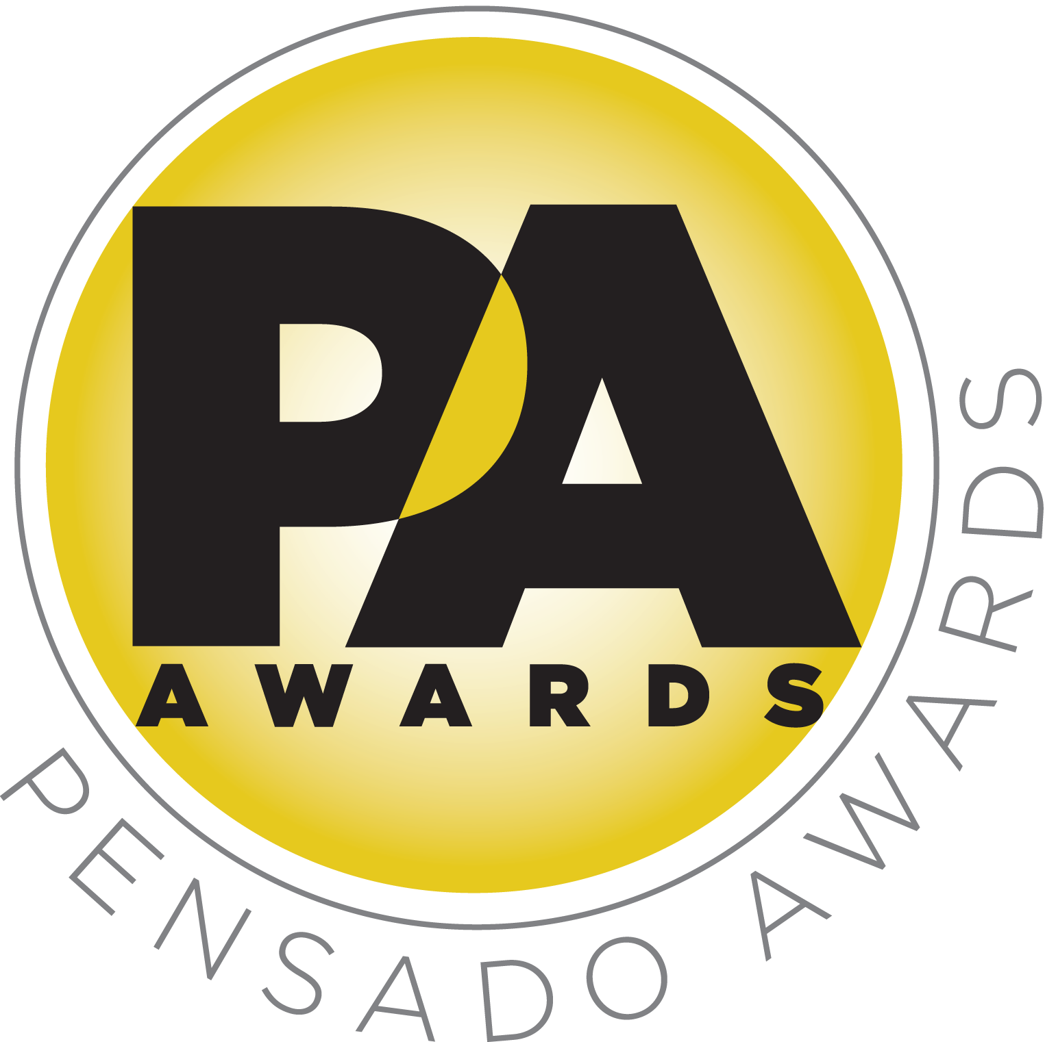

Randy Jackson and Quincy Jones Join the Co-Host/Presenter Roster for Second Annual Pensado Awards

Industry luminaries come out to “recognize the faces behind the sound”

LOS ANGELES, CA, August 22, 2015 — Two major names have been added to the roster of co-hosts and presenters for the second annual Pensado Awards, an award show created by the producers of the acclaimed online video series Pensado’s Place. Prominent TV personality, producer and musician Randy Jackson (American Idol, Journey, etc.) has joined on as co-host for the ceremony, and legendary producer Quincy Jones has been added as a presenter. This year’s festivities will take place on Sunday, August 30, 2015, at Sony Pictures Studios, 10202 W. Washington Blvd., Culver City, CA 90232. A video production of the ceremony will follow and be posted on the Pensado’s Place YouTube channel.

Although most recognizable from his long tenure as judge on American Idol, Randy Jackson’s impressive career includes his credits as musician, songwriter, GRAMMY® Award-winning producer, record-industry executive, business entrepreneur, best-selling author, talent manager, television producer and beloved television personality.

Named by TIIME Magazine as one of the six most influential Jazz artists of the 20th Century, Quincy Jones is an impresario in the broadest and most creative sense of the word. Over six decades Jones’ career has encompassed the roles of composer, record producer, artist, film producer, arranger, conductor, instrumentalist, TV producer, record company executive, television station owner, magazine founder, multi-media entrepreneur and humanitarian. Among his greatest successes are the three albums he produced with Michael Jackson, including Thriller, one of the most commercially and critically successful albums of all time.

Herb Trawick, Co-host/Executive Producer and Creator of Pensado’s Place, as well as the Manager and Advisor to Co-host Dave Pensado, states, “Randy and Quincy are two immediately recognizable figures in our industry, and their candor, expertise and pursuit of quality go hand-in-hand with what the Pensado Awards are all about.”

Randy Jackson joins the previously announced co-hosts – producer-engineers Chris Lord-Alge (Muse, Pink, Foo Fighters, Avril Lavigne, Green Day, Daughtry, Paramore, Black Eyed Peas), Sylvia Massy (Tool, System of a Down, Johnny Cash, Red Hot Chili Peppers), Young Guru (Jay Z, Beyoncé, Mariah Carey) and Justin Meldal-Johnsen (Beck, Nine Inch Nails, others).

Quincy Jones joins the list of previously announced presenters: producer/recording artist Dave Stewart, legendary producer/engineer Al Schmitt, producer-engineer Ed Cherney, producer-engineer Tony Maserati, Capitol Studios executive Paula Salvatore, mix engineer Manny Marroquin, engineer Andrew Scheps, engineer and studio head John McBride, engineer Ann Mincieli, producer/engineer Ross Hogarth, studio executive Rose Mann-Cherney, engineer/producer Joe Barresi, songwriter Nina Woodford-Wells, mastering engineer Maor Appelbaum, Ableton Certified Trainer and electronic musician Yeuda Ben-Atar, EastWest studio manager Candace Stewart, Larrabee studio manager Amy Burr, songwriter/producer/engineer Kuk Harrell, Bobby Lombardi (Market Development, G-Technology), vocalist Patti Austin, AES Executive Director Bob Moses, NAMM President Joe Lamond, The Recording Academy P&E Wing Managing Director Maureen Droney, mix engineer Luca Pretolesi, producer/musician/engineer Greg Wells, songwriter/vocalist Siedah Garrett, Studio at the Palms manager Zoe Thrall, and electronic artist and producer DJ Ali. Music will be curated by acclaimed turntablist and Beastie Boys collaborator Mix Master Mike.

This year’s awards ceremony will be held under the stars in Calley Park, which is located in the center of the Sony Pictures Studios lot. The night will kick off with a VIP reception on the complex’s Main Street area Theatre (aka Capra Park), followed by an afterparty, “Into the Lair,” at the Sony Commissary, which is connected to Calley Park. An “AfterMaster Lounge” in the Rita Hayworth Dining Room will host VIP guests and influencers throughout the evening.

AfterMaster® Audio Labs is serving as presenting sponsor for the upcoming ceremony. Title Sponsors are Audio-Technica, AVID, Blackbird Academy, Hal Leonard, iZotope, Recording Radio Film Connection (RRF), Studio 202 and Vintage King Audio. Premium sponsors are Augspurger, Barefoot Sound, Bedrock L.A., NAMM, SAE Institute, SUBPAC and 3DEXCITE.

The Pensado Awards are a natural outgrowth of the ethos behind Pensado’s Place. From the self-taught basement amateur to the seasoned industry producer, all manner of music professionals are discovering new methods of working and novel ways to reach fans and we are here to honor them. At the awards we highlight the brilliance and hard work of all those producers, songwriters, DJ’s, engineers, mixers, live wizards and behind-the-scenes technicians in audio that often go unnoticed. The Pensado Awards unites the best pros, amateurs, brands and press to come together as one community to celebrate the uncelebrated.

About Randy Jackson:
Randy Jackson’s fearless and forward-thinking mentality has guided him from musician, songwriter, and GRAMMY® Award-winning producer to revered record-industry executive, business entrepreneur, best-selling author, talent manager, television producer and beloved television personality. All of this stems from Jackson's passion for music. Jackson has lent his talents to hit records by Smokey Robinson, Whitney Houston, Aretha Franklin, and Madonna, to name a few. Meanwhile, he also entered the rock 'n' roll realm, recording and performing with legendary musicians such as Bob Dylan, Billy Joel, Bon Jovi, Keith Richards, Journey, Carlos Santana, Jerry Garcia, Bob Weir, and countless others. All in all, he has over 1,000 gold and platinum plaques to his name, with collective sales exceeding 200 million copies. Turning into one the highest-rated television shows of all time, Fox's American Idol became a phenomenon that yielded some of the most crucial artists of the twenty-first century. As the program's longest-standing panel judge, Jackson reached an iconic status within pop culture. His charitable work includes his role as Goodwill Ambassador for Save the Children U.S., as well as his involvement with the Gibson Foundation, Ronald McDonald House Charities, the Music in the Schools program of the National Academy of Recording Arts and Sciences, and the T.J. Martell Foundation, which honored him with its Lifetime Music Industry Award. In the aftermath of Hurricane Katrina, he was one of the architects of the multimillion-dollar fundraiser, Idol Gives Back, delivering relief to Louisiana. He also contributed to "We Are the World 2," benefiting Haitian relief efforts.

About Quincy Jones:
Named by TIME Magazine as one of the six most influential Jazz artists of the 20th Century, Quincy Jones is an impresario in the broadest and most creative sense of the word. Over six decades Jones’ career has encompassed the roles of composer, record producer, artist, film producer, arranger, conductor, instrumentalist, TV producer, record company executive, television station owner, magazine founder, multi-media entrepreneur and humanitarian. Among the multitude of awards that he has received for his contributions are an EMMY® Award, seven Academy Award nominations, the Academy of Motion Picture Arts and Sciences’ Jean Hersholt Humanitarian Award, 27 GRAMMY® Awards, and is the all-time most nominated GRAMMY artist with a total of 79 nominations. He is the recipient of the Republic of France’s Commandeur de la Legion d’Honneur, and in 2001 he was inducted as a “Kennedy Center Honoree,” the United States’ most prestigious artistic award, for his lifetime contributions to the culture of the country. He was recognized by the National Endowment for the Arts as a Jazz Master - the nation’s highest jazz honor, and was most recently bestowed the National Medal of Arts, our nation’s highest artistic honor. His massively impressive career in music, film and television has seen him work beside legends such as Billie Holiday, Ray Charles, Dizzy Gillespie, Count Basie, Ella Fitzgerald and Michael Jackson, among many others. A longtime humanitarian and activist, in 1999 Quincy Jones joined Bono and Bob Geldof during a meeting with Pope John Paul II as a part of the Jubilee 2000 delegation to end third world debt. The delegation’s visit resulted in $27 billion in third world debt being relieved. Through his Project Q Foundation, a joint initiative with the Harvard School of Public Health, Jones is actively working with NGO’s such as UNICEF, the Clinton Hunter Development Initiative and the Inter-American Development Bank, among others, to improve the health and well being of millions of children in developing countries such as Rwanda, South Africa and Asia. Jones is also the founder of the Quincy Jones Music Consortium, a cooperative of musicians, music and arts educators, corporations, foundations and philanthropists tasked with developing an innovative curriculum to be implemented in America’s schools that explores, celebrates and preserves the history of American Popular Music so that music education can be an ongoing part of the lives of the children of the United States.

###

Photo file 1: RandyJackson.JPG
Photo caption 1: Randy Jackson, recently added as a co-host for the upcoming Pensado Awards ceremony.

Photo file 2: QuincyJones.JPG
Photo caption 2: Quincy Jones, recently added as a presenter for the upcoming Pensado Awards ceremony. Photo credit: Randy Gorman Art.

About Pensado’s Place
The hour-long weekly web series Pensado’s Place was created over four years ago. Co-hosted by legendary mix engineer Dave Pensado (Beyoncé, Christina Aguilera, Kelly Clarkson, Mariah Carey, Elton John, Michael Jackson and more) and show creator Herb Trawick, Pensado’s Place includes interviews with top music industry artists, engineers, producers, mixers, and record executives, as well as in-depth tutorials in production, engineering and mixing. Pensado’s Place has positioned itself as “the most influential show for audio engineers,” mixers and producers (Forbes Magazine) in just three years. Pensado’s Place is more than just a show, as it highlights the very best in the industry of music, gaming, sound identity on film, and audio equipment, with a presence in live events. As a leading educational resource, Pensado’s Place is helping build the next generation of audio greats. http://www.pensadosplace.tv/.

CONTACTS:
Pensado Awards Contact:
Shevy Shovlin / Pensado Awards / Business Development Manager / 313-590-0886 / info@pensadoawards.com

PR Contacts:
Robert Clyne / Clyne Media / 615-662-1616 / Robert@clynemedia.com / www.clynemedia.com/
Lisa Roy / Rock & Roy / 310-463-1563 / lisaroyaudio@mac.com

