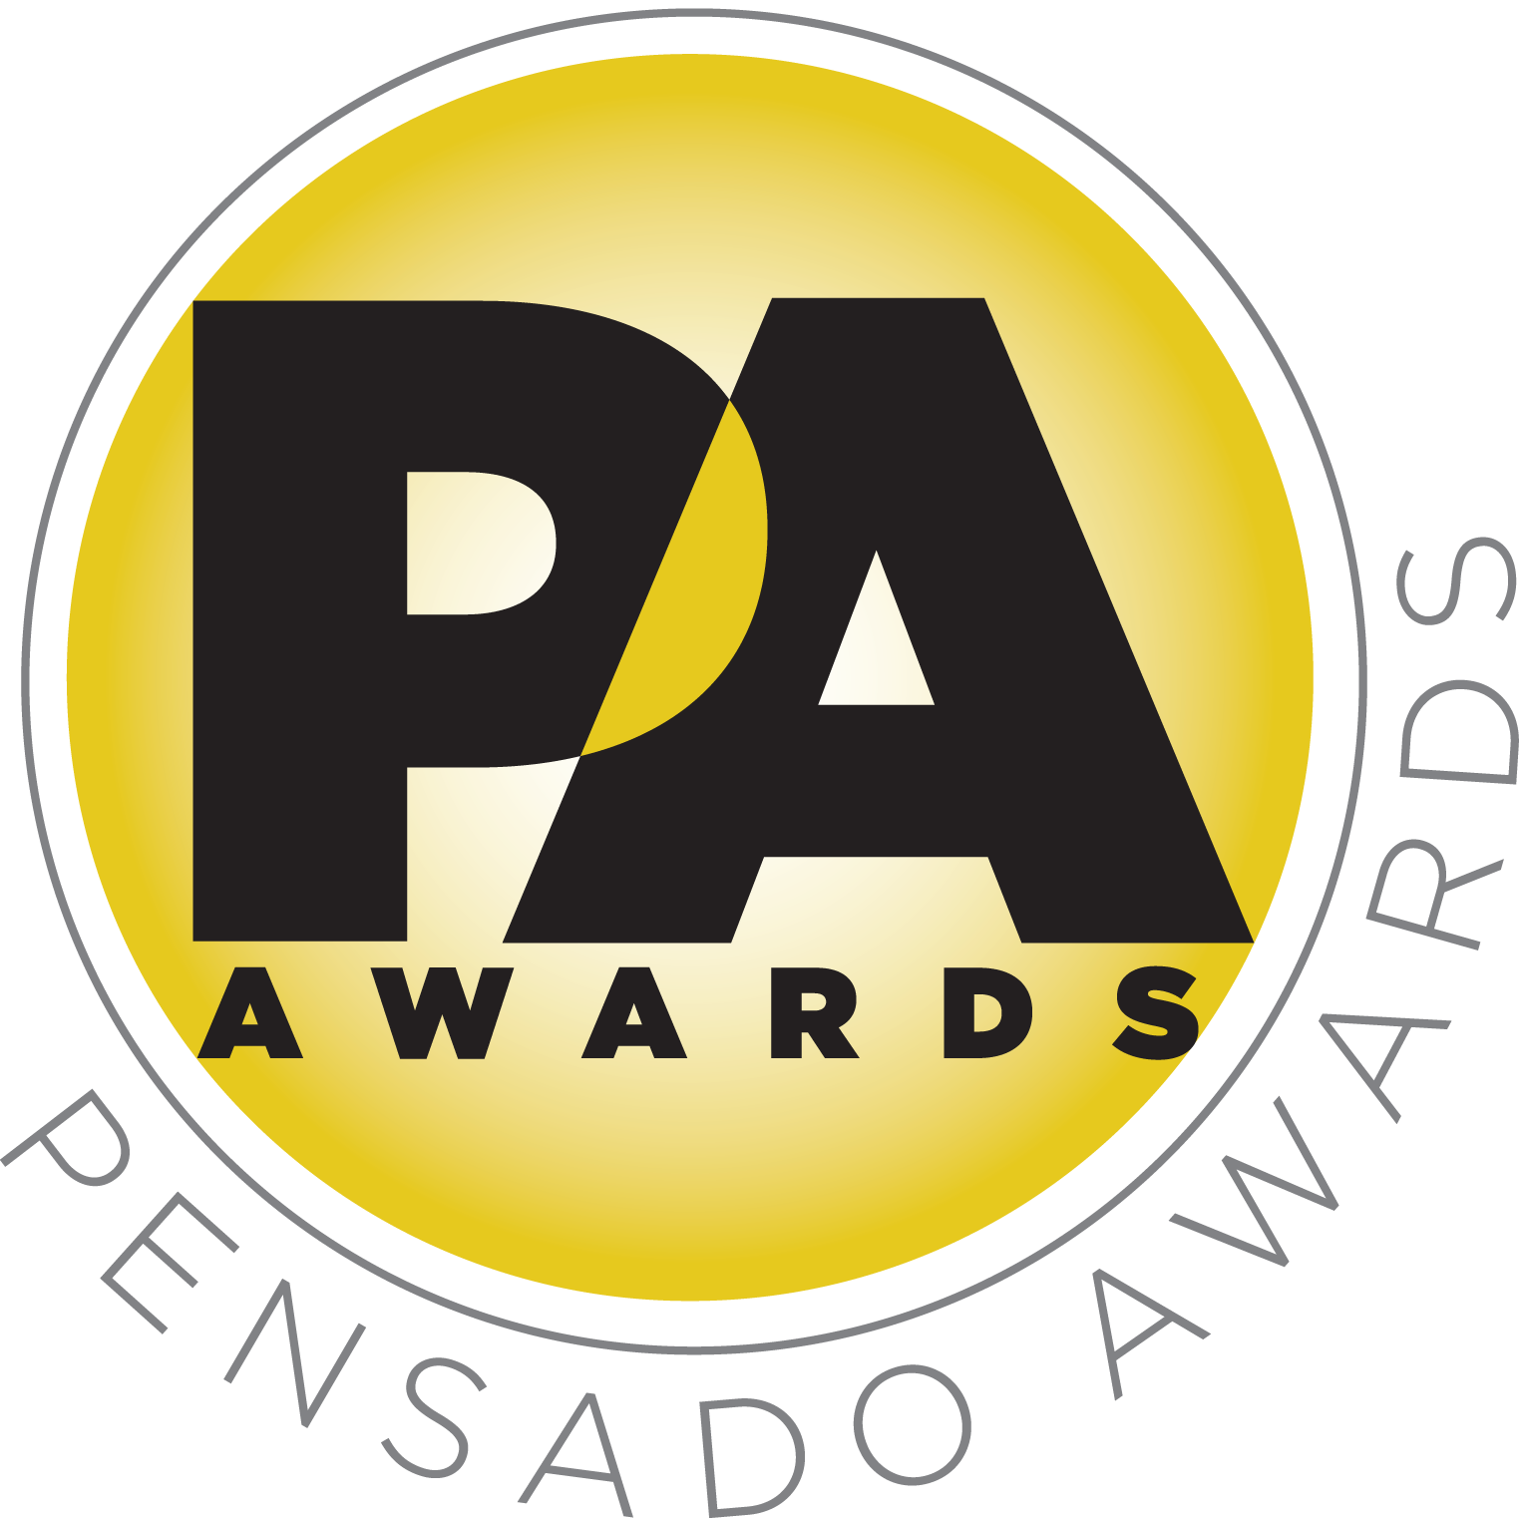

Chris Lord-Alge, Sylvia Massy and Young Guru to Co-Host Second Annual Pensado Awards

Awards show will once again “recognize the faces behind the sound”

Acclaimed recording engineer Sylvia Massy joins returning co-hosts Chris Lord-Alge and Young Guru

LOS ANGELES, CA, July 22, 2015 — Three co-hosts have been announced for the second annual Pensado Awards, an award show created by the producers of the acclaimed online video series Pensado’s Place. This year’s festivities will take place on Sunday, August 30, 2015, at Sony Pictures Studios, 10202 W. Washington Blvd., Culver City, CA 90232. A video production of the ceremony will follow and be posted on the Pensado’s Place YouTube channel. Co-hosting will be producer-engineers Chris Lord-Alge (Muse, Pink, Foo Fighters, Avril Lavigne, Green Day, Daughtry, Paramore, Black Eyed Peas), Sylvia Massy (Tool, System of a Down, Johnny Cash, Red Hot Chili Peppers) and Young Guru (Jay Z, Beyoncé, Mariah Carey), with an additional co-host to be announced soon. Lord-Alge and Young Guru are returning after last year’s highly successful ceremony, and will be joined by Massy for this year’s awards. A full list of sponsors and a surprise co-host will be announced soon.

Herb Trawick, the Co-host/Executive Producer and Creator of Pensado’s Place, as well as Manager and Advisor to Co-host Dave Pensado, stated, “We are very excited to have Chris and Young Guru returning as co-hosts for our ceremony, and to add Sylvia to the team is nothing short of phenomenal. These three individuals have resumes that speak for themselves, but they also present themselves with grace and candor, and they will be great spokespeople for our second annual awards.”

Dave Pensado (Co-host of Pensado’s Place, GRAMMY®-winning mix engineer, Teacher) stated, “Each of these three co-hosts brings a unique perspective to the art of music-making, and together they represent the best of what the recording industry can offer the world.”

Last year’s ceremony hosted a standing-room-only crowd of over 600 recording industry figures, with the live ceremony highlighted by presentations from the likes of Neil Young and Sir Paul McCartney, some as proud nominees, some as presenters, some there to simply be a part of the evening – and this year’s show is set to be even bigger. The awards will be held outdoors under the stars in Calley Park in the middle of the Sony Pictures Studios lot. A VIP reception will be held on the complex’s Main Street area; the “AfterMaster Lounge” will be located in the Rita Hayworth Theatre; and an after-party will take place in the Sony Commissary, which is connected to the park.

The Pensado Awards are a natural outgrowth of the ethos behind Pensado’s Place. In recent years, developments in music and technology have changed the landscape for producers, songwriters, engineers and musicians, encouraging artists and composers of all types to hone their craft. From the self-taught basement amateur to the seasoned industry producer, all manner of music professionals are discovering new methods of working and novel ways to reach fans. The science and art of music-making are in a rapid state of flux, with exciting opportunities awaiting among the talented figures in and out of the spotlight – the people who are currently engineering the next sound that will move the world in the music, film, television and digital realms. Over 100,000 albums and millions of songs are released every year, not to mention the hundreds of thousands of concerts put on worldwide, but the awards often end up in the hands of a lucky select group. So the brilliance and hard work of all those producers, songwriters, DJ’s, engineers, mixers, live wizards and behind-the-scenes technicians in audio often go unnoticed. The Pensado Awards, founded as a means of acknowledging these talented individuals and their work, are a grand opportunity for the best pros, amateurs, brands and press to come together as one community to celebrate the uncelebrated.

About Pensado’s Place
The hour-long weekly web series Pensado’s Place was created nearly four years ago. Co-hosted by legendary mix engineer Dave Pensado (Beyoncé, Christina Aguilera, Kelly Clarkson, Mariah Carey, Elton John, Michael Jackson and more) and show creator Herb Trawick, Pensado’s Place includes interviews with top music industry artists, engineers, producers, mixers, and record executives, as well as in-depth tutorials in production, engineering and mixing. Pensado’s Place has positioned itself as “the most influential show for audio engineers,” mixers and producers (Forbes Magazine) in just three years. Pensado’s Place is more than just a show, as it highlights the very best in the industry of music, gaming, sound identity on film, and audio equipment, with a presence in live events. As a leading educational resource, Pensado’s Place is helping build the next generation of audio greats. http://www.pensadosplace.tv/
# # #

Photo Files: CLA.JPG, SylviaMassy.JPG, YoungGuru.JPG

CONTACTS:

Pensado Awards Contact:
Shevy Shovlin / Pensado Awards / Business Development Manager / 313-590-0886 / info@pensadoawards.com

PR Contacts:
Robert Clyne / Clyne Media / 615-662-1616 / Robert@clynemedia.com / www.clynemedia.com/
Lisa Roy / Rock & Roy / 310-463-1563 / lisaroyaudio@mac.com

