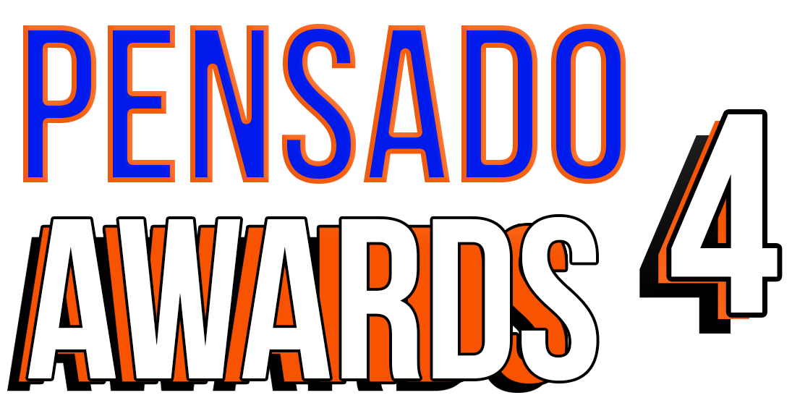

Industry Leaders Support The Fourth Annual Pensado Awards, Sunday, December 3, 2017

The live ceremony, featuring a who’s-who of the recording community, will once again “recognize the faces behind the sound”

Hip-hop production collective 1500 or Nothin', the Premier Sponsor for the fourth annual Pensado Awards, is joined by leading audio companies, industry organizations and music industry media

LOS ANGELES, CA, November 21, 2017 — The fourth annual Pensado Awards (taking place on Sunday, December 3, 2017, at Los Angeles’ historic Fonda Theatre, 6126 Hollywood Boulevard, Los Angeles, California 90028), the upcoming awards show acknowledging today’s emerging brand of music professional and “recognizing the faces behind the sound,” is pleased to announce additional sponsor partners in advance of the award ceremony next month.

The list of sponsors comprises some of the most prominent names in professional audio, M.I., audio education and the media. Hip-hop production collective 1500 or Nothin', an American musical ensemble composed of record producers, songwriters, musicians and music videographers, based in Inglewood, CA, serves as the Premier Sponsor for the fourth annual Pensado Awards. Additional main sponsors include The Blackbird Academy, NAMM, Avid, Westlake Pro, Roland, Recording Academy® Producers & Engineers Wing®, Audio-Technica, AFM & SAG-AFTRA, iZotope, The Fab Factory, accusonus, FabFilter, BeatSkillz, Celemony, Tascam, Groove3, IK Multimedia, Indaba Music, LANDR, Heavyocity Media, International Music Software Trade Association(IMSTA) and Music Connection Magazine.

Herb Trawick, the Co-host/Executive Producer and Creator of Pensado’s Place, as well as Manager and Advisor to Co-host Dave Pensado, stated, “We continue to be blessed to have the support of some of the leading brands and organizations in the industry. Each is a leader in their own right and we thank them for their ongoing support.”

Created by Herb Trawick and Dave Pensado of Penwick Media (the producers of Pensado's Place and other industry-leading audio-related media), the Pensado Awards were founded as a means of acknowledging talented music producers, engineers, mixers, songwriters and their work, serving as a grand opportunity for the best pros, amateurs, brands and press to come together as one community to celebrate the uncelebrated. Since its inception, the show has continued to gain momentum and garner attention throughout the industry and beyond. The Fonda Theatre will provide an intimate backdrop for Pensado Awards 4, which will feature an entirely new vibe and new show format using cutting-edge technology, plus additional surprises throughout the night. This year’s co-hosts are drummer Samantha Maloney (Hole, Mötley Crüe, Peaches), legendary producer, engineer and mixer Chris Lord-Alge (Pink, Foo Fighters, Avril Lavigne, Green Day) and Kosine of acclaimed production duo Da Internz (Ludacris, Nicki Minaj, John Legend).

More about the Pensado Awards:
The Pensado Awards are a natural outgrowth of the ethos behind Pensado’s Place. In recent years, developments in music and technology have changed the landscape for producers, songwriters, engineers and musicians, encouraging artists and composers of all types to hone their craft. From the self-taught basement enthusiast to the seasoned industry producer, all manner of music professionals are discovering new methods of working and novel ways to reach fans. The science and art of music-making are in a rapid state of flux, with exciting opportunities awaiting among the talented figures in and out of the spotlight – the people who are currently engineering the next sound that will move the world in the music, film, television and digital realms. Over 100,000 albums and millions of songs are released every year, not to mention the hundreds of thousands of concerts put on worldwide, but the awards often end up in the hands of a lucky select group. So the brilliance and hard work of all those producers, songwriters, DJ’s, engineers, mixers, live wizards and behind-the-scenes technicians in audio often go unnoticed. The Pensado Awards, founded as a means of acknowledging these talented individuals and their work, are a grand opportunity for the best pros, amateurs, brands and press to come together as one community to celebrate the uncelebrated.

###

Photo file: PensadoAwards4_Logo.JPG
Photo caption: Pensado Awards 4 logo

About Pensado’s Place
The hour-long weekly web series Pensado’s Place was created over five years ago. Co-hosted by legendary mix engineer Dave Pensado (Black Eyed Peas, Beyoncé, Christina Aguilera, Kelly Clarkson, Michael Jackson and more) and show creator Herb Trawick, Pensado’s Place includes interviews with top music industry artists, engineers, producers, mixers, and record executives, as well as in-depth tutorials in production, engineering and mixing. Pensado’s Place has positioned itself as “the most influential show for audio engineers,” mixers and producers (Forbes Magazine). Pensado’s Place is more than just a show, as it highlights the very best in the audio industry from music, film, TV, gaming, live, hardware and software with a presence in live events. As a leading educational resource, Pensado’s Place is helping build the next generation of audio greats. http://www.pensadosplace.tv/.

PR Contacts:
Robert Clyne / Clyne Media / 615-662-1616 / Robert@clynemedia.com / www.clynemedia.com/
Lisa Roy / Rock & Roy / 310-463-1563 / lisaroyaudio@mac.com

