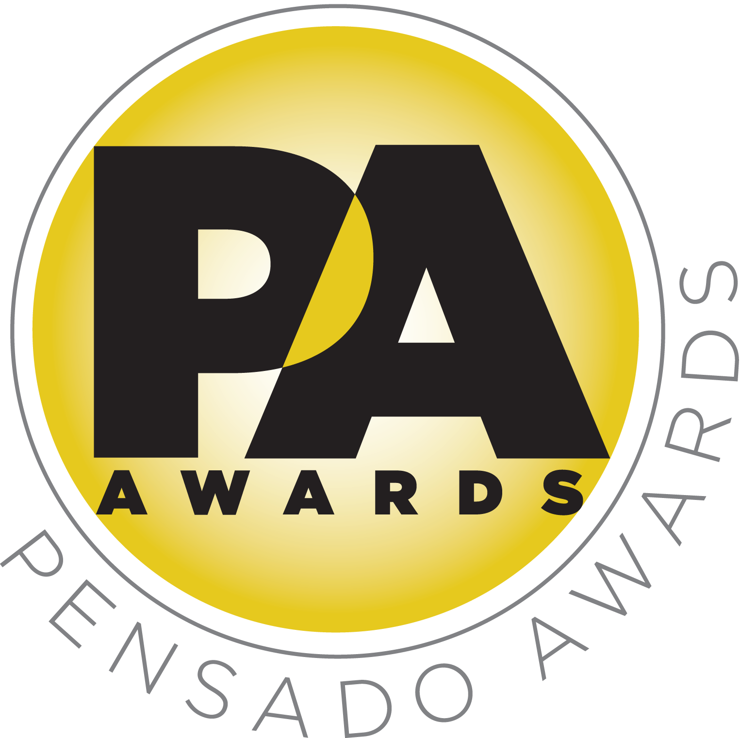

Third Annual Pensado Awards Winners Announced at Standing-Room-Only Event

Crowd of 1000 industry professional and celebrities packs the Sony Pictures Studios in Culver City, CA, for annual Pensado Awards

Winners announced in 15 categories at award show that “celebrates the faces behind the sound”

LOS ANGELES, CA, August 24, 2016 — The Pensado Awards, an award show created by Herb Trawick and Dave Pensado of Penwick Media (the producers of the acclaimed online video series Pensado's Place and other industry-leading audio-related media) as a means to acknowledge today’s emerging brand of music professional and “recognize the faces behind the sound,” held its third annual awards ceremony on Saturday, August 20, 2016, at Sony Pictures Studios in Culver City, CA.

The ceremony hosted a standing-room-only crowd of over 1000 recording industry figures – some as proud nominees, some as presenters, some there to simply be a part of the evening – including songwriter/producer busbee; GRAMMY®-winning movie scoring mixer Alan Meyerson; hip-hop production collective 1500 or Nothin’; producer and instrumentalist DJ Iz; a contingent from G.O.O.D. Music; vocalist Patti Austin; multi-GRAMMY award-winning engineer/producers Ron Fair, Jack Joseph Puig, Ed Cherney, Mick Guzauski, and Al Schmitt; and many more. A special highlight was a taped tribute to producer/engineer/mixer Chris Lord-Alge (Pink, Foo Fighters, Avril Lavigne, Green Day), the winner of the Pensado Giant Award, from Stevie Nicks, Bruce Springsteen, Dwight Yoakam, Scott Borchetta (Big Machine Label Group), Steven Tyler and Chris’s brother, GRAMMY Award winning engineer/mixer Tom Lord-Alge.

The event was co-hosted by singer-songwriter/actress/fashion designer Taryn Manning (electronic duo Boomkat, 8 Mile, Orange Is the New Black), drummer Samantha Maloney (Hole, Mötley Crüe, Peaches), Chris Lord-Alge, recording/mix engineer MixedByAli (Kendrick Lamar, Dr. Dre, Robin Thicke) and mastering engineer Gavin Lurssen (Tom Waits, Sheryl Crow, T-Bone Burnett). The musical theme of the awards show was “Celebrate the Guitar,” with live performances by Phil X (Triumph, Bon Jovi), Michael “Fish” Herring (Prince, Celine Dion, Christina Aguilera) and Ethan Farmer (Aretha Franklin, Janet Jackson, Justin Timberlake).

A truly special aspect of the evening saw the audio community banding together to raise funds and increase awareness around David Platillero, a talented young producer-engineer and musician who suffered a severe traffic accident earlier this year while riding his bicycle to attend classes at Nashville’s The Blackbird Academy. David’s injuries require intensive rehabilitation, so supporting David and his family was a key goal of this year’s Awards. Throughout the evening, Trawick, Pensado and the event’s co-hosts drove donations while the Pensado media and PR team helped raise awareness on social media by using the hashtag #WeStandForDavid. The audience went wild at the moment of a surprise appearance on stage by David with his father John Platillero and The Blackbird Academy founder and noted producer John McBride, who was one of the first people at David’s bedside in the emergency room at Vanderbilt Hospital. David and his family were truly touched by the outreach of the audio community and thanked everyone for their support and this amazing evening.

The Pensado Award show drew tremendous attention on social media with the hashtags #PensadoAwards and #WeStandForDavid, having over 500 posts that garnered over 5.5 million impressions.

At the ceremony, the following winners were announced:
- OMG! Mix of the Year: Josh Gudwin/Andrew Wuepper for “Sorry” (Justin Bieber); Vance Powell for “Tennessee Whiskey” (Chris Stapleton)
- Game Changer of the Year Award: Dave Cobb
- Break Thru Songwriter: Brody Brown
- Master of Mastering: Joe LaPorta
- Tracking Engineer: Steve Genewick
- Best Non-English Song: JJ Lin, “Twilight”
- Outstanding Brand: Indaba Music
- Break Thru Mixer Award: Delbert Bowers
- Live/FOH: Wilberto Madera (Pitbull)
- Spin Doctor DJ Award: Henry Fong
- AIR Award (Best Assistant, Intern or Runner): Shamir Nicholas, Chris Galland and Wesley Seidman
- Outstanding Achievement in Sound for Visual Medium Award: Straight Outta Compton
- Pensado Giant Award: Chris Lord-Alge
- Dave Pensado Educator Award: Learn from Legends, Recording Connection
- Herb Trawick Visionary Award: Xfer Records

A full list of nominees can be found at http://pensadoawards.com/award_categories.html.

The culmination of the awards segment was the presentation of the Pensado Giant Award to Chris Lord-Alge by Focusrite President Phil Wagner and noted industry marketing/publicity professional Lisa Roy, both long-time friends of Lord-Alge and his family. Upon accepting the award, Chris gave thanks to many of his industry friends and clients, and very special thanks went to his brother Tom Lord-Alge, who unfortunately could not attend, and his mother Vivian, who had flown in from the east coast to watch Chris accept his award. Chris talked about when he was growing up and the influence and support from his mother, who always encouraged Chris and Tom to pursue their craft.

The Pensado Awards are a natural outgrowth of the ethos behind Pensado’s Place. From the self-taught basement amateur to the seasoned industry producer, all manner of music professionals are discovering new methods of working and novel ways to reach fans, and these awards are here to honor them. The awards highlight the brilliance and hard work of all those producers, songwriters, DJ’s, engineers, mixers, live wizards and behind-the-scenes technicians in audio that often go unnoticed. The Pensado Awards unites the best pros, amateurs, brands and press to come together as one community to celebrate the uncelebrated.

Herb Trawick, Co-host/Executive Producer and Creator of Pensado’s Place, as well as the Manager and Advisor to Co-host Dave Pensado, states, “The overwhelming response of the industry is that we hit it out of the park with this year’s awards. I congratulate all of our winners and nominees and thank our co-hosts, presenters and sponsors. This year’s ceremony gave us a chance to give back to one of our own by taking the opportunity to raise funds, awareness and support around David Platillero, who is one of the most amazing people I have ever met in my life. The audio community is one giant family, and both Dave Pensado and I feel so blessed to be part of that family every day. This year’s awards were the best yet, and the Pensado organization continues to grow and expand, so stay tuned, as we have so many exciting things to announce in the coming months.”

This year’s Pensado Awards drew a list of sponsors that comprises some of the most prominent names in professional audio, M.I. and audio education, including The Blackbird Academy, Vintage King Audio, Avid, iZotope, The Recording Academy® Producers and Engineers Wing®, LANDR, DTS, Westlake Pro, Barefoot Sound, The Recording Connection Audio Institute, Fab Factory, Augspurger, Music Connection, Burl Audio, Gibson Brands, Milkman Sound, Rock N Roll Relics and Shinola Detroit.

###

Photo file 1: PensadoAwards2016_Photo1.JPG
Photo caption 1: Pictured L-R: Pensado Awards 2016 co-host Gavin Lurssen; awards co-creator Herb Trawick; Chris Lord-Alge, awards co-host and recipient of the Pensado Giant Award; co-host Taryn Manning; awards co-creator Dave Pensado; and John McBride, The Blackbird Academy founder and noted producer. Photo by Chris Schmitt Photography. © 2016.

Photo file 2: PensadoAwards2016_Photo2.JPG
Photo caption 2: The audience at the 2016 Pensado Awards. Photo by Chris Schmitt Photography. © 2016.

Photo file 3: PensadoAwards2016_Photo3.JPG
Photo caption 3: Pictured L-R: Pensado Awards 2016 co-hosts Taryn Manning, Gavin Lurssen, MixedByAli, Chris Lord-Alge (arms in air) and Samantha Maloney. Photo by Chris Schmitt Photography. © 2016.

Photo file 4: PensadoAwards2016_Photo4.JPG
Photo caption 4: Pictured L-R: Pensado Awards 2016 co-hosts Taryn Manning and Chris Lord-Alge (recipient of Pensado Giant Award). Photo by Chris Schmitt Photography. © 2016.

About The Pensado Awards
The Pensado Awards are a natural outgrowth of the ethos behind Pensado’s Place. In recent years, developments in music and technology have changed the landscape for producers, songwriters, engineers and musicians, encouraging artists and composers of all types to hone their craft. From the self-taught basement amateur to the seasoned industry producer, all manner of music professionals are discovering new methods of working and novel ways to reach fans. The science and art of music-making are in a rapid state of flux, with exciting opportunities awaiting among the talented figures in and out of the spotlight – the people who are currently engineering the next sound that will move the world in the music, film, television and digital realms. Over 100,000 albums and millions of songs are released every year, not to mention the hundreds of thousands of concerts put on worldwide, but the awards often end up in the hands of a lucky select group. So the brilliance and hard work of all those producers, songwriters, DJ’s, engineers, mixers, live wizards and behind-the-scenes technicians in audio often go unnoticed. The Pensado Awards, founded as a means of acknowledging these talented individuals and their work, are a grand opportunity for the best pros, amateurs, brands and press to come together as one community to celebrate the uncelebrated.

About Pensado’s Place
The hour-long weekly web series Pensado’s Place was created over five years ago. Co-hosted by legendary mix engineer Dave Pensado (Beyoncé, Christina Aguilera, Kelly Clarkson, Mariah Carey, Elton John, Michael Jackson and more) and show creator Herb Trawick, Pensado’s Place includes interviews with top music industry artists, engineers, producers, mixers, and record executives, as well as in-depth tutorials in production, engineering and mixing. Pensado’s Place has positioned itself as “the most influential show for audio engineers,” mixers and producers (Forbes Magazine). Pensado’s Place is more than just a show, as it highlights the very best in the industry of music, gaming, sound identity on film, and audio equipment, with a presence in live events. As a leading educational resource, Pensado’s Place is helping build the next generation of audio greats. http://www.pensadosplace.tv/.

CONTACTS:
PR Contacts:
Robert Clyne / Clyne Media / 615-662-1616 / Robert@clynemedia.com / www.clynemedia.com/
Lisa Roy / Rock & Roy / 310-463-1563 / lisaroyaudio@mac.com

