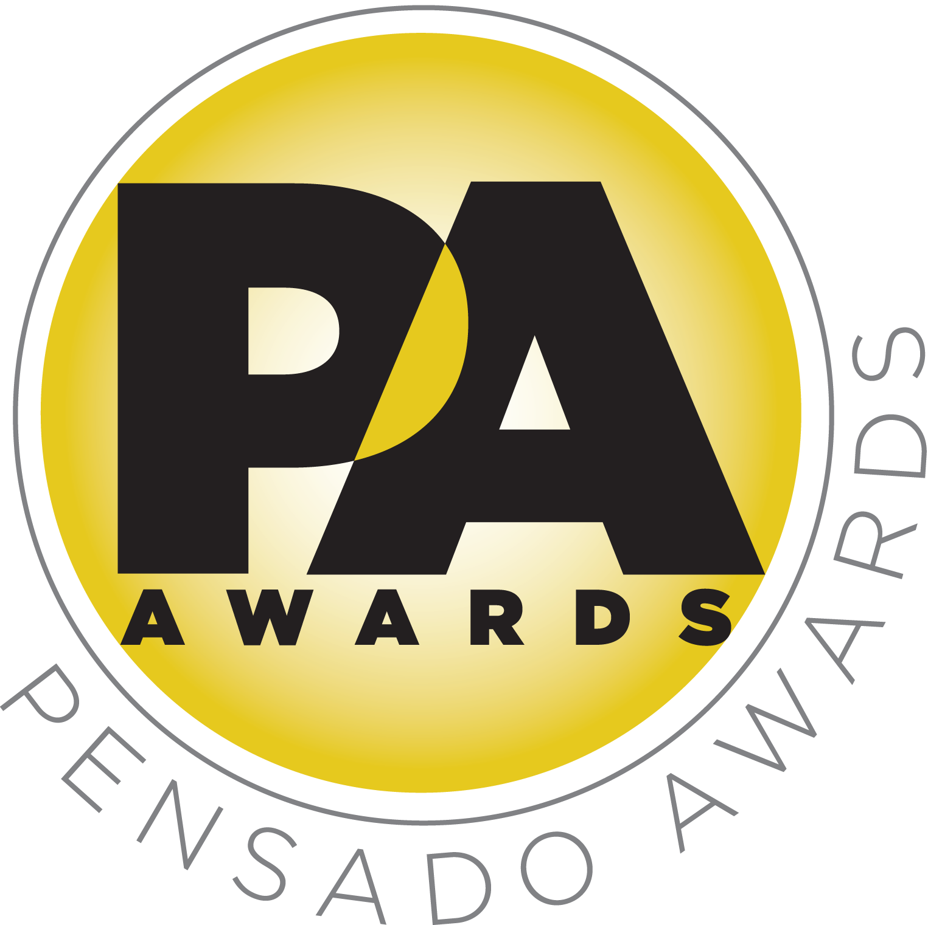

*** TIP SHEET FOR SATURDAY, AUGUST 20, 2016 ***

Industry Gears Up for Third Annual Pensado Awards, on Saturday,
August 20, 2016

Some of the recording industry’s most iconic figures gather to “recognize the faces behind the sound”

WHO:
The team behind Pensado’s Place, the acclaimed weekly web series known as the most influential show for audio engineers, mixers and producers, and its co-hosts Herb Trawick and Dave Pensado (Beyoncé, Christina Aguilera, Kelly Clarkson, Mariah Carey, Elton John, Michael Jackson and more), holds the third annual Pensado Awards, co-hosted by singer-songwriter/actress/fashion designer Taryn Manning (electronic duo Boomkat, 8 Mile, Orange Is the New Black), drummer Samantha Maloney (Hole, Mötley Crüe, Peaches), producer/engineer/mixer Chris Lord-Alge (Pink, Foo Fighters, Avril Lavigne, Green Day), recording/mix engineer MixedByAli (Kendrick Lamar, Dr. Dre, Robin Thicke) and mastering engineer Gavin Lurssen (Tom Waits, Sheryl Crow, T-Bone Burnett). The musical theme of the evening will be “Celebrate the Guitar”; underscoring that theme will be three live performers throughout the ceremony: Phil X (Triumph, Bon Jovi) on electric guitar, Michael “Fish” Herring (Prince, Celine Dion, Christina Aguilera) on acoustic guitar and Ethan Farmer (Aretha Franklin, Janet Jackson, Justin Timberlake) on bass guitar.

WHAT:
Dubbed by insiders as the must-attend audio event of the year, the Pensado Awards were founded as a means of acknowledging talented music producers, engineers, mixers and their work, serving as a grand opportunity for the best pros, amateurs, brands and press to come together as one community to celebrate the uncelebrated. The 2014 and 2015 events were rousing successes, with over 800 industry figures attending the 2015 ceremony.

Presenters are slated to include songwriter/producer busbee; OSCAR®-winning sound designer Mark Mangini; hip-hop production collective 1500 or Nothin’; producer and instrumentalist DJ Iz; a contingent from G.O.O.D. Music; and other surprise guests. Additionally, music legends Steven Tyler, Bruce Springsteen and Dwight Yoakam will contribute special video messages.

WHERE:
Sony Pictures Studios, 10202 W. Washington Blvd., Culver City, CA 90232, under the stars in Calley Park in the middle of the Sony Pictures Studios lot. A VIP reception will be held in the Rita Hayworth Theatre; and an afterparty will take place in the Sony Commissary, which is connected to the park.

WHEN: Saturday, August 20, 2016. Doors will open at 6:30 p.m. PDT.

PR Contacts at event:
Robert Clyne / Clyne Media / 615-300-4666 / Robert@clynemedia.com / www.clynemedia.com/
Lisa Roy / Rock & Roy / 310-463-1563 / lisaroyaudio@mac.com

