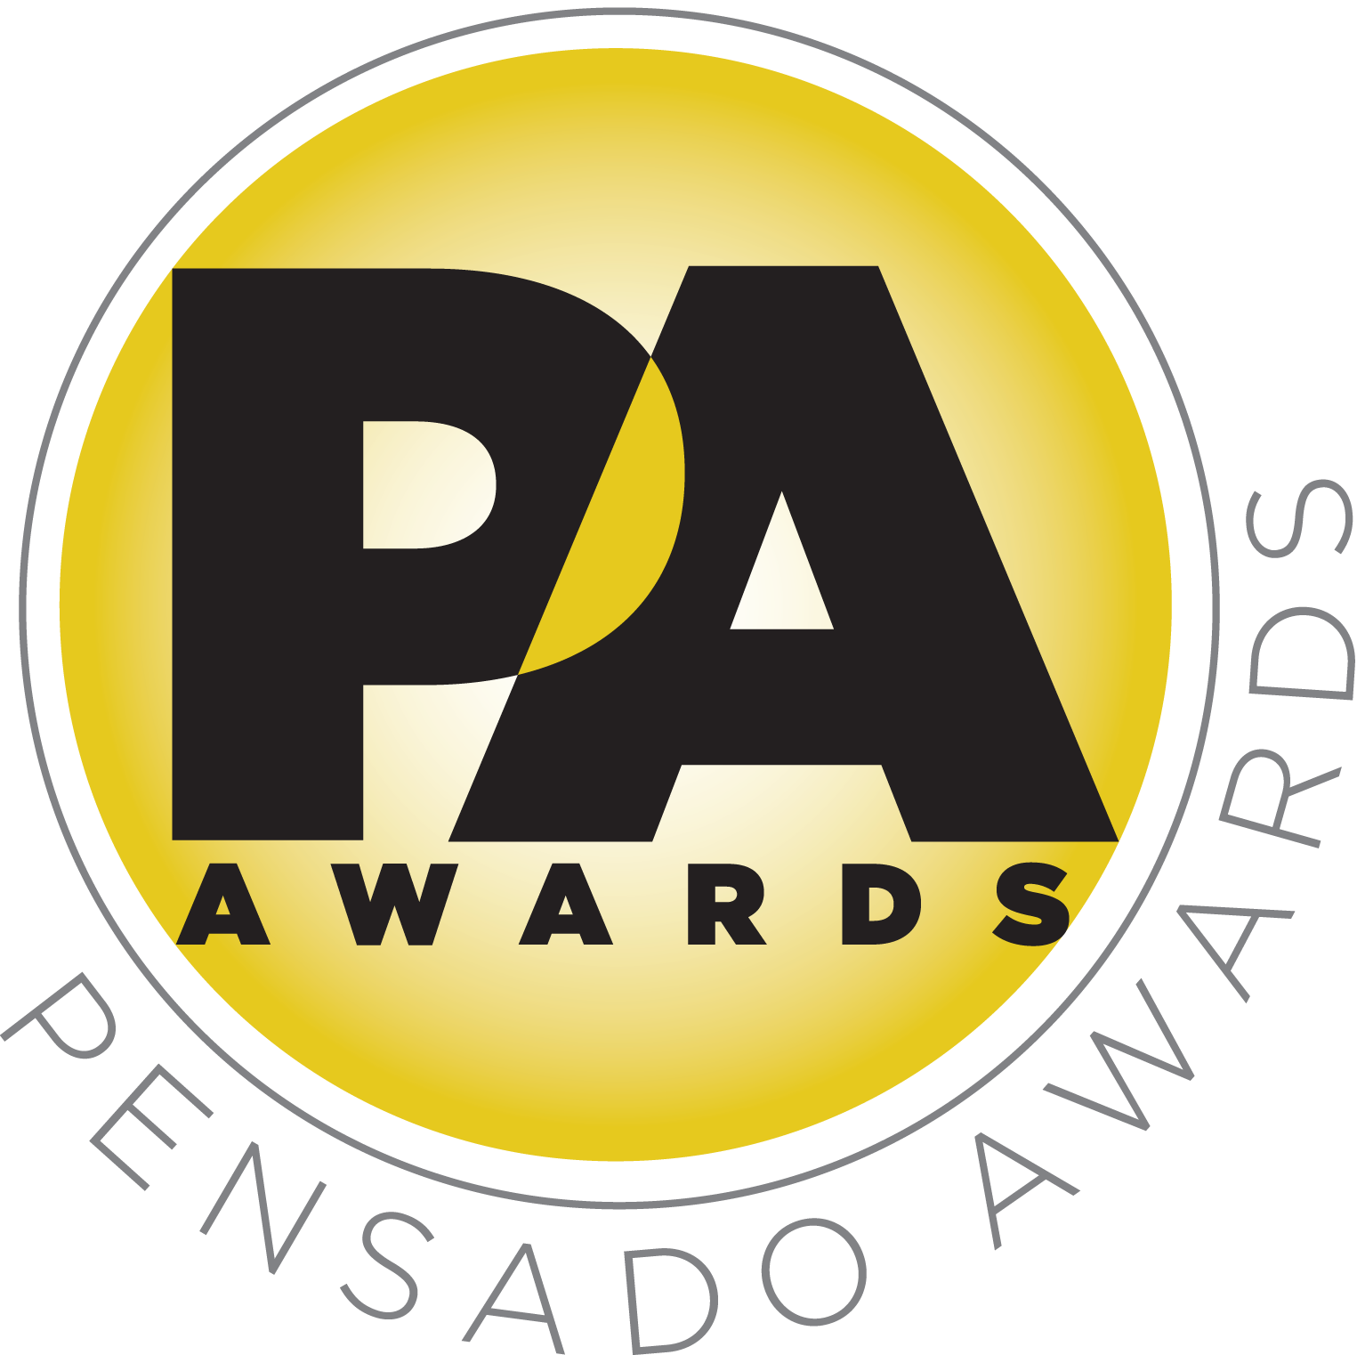

Pro Committee Announced for Third Annual Pensado Awards, Saturday, August 20, 2016

LOS ANGELES, CA, July 13, 2016 — The Pensado Awards recently announced the date and venue for its third-annual ceremony – dubbed by insiders as the must-attend audio event of the year. Today, the awards’ organizers have announced this year’s pro committee, made up of artists, engineers, producers and industry notables, who together will serve as the judging panel for the awards. Created by Herb Trawick and Dave Pensado of Penwick Media (the producers of Pensado's Place and other industry-leading audio-related media), the awards were founded as a means of acknowledging talented music producers, engineers, mixers and their work, serving as a grand opportunity for the best pros, amateurs, brands and press to come together as one community to celebrate the uncelebrated.

This year’s festivities will take place on Saturday, August 20, 2016, at Sony Pictures Studios, 10202 W. Washington Blvd., Culver City, CA 90232. The awards will be held outdoors under the stars in Calley Park in the middle of the Sony Pictures Studios lot. A VIP reception will be held on the complex’s Main Street area, and an afterparty will take place in the Sony Commissary, which is connected to the park. Co-hosts will include producer/engineer Chris Lord-Alge (Pink, Foo Fighters, Avril Lavigne, Green Day), recording/mix engineer MixedByAli (Kendrick Lamar, Dr. Dre, Robin Thicke) and mastering engineer Gavin Lurssen (Tom Waits, Sheryl Crow, T-Bone Burnett). Tickets for the live ceremony are available for $50.00 here. A complete list of award categories can be found here.

.The Pensado Awards Pro Committee is made up of artists, engineers, producers and industry notables (many of whom have been featured guests on Pensado’s Place). This year’s Pro Committee can be found here, and includes such notable recording/audio professionals as Ed Cherney (Eric Clapton, Willie Nelson), Reuben Cohen (Pharrell Williams, Game of Thrones), DJ IZ (Usher), Greg Wells (Keith Urban, Katy Perry), Zoe Thrall (Studio at the Palms Las Vegas), Josh Gudwin (Justin Bieber), Al Schmitt (Bob Dylan, Paul McCartney), Stuart White (Beyoncé, Sia), Candace Stewart (EastWest Studios), Roxanne Ricks (Audio-Technica) and others. An extensive list of sponsors, as well as a full roster of categories, nominees and co-hosts, will be announced in the coming weeks.

The Pensado Awards are a natural outgrowth of the ethos behind Pensado’s Place. In recent years, developments in music and technology have changed the landscape for producers, songwriters, engineers and musicians, encouraging artists and composers of all types to hone their craft. From the self-taught basement amateur to the seasoned industry producer, all manner of music professionals are discovering new methods of working and novel ways to reach fans. The science and art of music-making are in a rapid state of flux, with exciting opportunities awaiting among the talented figures in and out of the spotlight – the people who are currently engineering the next sound that will move the world in the music, film, television and digital realms. Over 100,000 albums and millions of songs are released every year, not to mention the hundreds of thousands of concerts put on worldwide, but the awards often end up in the hands of a lucky select group. So the brilliance and hard work of all those producers, songwriters, DJ’s, engineers, mixers, live wizards and behind-the-scenes technicians in audio often go unnoticed. The Pensado Awards, founded as a means of acknowledging these talented individuals and their work, are a grand opportunity for the best pros, amateurs, brands and press to come together as one community to celebrate the uncelebrated.

Herb Trawick, the Co-host/Executive Producer and Creator of Pensado’s Place, as well as Manager and Advisor to Co-host Dave Pensado, stated, “Our Pro Committee is an essential part of the Pensado Awards and this year’s list of members reads like a Who’s-Who of the music industry. We thank each and every one of them for their ongoing support and look forward to working with them to make our third annual awards show the best ever.”

###

Photo file 1: PensadoAwards16_Statuette.JPG
Photo caption 1: Pensado Awards Megaphone Statuette

Photo file 2: Pensado_Trawick.JPG
Photo caption 2: Pictured L-R: Dave Pensado and Herb Trawick

About Pensado’s Place
The hour-long weekly web series Pensado’s Place was created over five years ago. Co-hosted by legendary mix engineer Dave Pensado (Beyoncé, Christina Aguilera, Kelly Clarkson, Mariah Carey, Elton John, Michael Jackson and more) and show creator Herb Trawick, Pensado’s Place includes interviews with top music industry artists, engineers, producers, mixers, and record executives, as well as in-depth tutorials in production, engineering and mixing. Pensado’s Place has positioned itself as “the most influential show for audio engineers,” mixers and producers (Forbes Magazine). Pensado’s Place is more than just a show, as it highlights the very best in the industry of music, gaming, sound identity on film, and audio equipment, with a presence in live events. As a leading educational resource, Pensado’s Place is helping build the next generation of audio greats. http://www.pensadosplace.tv/.

CONTACTS:
Pensado Awards Contact:
Shevy Shovlin / Pensado Awards / Business Development Manager / 313-590-0886 / info@pensadoawards.com

PR Contacts:
Robert Clyne / Clyne Media / 615-662-1616 / Robert@clynemedia.com / www.clynemedia.com/
Lisa Roy / Rock & Roy / 310-463-1563 / lisaroyaudio@mac.com

