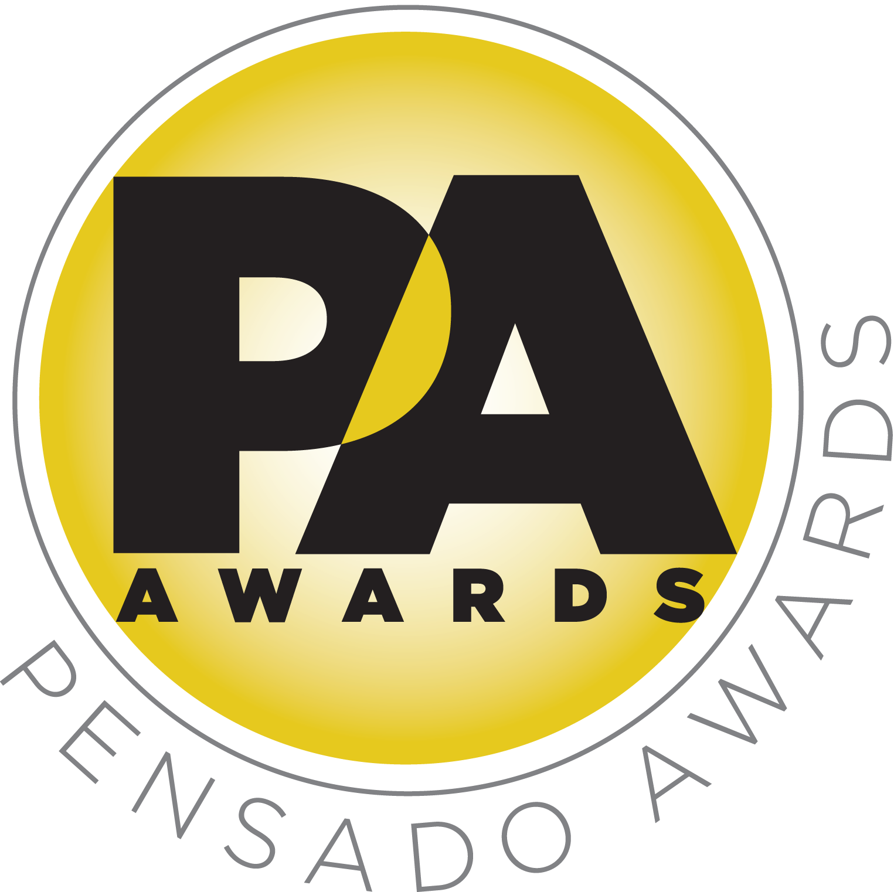

Third Annual Pensado Awards Posted Online

Pensado online community can now experience one of the most talked-about industry events of the year in stunning HD

Broadcast video production of the awards combines the evening’s live ceremony with pre-taped clips displaying the energy, charm and wit that Pensado’s Place viewers have grown to expect

LOS ANGELES, CA, October 31, 2016 — The third annual Pensado Awards, an award show created by Herb Trawick and Dave Pensado of Penwick Media (the producers of the acclaimed online video series Pensado's Place and other industry-leading audio-related media) as a means to acknowledge today’s emerging brand of music professional and “recognize the faces behind the sound,” has now been posted online at http://www.pensadosplace.tv/pensado-awards/ as an embedded Vimeo. Presented in stunning HD, this video production combines separately taped clips (showcasing Herb’s and Dave’s signature charm) with the proceedings of the live ceremony, which took place on Saturday, August 20, 2016, at Sony Pictures Studios in Culver City, CA.

The ceremony hosted a standing-room-only crowd of over 1000 recording industry figures – some as proud nominees, some as presenters, some there to simply be a part of the evening – including songwriter/producer busbee; GRAMMY®-winning movie scoring mixer Alan Meyerson; hip-hop production collective 1500 or Nothin’; producer and instrumentalist DJ Iz; a contingent from G.O.O.D. Music; vocalist Patti Austin; multi-GRAMMY award-winning engineer/producers Ron Fair, Jack Joseph Puig, Ed Cherney, Mick Guzauski, and Al Schmitt; and many more. A special highlight was a taped tribute to producer/engineer/mixer Chris Lord-Alge (Pink, Foo Fighters, Avril Lavigne, Green Day), the winner of the Pensado Giant Award, from Stevie Nicks, Bruce Springsteen, Dwight Yoakam, Steven Tyler and Chris’s brother, GRAMMY Award winning engineer/mixer Tom Lord-Alge.

The event was co-hosted by singer-songwriter/actress/fashion designer Taryn Manning (electronic duo Boomkat, 8 Mile, Orange Is the New Black), drummer Samantha Maloney (Hole, Mötley Crüe, Peaches), Chris Lord-Alge, recording/mix engineer MixedByAli (Kendrick Lamar, Dr. Dre, Robin Thicke) and mastering engineer Gavin Lurssen (Tom Waits, Sheryl Crow, T-Bone Burnett). The musical theme of the awards show was “Celebrate the Guitar,” with live performances by Phil X (Triumph, Bon Jovi), Michael “Fish” Herring (Prince, Celine Dion, Christina Aguilera) and Ethan Farmer (Aretha Franklin, Janet Jackson, Justin Timberlake). The Pensado Awards show drew tremendous attention on social media, having over 500 posts that garnered over 5.5 million impressions on the night of the ceremony alone. Press impressions in the weeks leading up to the ceremony, and in the immediate aftermath, totaled nearly 15 million.

At the ceremony, the following winners were announced:
- OMG! Mix of the Year: Josh Gudwin/Andrew Wuepper for “Sorry” (Justin Bieber); Vance Powell for “Tennessee Whiskey” (Chris Stapleton)
- Game Changer of the Year Award: Dave Cobb
- Break Thru Songwriter: Brody Brown
- Master of Mastering: Joe LaPorta
- Tracking Engineer: Steve Genewick
- Best Non-English Song: JJ Lin, “Twilight”
- Outstanding Brand: Indaba Music
- Break Thru Mixer Award: Delbert Bowers
- Live/FOH: Wilberto Madera (Pitbull)
- Spin Doctor DJ Award: Henry Fong
- AIR Award (Best Assistant, Intern or Runner): Shamir Nicholas, Chris Galland and Wesley Seidman
- Outstanding Achievement in Sound for Visual Medium Award: Straight Outta Compton
- Pensado Giant Award: Chris Lord-Alge
- Dave Pensado Educator Award: Learn from Legends, Recording Connection
- Herb Trawick Visionary Award: Xfer Records

A full list of nominees can be found at http://pensadoawards.com/award_categories.html.

The culmination of the awards segment was the presentation of the Pensado Giant Award to Chris Lord-Alge, who offered thanks to many of his industry friends and clients, and very special thanks went to his brother Tom Lord-Alge, who unfortunately could not attend, and his mother Vivian, who had flown in from the east coast to watch Chris accept his award.

Herb Trawick, Co-host/Executive Producer and Creator of Pensado’s Place, as well as the Manager and Advisor to Co-host Dave Pensado, states, “We are very proud of our third annual Pensado Awards, and we’re so glad that we’re now able to share it in HD with our online family. We hope you all enjoy the ceremony and the taped segments we added just for you. This year’s awards were the best yet, and the Pensado organization continues to grow and expand, so stay tuned, as we have so many exciting things to announce in the coming months.”

This year’s Pensado Awards drew a list of sponsors that comprises some of the most prominent names in professional audio, M.I. and audio education, including The Blackbird Academy, Vintage King Audio, Avid, iZotope, The Recording Academy® Producers and Engineers Wing®, LANDR, DTS, Westlake Pro, Barefoot Sound, The Recording Connection Audio Institute, Fab Factory, Augspurger, Music Connection, Burl Audio, Gibson Brands, Milkman Sound, Rock N Roll Relics and Shinola Detroit.

###

Photo file: CoHosts.JPG
Photo caption: Pictured L-R: co-hosts Taryn Manning, Gavin Lurssen, Chris Lord-Alge, MixedByAli and Samantha Maloney, welcoming the crowd and the online audience to the third annual Pensado Awards.

About The Pensado Awards
The Pensado Awards are a natural outgrowth of the ethos behind Pensado’s Place. In recent years, developments in music and technology have changed the landscape for producers, songwriters, engineers and musicians, encouraging artists and composers of all types to hone their craft. From the self-taught basement amateur to the seasoned industry producer, all manner of music professionals are discovering new methods of working and novel ways to reach fans. The science and art of music-making are in a rapid state of flux, with exciting opportunities awaiting among the talented figures in and out of the spotlight – the people who are currently engineering the next sound that will move the world in the music, film, television and digital realms. Over 100,000 albums and millions of songs are released every year, not to mention the hundreds of thousands of concerts put on worldwide, but the awards often end up in the hands of a lucky select group. So the brilliance and hard work of all those producers, songwriters, DJ’s, engineers, mixers, live wizards and behind-the-scenes technicians in audio often go unnoticed. The Pensado Awards, founded as a means of acknowledging these talented individuals and their work, are a grand opportunity for the best pros, amateurs, brands and press to come together as one community to celebrate the uncelebrated.

About Pensado’s Place
The hour-long weekly web series Pensado’s Place was created over five years ago. Co-hosted by legendary mix engineer Dave Pensado (Beyoncé, Christina Aguilera, Kelly Clarkson, Mariah Carey, Elton John, Michael Jackson and more) and show creator Herb Trawick, Pensado’s Place includes interviews with top music industry artists, engineers, producers, mixers, and record executives, as well as in-depth tutorials in production, engineering and mixing. Pensado’s Place has positioned itself as “the most influential show for audio engineers,” mixers and producers (Forbes Magazine). Pensado’s Place is more than just a show, as it highlights the very best in the industry of music, gaming, sound identity on film, and audio equipment, with a presence in live events. As a leading educational resource, Pensado’s Place is helping build the next generation of audio greats. http://www.pensadosplace.tv/.

CONTACTS:
PR Contacts:
Robert Clyne / Clyne Media / 615-662-1616 / Robert@clynemedia.com / www.clynemedia.com/
Lisa Roy / Rock & Roy / 310-463-1563 / lisaroyaudio@mac.com

