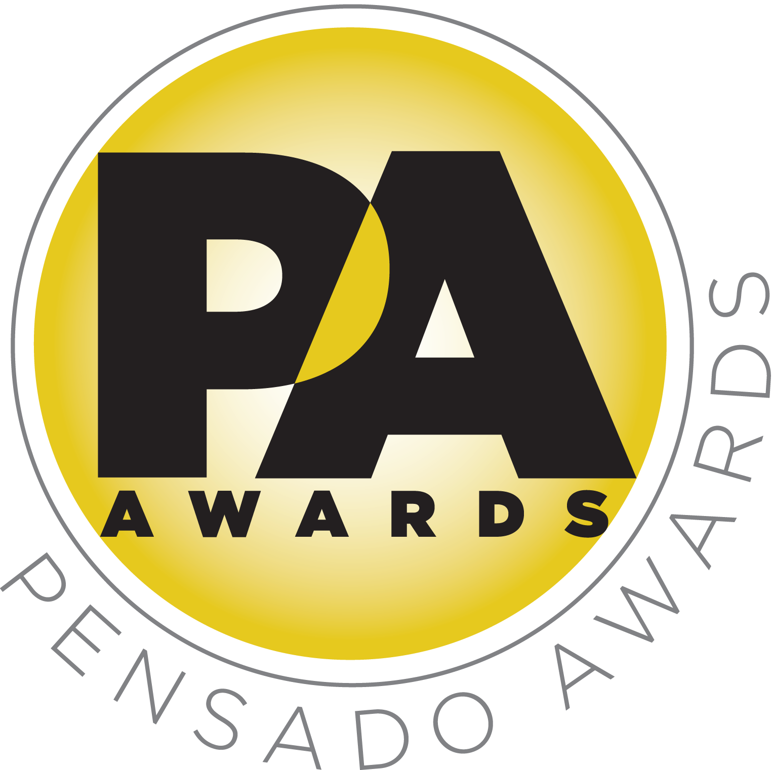

Nominees Announced for Third Annual Pensado Awards, Saturday, August 20, 2016

— Dozens of talented individuals fill 15 categories, from up-and-comers to legends of the industry —

LOS ANGELES, CA, August 2, 2016 — The third annual Pensado Awards (taking place on Saturday, August 20, 2016, at Sony Pictures Studios, 10202 W. Washington Blvd., Culver City, CA 90232), dubbed by insiders as the must-attend audio event of the year, has announced its nominees in 15 categories.

A few key highlights among the categories and nominees include Game Changer Producer of the Year (nominees: Greg Kurstin for Adele, “Hello”; Mike Posner, Martin Terefe and SeeB for Mike Posner, “I Took a Pill in Ibiza [Seeb Remix]”; Dave Cobb and Chris Stapleton for Chris Stapleton, “Tennessee Whiskey”; Ninteen85, DJ Maphorisa, Noah "40" Shebib and Wiz Kid for Drake, “One Dance”; and Pharrell Williams, Sounwave and Michael Kuhle for Kendrick Lamar, “Alright”); Break Thru Songwriter (Paul Barry and James Bay for James Bay, "Let It Go"; Greg Kurstin for Adele, "Hello"; Brody Brown for Lukas Graham, "7 Years"; Julia Michaels for Fifth Harmony, "Work From Home"; and Tyler Joseph for Twenty One Pilots, "Ride”); Spin Doctor DJ Award (Henry Fong, Dillon Francis, Flume, Martin Garrix and Zedd); and Outstanding Achievement in Sound for Visual Medium (nominees include the audio teams behind Darryl's House, The Voice, Empire, Jimmy Kimmel Live! and Straight Outta Compton). Other categories include OMG! Mix of the Year, Master of Mastering, Tracking Engineer, Best Non-English Song, Outstanding Brand, Break Thru Mixer Award, Live/FOH, AIR Award (Best Assistant, Intern or Runner), Pensado Giant Award, Dave Pensado Educator Award and Herb Trawick Visionary Award. A full list of nominees can be found at http://pensadoawards.com/award_categories.html.

Created by Herb Trawick and Dave Pensado of Penwick Media (the producers of Pensado's Place and other industry-leading audio-related media), the awards were founded as a means of acknowledging talented music producers, engineers, mixers and their work, serving as a grand opportunity for the best pros, amateurs, brands and press to come together as one community to celebrate the uncelebrated. The awards will be held outdoors under the stars in Calley Park in the middle of the Sony Pictures Studios lot. A VIP reception will be held on the complex’s Main Street area, and an afterparty will take place in the Sony Commissary, which is connected to the park. Co-hosts will include singer-songwriter/actress/fashion designer Taryn Manning (electronic duo Boomkat, 8 Mile, Orange Is the New Black), drummer Samantha Maloney (Hole, Mötley Crüe, Peaches), producer/engineer Chris Lord-Alge (Pink, Foo Fighters, Avril Lavigne, Green Day), recording/mix engineer MixedByAli (Kendrick Lamar, Dr. Dre, Robin Thicke) and mastering engineer Gavin Lurssen (Tom Waits, Sheryl Crow, T-Bone Burnett). The musical theme of the evening will be “Celebrate the Guitar”; underscoring that theme will be three live performers throughout the ceremony: Phil X (Triumph, Bon Jovi) on electric guitar, Michael “Fish” Herring (Prince, Celine Dion, Christina Aguilera) on acoustic guitar and Ethan Farmer (Aretha Franklin, Janet Jackson, Justin Timberlake) on bass guitar. Tickets for the live ceremony are available for $50.00 here.

Herb Trawick, the Co-host/Executive Producer and Creator of Pensado’s Place, as well as Manager and Advisor to Co-host Dave Pensado, stated, “We are getting very close to the awards show date, and we are pleased to unveil our nominees. They represent a diverse cross-section of our industry, from studio employees to established names. Each is a vital piece of the music industry machine, and we are excited to honor each one of them. It is a distinct pleasure to see their names gathered on one list, and we look forward to distributing the awards on August 20.”
###

Photo file 1: PensadoAwards16_Statuette.JPG
Photo caption 1: Pensado Awards Megaphone Statuette

Photo file 2: Pensado_Trawick.JPG
Photo caption 2: Pictured L-R: Dave Pensado and Herb Trawick

About The Pensado Awards
The Pensado Awards are a natural outgrowth of the ethos behind Pensado’s Place. In recent years, developments in music and technology have changed the landscape for producers, songwriters, engineers and musicians, encouraging artists and composers of all types to hone their craft. From the self-taught basement amateur to the seasoned industry producer, all manner of music professionals are discovering new methods of working and novel ways to reach fans. The science and art of music-making are in a rapid state of flux, with exciting opportunities awaiting among the talented figures in and out of the spotlight – the people who are currently engineering the next sound that will move the world in the music, film, television and digital realms. Over 100,000 albums and millions of songs are released every year, not to mention the hundreds of thousands of concerts put on worldwide, but the awards often end up in the hands of a lucky select group. So the brilliance and hard work of all those producers, songwriters, DJ’s, engineers, mixers, live wizards and behind-the-scenes technicians in audio often go unnoticed. The Pensado Awards, founded as a means of acknowledging these talented individuals and their work, are a grand opportunity for the best pros, amateurs, brands and press to come together as one community to celebrate the uncelebrated.

About Pensado’s Place
The hour-long weekly web series Pensado’s Place was created over five years ago. Co-hosted by legendary mix engineer Dave Pensado (Beyoncé, Christina Aguilera, Kelly Clarkson, Mariah Carey, Elton John, Michael Jackson and more) and show creator Herb Trawick, Pensado’s Place includes interviews with top music industry artists, engineers, producers, mixers, and record executives, as well as in-depth tutorials in production, engineering and mixing. Pensado’s Place has positioned itself as “the most influential show for audio engineers,” mixers and producers (Forbes Magazine). Pensado’s Place is more than just a show, as it highlights the very best in the industry of music, gaming, sound identity on film, and audio equipment, with a presence in live events. As a leading educational resource, Pensado’s Place is helping build the next generation of audio greats. http://www.pensadosplace.tv/.

CONTACTS:
Pensado Awards Contact:
Shevy Shovlin / Pensado Awards / Business Development Manager / 313-590-0886 / info@pensadoawards.com

PR Contacts:
Robert Clyne / Clyne Media / 615-662-1616 / Robert@clynemedia.com / www.clynemedia.com/
Lisa Roy / Rock & Roy / 310-463-1563 / lisaroyaudio@mac.com

