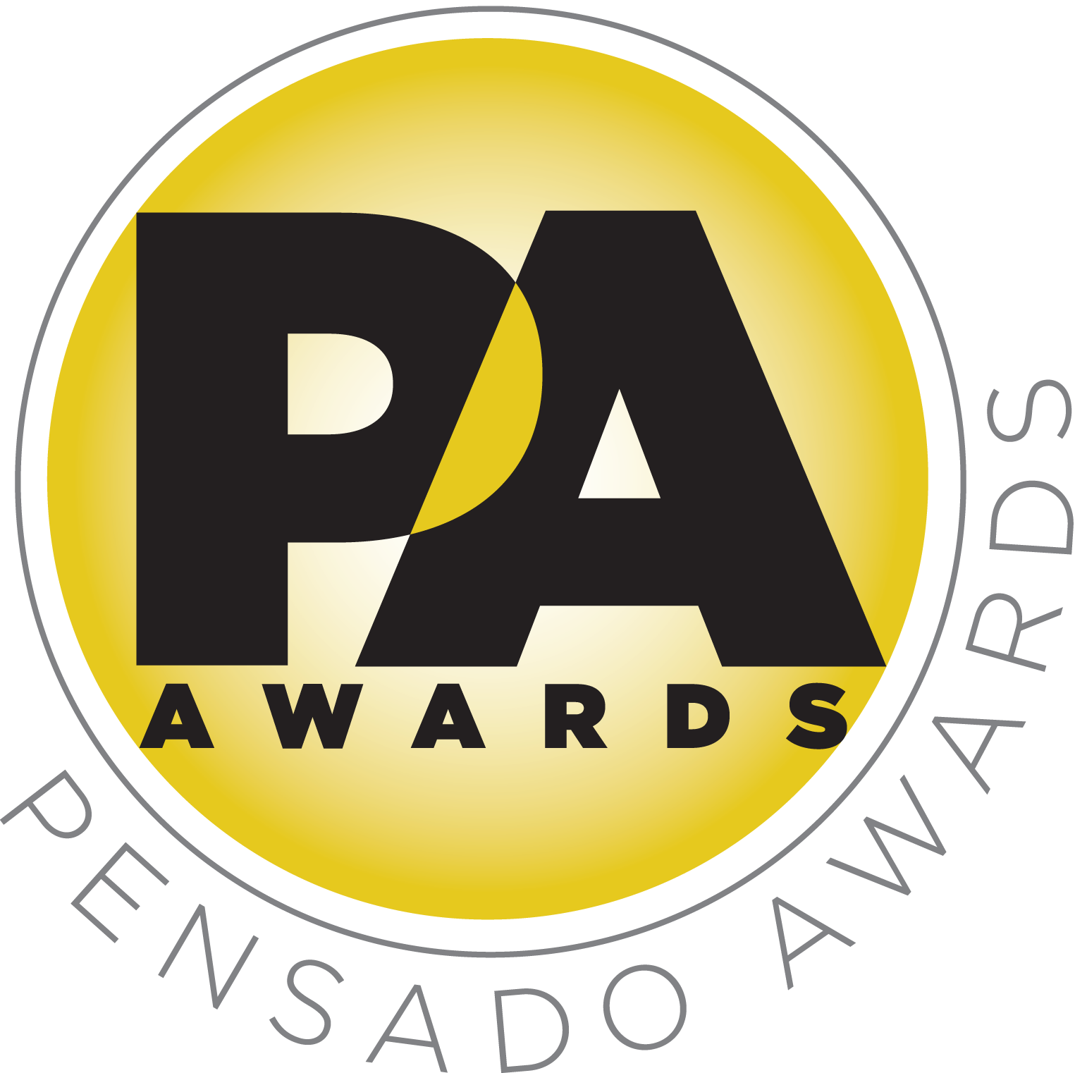

Recording Industry Luminaries to Meet Under the Stars at Third Annual Pensado Awards, Saturday, August 20, 2016

Awards show will once again “recognize the faces behind the sound”

The ceremony, featuring a who’s-who of the recording community, will be available to view on the Pensado’s Place media channels after the event

LOS ANGELES, CA, June 28, 2016 — The Pensado Awards has announced the date and venue for its third-annual ceremony – dubbed by insiders as the must-attend audio event of the year. Created by Herb Trawick and Dave Pensado of Penwick Media (the producers of Pensado's Place and other industry-leading audio-related media), the awards were founded as a means of acknowledging talented music producers, engineers, mixers and their work, serving as a grand opportunity for the best pros, amateurs, brands and press to come together as one community to celebrate the uncelebrated. Since its inception, the show has continued to gain momentum and garner attention throughout the industry.

This year’s festivities will take place on Saturday, August 20, 2016, at Sony Pictures Studios, 10202 W. Washington Blvd., Culver City, CA 90232. A video production of the ceremony will follow and be posted on the Pensado’s Place YouTube channel. Co-hosts will include producer/engineer Chris Lord-Alge (Pink, Foo Fighters, Avril Lavigne, Green Day), recording/mix engineer MixedByAli (Kendrick Lamar, Dr. Dre, Robin Thicke) and mastering engineer Gavin Lurssen (Tom Waits, Sheryl Crow, T-Bone Burnett). An extensive list of sponsors, as well as a full roster of categories, nominees and co-hosts, will be announced in the coming weeks. Tickets for the live ceremony are available for $50.00 here. A complete list of award categories can be found here. The awards will be held outdoors under the stars in Calley Park in the middle of the Sony Pictures Studios lot. A VIP reception will be held on the complex’s Main Street area, and an afterparty will take place in the Sony Commissary, which is connected to the park.

Last year’s ceremony hosted a crowd of over 800 recording industry figures, highlighted by presentations from the likes of prominent TV personality, producer and musician Randy Jackson (American Idol, Journey, etc.), engineer Young Guru (Jay Z, Beyoncé, Mariah Carey), legendary producer Quincy Jones, producer/recording artist Dave Stewart and many others, some as proud nominees, some as presenters, some there to simply be a part of the evening – and this year’s show is set to be even bigger.

The Pensado Awards are a natural outgrowth of the ethos behind Pensado’s Place. In recent years, developments in music and technology have changed the landscape for producers, songwriters, engineers and musicians, encouraging artists and composers of all types to hone their craft. From the self-taught basement amateur to the seasoned industry producer, all manner of music professionals are discovering new methods of working and novel ways to reach fans. The science and art of music-making are in a rapid state of flux, with exciting opportunities awaiting among the talented figures in and out of the spotlight – the people who are currently engineering the next sound that will move the world in the music, film, television and digital realms. Over 100,000 albums and millions of songs are released every year, not to mention the hundreds of thousands of concerts put on worldwide, but the awards often end up in the hands of a lucky select group. So the brilliance and hard work of all those producers, songwriters, DJ’s, engineers, mixers, live wizards and behind-the-scenes technicians in audio often go unnoticed. The Pensado Awards, founded as a means of acknowledging these talented individuals and their work, are a grand opportunity for the best pros, amateurs, brands and press to come together as one community to celebrate the uncelebrated.

Herb Trawick, the Co-host/Executive Producer and Creator of Pensado’s Place, as well as Manager and Advisor to Co-host Dave Pensado, stated, “Once again, we are thrilled to have the opportunity to put on an awards show that speaks to the people who are the backbone of the recording industry. This year’s event will be completely off the hook, with special guests and a host of surprises.”

“As an engineer and mixer myself, I know how hard all the behind-the-scenes people work, and we want to give them the recognition they deserve,” stated Dave Pensado (Co-host of Pensado’s Place, GRAMMY®-winning mix engineer, Teacher). “These awards acknowledge amateurs and professionals for their dedication to the recording craft and the audio community in general. We hope you join in this year’s celebration, either in person or online.”

###

Photo file 1: PensadoAwards16_Statuette.JPG
Photo caption 1: Pensado Awards Megaphone Statuette

Photo file 2: Pensado_Trawick.JPG
Photo caption 2: Pictured L-R: Dave Pensado and Herb Trawick

About Pensado’s Place
The hour-long weekly web series Pensado’s Place was created over five years ago. Co-hosted by legendary mix engineer Dave Pensado (Beyoncé, Christina Aguilera, Kelly Clarkson, Mariah Carey, Elton John, Michael Jackson and more) and show creator Herb Trawick, Pensado’s Place includes interviews with top music industry artists, engineers, producers, mixers, and record executives, as well as in-depth tutorials in production, engineering and mixing. Pensado’s Place has positioned itself as “the most influential show for audio engineers,” mixers and producers (Forbes Magazine). Pensado’s Place is more than just a show, as it highlights the very best in the industry of music, gaming, sound identity on film, and audio equipment, with a presence in live events. As a leading educational resource, Pensado’s Place is helping build the next generation of audio greats. http://www.pensadosplace.tv/.

CONTACTS:
Pensado Awards Contact:
Shevy Shovlin / Pensado Awards / Business Development Manager / 313-590-0886 / info@pensadoawards.com

PR Contacts:
Robert Clyne / Clyne Media / 615-662-1616 / Robert@clynemedia.com / www.clynemedia.com/
Lisa Roy / Rock & Roy / 310-463-1563 / lisaroyaudio@mac.com

