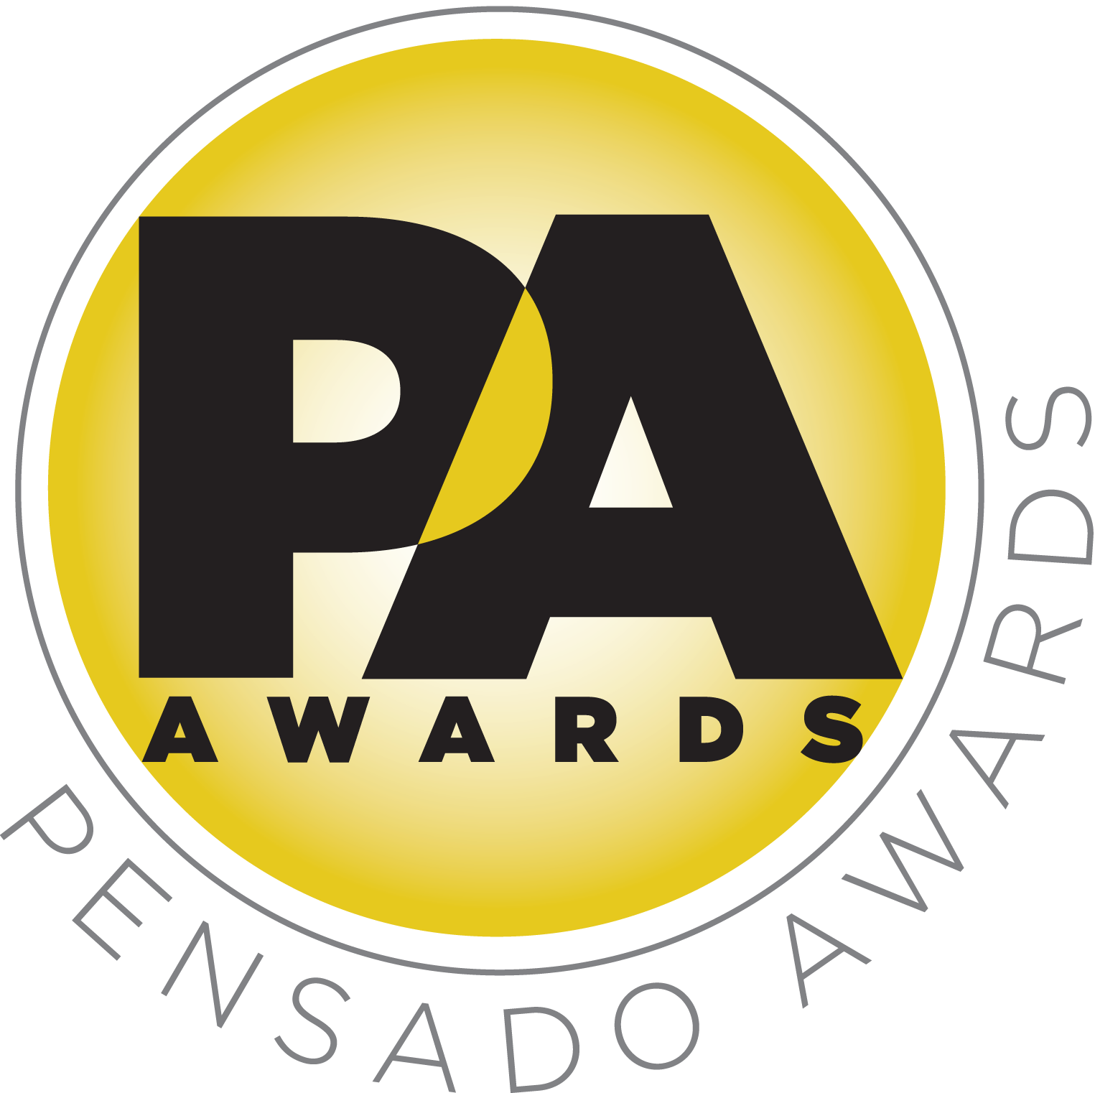

Third Annual Pensado Awards Continues to Garner Accolades as the Best and Biggest Yet

Crowd of 1000 industry professionals and celebrities pack the Sony Pictures Studios lot in Culver City, CA, for annual Pensado Awards

LOS ANGELES, CA, September 9, 2016 — The Pensado Awards, an award show created by Herb Trawick and Dave Pensado of Penwick Media (the producers of the acclaimed online video series Pensado's Place and other industry-leading audio-related media) as a means to acknowledge today’s emerging brand of music professional and “recognize the faces behind the sound,” continues to receive praise from sponsors, co-hosts and winners alike. The third annual awards ceremony was held on Saturday, August 20, 2016, at Sony Pictures Studios in Culver City, CA, and hosted a standing-room-only crowd of over 1000 recording industry professionals.

Co-host and noted drummer Samantha Maloney (Hole, Mötley Crüe, Peaches) stated, “I wanted to be involved in the Pensado Awards because Dave and Herb are out there doing a spectacular job with their Pensado’s Place show. Not only do they teach and showcase the next generation of talent and feature the latest in audio technology, but they inspire and enlighten us by bringing us ‘into the lair’ with some of the best talent that audio engineering has to offer. I don’t know where else I can find such an array of knowledge and talent in this business on any screen. Some of their in-depth interviews put 60 Minutes to shame!”
“As a long-time supporter and sponsor of Pensado’s Place and the Pensado Awards, I am thrilled that at this year’s Pensado Awards, Herb and Dave chose to help raise funds for David Platillero, a talented young producer-engineer who suffered a severe injury earlier this year while enrolled at our Blackbird Academy,” stated John McBride, owner and founder of Blackbird Studio and the Blackbird Academy. "David, while riding his bicycle, was hit by a distracted driver and has been paralyzed. He requires extensive rehabilitation and is making incredible headway on his road to recovery. There are no words that can express what this support means for David and his family. I am especially moved by the great sense of community that Herb and Dave have brought to the forefront – the support of the music industry around David has filled my heart with joy. Thank you to all who have contributed … and a huge thanks to Herb and Dave for their generous hearts!”

“Herb and Dave have created an event that is monumentally important because it displays the spirit of the tenacious and hard-working men and women behind the glass, the people that make music possible,” commented sponsor Brian Kraft, Chief Academic Officer/COO of The Recording Connection and winners of the Dave Pensado Educator Award for their Learn from Legends program. “Without them, we have no music. The people that the Pensado Awards salute are the people therefore that make our lives meaningful.”

GRAMMY® Award-winning mastering engineer and co-host Gavin Lurssen (Tom Waits, Sheryl Crow, T-Bone Burnett) shared, “It’s very important to make sure in any profession that the practitioner bonds with and embraces the community they work in. This year’s awards were a fun-packed evening with all of my heroes in attendance. What is remarkable about this industry is that my heroes are not only accessible but also in many cases they are my clients. To have all these people, and others coming into our industry, gathering together for this evening celebrating audio excellence is a very special thing that Herb and Dave have created, especially under the open skies and perfect weather in Los Angeles.”

In addition to the standing-room-only crowd of over 1000 recording industry professionals. the Pensado Awards also drew tremendous attention on social media with the hashtags #PensadoAwards and #WeStandForDavid, having over 500 posts that garnered over 5.5 million impressions on the night of the awards alone.

The Pensado Awards are a natural outgrowth of the ethos behind Pensado’s Place. From the self-taught basement amateur to the seasoned industry producer, all manner of music professionals are discovering new methods of working and novel ways to reach fans, and these awards are here to honor them. The awards highlight the brilliance and hard work of all those producers, songwriters, DJ’s, engineers, mixers, live wizards and behind-the-scenes technicians in audio that often go unnoticed. The Pensado Awards unites the best pros, amateurs, brands and press to come together as one community to celebrate the uncelebrated.

This year’s Pensado Awards drew a list of sponsors that comprises some of the most prominent names in professional audio, M.I. and audio education, including The Blackbird Academy, Vintage King Audio, Avid, iZotope, The Recording Academy® Producers and Engineers Wing®, LANDR, DTS, Westlake Pro, Barefoot Sound, The Recording Connection Audio Institute, Fab Factory, Augspurger, Music Connection, Burl Audio, Gibson Brands, Milkman Sound, Rock N Roll Relics and Shinola Detroit.

###

Photo file 1: PensadoAwards_Group.JPG
Photo caption 1: An assemblage of co-hosts, presenters and honorees on stage at the grand finale of the third annual Pensado Awards, Saturday, August 20, 2016, at Sony Pictures Studios in Culver City, CA. At center is David Platillero, a talented young producer-engineer who suffered a severe injury earlier this year while enrolled at the Blackbird Academy. The evening’s festivities raised funds for his ongoing rehabilitation. Photo by Chris Schmitt Photography. © 2016.

Photo file 2: PensadoAwards_CLA_Samantha.JPG
Photo caption 2: Pictured L-R: Co-hosts Chris Lord-Alge and Samantha Maloney. Photo by Chris Schmitt Photography. © 2016.

About The Pensado Awards
The Pensado Awards are a natural outgrowth of the ethos behind Pensado’s Place. In recent years, developments in music and technology have changed the landscape for producers, songwriters, engineers and musicians, encouraging artists and composers of all types to hone their craft. From the self-taught basement amateur to the seasoned industry producer, all manner of music professionals are discovering new methods of working and novel ways to reach fans. The science and art of music-making are in a rapid state of flux, with exciting opportunities awaiting among the talented figures in and out of the spotlight – the people who are currently engineering the next sound that will move the world in the music, film, television and digital realms. Over 100,000 albums and millions of songs are released every year, not to mention the hundreds of thousands of concerts put on worldwide, but the awards often end up in the hands of a lucky select group. So the brilliance and hard work of all those producers, songwriters, DJ’s, engineers, mixers, live wizards and behind-the-scenes technicians in audio often go unnoticed. The Pensado Awards, founded as a means of acknowledging these talented individuals and their work, are a grand opportunity for the best pros, amateurs, brands and press to come together as one community to celebrate the uncelebrated.

About Pensado’s Place
The hour-long weekly web series Pensado’s Place was created over five years ago. Co-hosted by legendary mix engineer Dave Pensado (Beyoncé, Christina Aguilera, Kelly Clarkson, Mariah Carey, Elton John, Michael Jackson and more) and show creator Herb Trawick, Pensado’s Place includes interviews with top music industry artists, engineers, producers, mixers, and record executives, as well as in-depth tutorials in production, engineering and mixing. Pensado’s Place has positioned itself as “the most influential show for audio engineers,” mixers and producers (Forbes Magazine). Pensado’s Place is more than just a show, as it highlights the very best in the industry of music, gaming, sound identity on film, and audio equipment, with a presence in live events. As a leading educational resource, Pensado’s Place is helping build the next generation of audio greats. http://www.pensadosplace.tv/.

CONTACTS:
PR Contacts:
Robert Clyne / Clyne Media / 615-662-1616 / Robert@clynemedia.com / www.clynemedia.com/
Lisa Roy / Rock & Roy / 310-463-1563 / lisaroyaudio@mac.com

