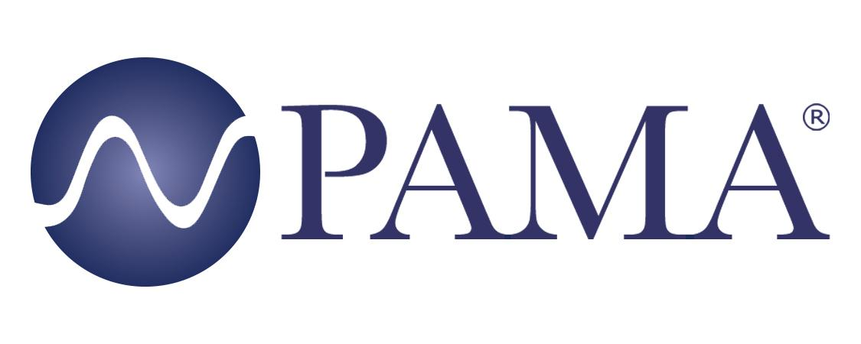

PR Contact:
Robert Clyne
President
Clyne Media, Inc.
T. 615.662.1616
robert@clynemedia.com

PAMA Contact:
Jennifer Shockley, CAE
Executive Director
Professional Audio Manufacturers Alliance
T. 717.614.4271
jennifer@aimanswers.com

For Immediate Release

PAMA Invites Industry to Join December 17 Event Featuring Dr. Chris Kuehl

Lemoyne, PA, December 13, 2021 – As part of its ongoing commitment to sharing perspectives from knowledgeable and respected industry voices, the Professional Audio Manufacturers Alliance (PAMA) is extending an invitation to the audio community to join its December 17 membership meeting with Dr. Chris Kuehl, co-founder and managing director of Armada Corporate Intelligence, as the featured guest.

Back by popular demand, Dr. Kuehl provided a forecast for economic recovery post-COVID, thoughts on the long-term effect of work-from-home policies, and the impact of the pandemic on various manufacturing sectors at PAMA’s December 2020 membership meeting. In the upcoming meeting, Dr. Kuehl will discuss the reality that many issues such as supply chain breakdowns, inflation and labor shortages have lingered, plus new challenges such as higher interest rates, more geopolitical issues and the impact of governmental activity.

“The perspectives Dr. Kuehl shared with our membership last December were insightful and fascinating,” states PAMA Board of Directors chair Chris Regan. “We are eager to hear his analysis of 2021 and his predictions for 2022 as the manufacturing community faces another year of uncertainty.”

The free event will be held online at 2 PM EST, December 17, 2021. Registration is required to attend. Registration is available here and is also linked from the PAMA events page: pamalliance.org/events.

Video archives of past PAMA membership meetings can be found on the event page. Also available on the site are videos of PAMA’s student career opportunities series of online sessions.

Learn more about PAMA’s advocacy for audio excellence at pamalliance.org

Photo file 1: Chris-Kuehl.jpg
Photo caption 1: The audio community is invited to join PAMA’s December 17 membership meeting where Dr. Chris Kuehl, co-founder and managing director of Armada Corporate Intelligence, will be the featured guest. Dr. Kuehl will provide insights into the impact of the ongoing pandemic on manufacturing

About PAMA:
Founded in 2003, the Professional Audio Manufacturers Alliance (PAMA) is the collective voice and forum for the leading manufacturers of professional audio products and the people who use them. PAMA member companies conduct business worldwide in support of high-quality audio across a wide range of industries – pursuing the state of the art in technology and practice to enable audio professionals to elevate their craft and delight listeners and audiences every day. PAMA’s mission is to promote awareness and appreciation of high-quality professional audio through market leadership, communication and education. Our core customers are pro-audio professionals around the world with an interest in promoting high-quality audio. Learn more at www.pamalliance.org.

